options(warn=-1)  
setwd('/Users/dsing001/LV/R')  
  
#load the csv file and provide the name as lv  
  
library(ggplot2)  
library(discretization)  
library(randomForest)

## randomForest 4.6-10  
## Type rfNews() to see new features/changes/bug fixes.

library(ROCR)

## Loading required package: gplots  
## KernSmooth 2.23 loaded  
## Copyright M. P. Wand 1997-2009  
##   
## Attaching package: 'gplots'  
##   
## The following object is masked from 'package:stats':  
##   
## lowess

library(LV)  
  
filename <- 'LendingClub.csv'  
header <- TRUE  
filename

## [1] "LendingClub.csv"

clscol='Class'  
  
# remove all the uncomplete data  
X <- read.csv(file=filename,header=header)  
clscolpos <- match(clscol,colnames(X))  
X <- X[complete.cases(X),]  
X <- moveclasscolintheend(X,clscolpos)  
X[,clscolpos] <- as.character(X[,clscolpos])  
  
# Change the levels to 0 and 1  
X[X[,clscolpos]=='Creditworthy',clscolpos] <- '0'  
X[X[,clscolpos]=='Uncreditworthy',clscolpos] <- '1'  
X[,clscolpos] <- as.factor(as.numeric(X[,clscol]))  
  
  
  
  
#After prelim processing I found that some of the data has vey few values in some of the levels and this could be an issue.  
#Also, based on graphs It looked like that some of the data in these factors is independent i.e. chi square test.  
#Thus running whether a process which will merge all the levels of a column which are independent base on chi square. I.e. these levels does not have discrimintaive power w.r.t. class.  
  
# However, first create 3 subsets to make sure that we run this process only on the train data and doesnt do it on test data otherwise there might be a bias in our model.  
  
# Generate the 3 sets. i.e test set 0.3 Valid set is 0.07 and train is 0.63  
dt_set <- generte_train_test_validset(X,test_ratio=0.3,valid_ratio=0.1)

## [1] "we have valid test"  
## [1] "valid set is generated"

train_data <- dt_set$train_data  
test_data <- dt_set$test_data  
valid_data <- dt_set$valid_data  
  
#Run the merge level proces. Not that independence will be tested only on the train data but to be consstent we have to merge the same lable in test data and valid data as well.  
td <- merge_lvls(train_data,test_data,valid_data)

## [1] 0 0 0 0 0 0  
## Levels: 0 1  
## [1] 2 4 6 7 9 15 20 21  
## 'data.frame': 15578 obs. of 21 variables:  
## $ Loan.Amount : int 1200 7500 3000 3200 5000 2525 10625 10000 3000 6625 ...  
## $ Loan.Term : Factor w/ 2 levels "36 Months","60 Months": 1 1 1 1 1 1 1 1 1 1 ...  
## $ Employment.Length : num 10 3 3 5 10 3 10 1 9 0.5 ...  
## $ Home.Ownership : Factor w/ 5 levels "MORTGAGE","NOne",..: 4 5 1 5 1 5 1 1 1 5 ...  
## $ Annual.Income : num 54000 85000 80800 54000 90000 27000 34000 56000 100000 13200 ...  
## $ Loan.Purpose : Factor w/ 15 levels "0","Car","Credit Card",..: 4 4 3 4 6 4 4 4 13 4 ...  
## $ Address.State : Factor w/ 51 levels "","AK","AL","AR",..: 44 6 44 21 6 19 27 24 12 6 ...  
## $ Debt.To.Income.Ratio : num 5.47 8.1 14.97 6.51 17.25 ...  
## $ No..Delinquencies.In.Last.2.Years: Factor w/ 10 levels "Eight","Five",..: 5 5 6 5 5 5 5 5 6 5 ...  
## $ Earliest.Credit.Line.Opened : num 31068 36846 36004 38872 35566 ...  
## $ FICO.Credit.Score : int 675 710 665 740 680 705 675 765 745 725 ...  
## $ No..Inquiries.In.Last.6.Months : int 0 1 0 0 1 1 2 0 0 0 ...  
## $ Months.Since.Last.Delinquency : int 64 0 13 0 0 0 57 0 16 0 ...  
## $ No..Of.Credit.Lines : int 5 3 13 7 20 5 5 7 14 3 ...  
## $ No..Adverse.Public.Records : Factor w/ 5 levels "Four","None",..: 2 2 2 2 2 2 3 2 2 2 ...  
## $ Total.Credit.Balance : int 2584 33667 4740 3198 50000 5630 13846 6068 3021 6282 ...  
## $ Use.Of.Credit.Line : num 40.4 73.2 39.5 51.1 51.1 23 71 16.7 4.8 44.6 ...  
## $ Total.Number.Of.Credit.Lines : int 31 11 23 11 51 8 16 49 25 9 ...  
## $ Loan.Application.Description : int 748 293 487 141 65 171 62 240 651 1000 ...  
## $ No..Of.Public.Record.Bankruptcies: Factor w/ 3 levels "None","One","Two": 1 1 1 1 1 1 2 1 1 1 ...  
## $ Class : Factor w/ 2 levels "0","1": 1 1 1 1 1 1 1 1 1 1 ...  
## NULL  
## [1] "Home.Ownership"  
## [1] "MORTGAGE" "NOne" "OTHER" "OWN" "RENT"   
## [1] 4  
## [1] FALSE  
## [1] "usual"  
## [1] 4  
## [1] "print the p values for factor levels which are independent.These are order by p values. It is for column Home.Ownership"  
## col lvl1 lvl2 pvalue  
## 3 Home.Ownership MORTGAGE OTHER 0.9689587  
## [1] "here"  
## [1] "OTHER"  
## [1] "Home.Ownership"  
## [1] "MORTGAGE" "NOne" "OWN" "RENT"   
## [1] 4  
## [1] FALSE  
## [1] "usual"  
## [1] 3  
## [1] "print the p values for factor levels which are independent.These are order by p values. It is for column Home.Ownership"  
## col lvl1 lvl2 pvalue  
## 7 Home.Ownership OWN RENT 0.9087127  
## [1] "here"  
## [1] "RENT"  
## [1] "Home.Ownership"  
## [1] "MORTGAGE" "NOne" "OWN"   
## [1] 4  
## [1] FALSE  
## [1] "usual"  
## [1] 2  
## [1] "print the p values for factor levels which are independent.These are order by p values. It is for column Home.Ownership"  
## col lvl1 lvl2 pvalue  
## 2 Home.Ownership MORTGAGE NOne 0.8400754  
## [1] "here"  
## [1] "NOne"  
## 'data.frame': 15578 obs. of 21 variables:  
## $ Loan.Amount : int 1200 7500 3000 3200 5000 2525 10625 10000 3000 6625 ...  
## $ Loan.Term : Factor w/ 2 levels "36 Months","60 Months": 1 1 1 1 1 1 1 1 1 1 ...  
## $ Employment.Length : num 10 3 3 5 10 3 10 1 9 0.5 ...  
## $ Home.Ownership : Factor w/ 2 levels "MORTGAGE","OWN": 2 2 1 2 1 2 1 1 1 2 ...  
## $ Annual.Income : num 54000 85000 80800 54000 90000 27000 34000 56000 100000 13200 ...  
## $ Loan.Purpose : Factor w/ 15 levels "0","Car","Credit Card",..: 4 4 3 4 6 4 4 4 13 4 ...  
## $ Address.State : Factor w/ 51 levels "","AK","AL","AR",..: 44 6 44 21 6 19 27 24 12 6 ...  
## $ Debt.To.Income.Ratio : num 5.47 8.1 14.97 6.51 17.25 ...  
## $ No..Delinquencies.In.Last.2.Years: Factor w/ 10 levels "Eight","Five",..: 5 5 6 5 5 5 5 5 6 5 ...  
## $ Earliest.Credit.Line.Opened : num 31068 36846 36004 38872 35566 ...  
## $ FICO.Credit.Score : int 675 710 665 740 680 705 675 765 745 725 ...  
## $ No..Inquiries.In.Last.6.Months : int 0 1 0 0 1 1 2 0 0 0 ...  
## $ Months.Since.Last.Delinquency : int 64 0 13 0 0 0 57 0 16 0 ...  
## $ No..Of.Credit.Lines : int 5 3 13 7 20 5 5 7 14 3 ...  
## $ No..Adverse.Public.Records : Factor w/ 5 levels "Four","None",..: 2 2 2 2 2 2 3 2 2 2 ...  
## $ Total.Credit.Balance : int 2584 33667 4740 3198 50000 5630 13846 6068 3021 6282 ...  
## $ Use.Of.Credit.Line : num 40.4 73.2 39.5 51.1 51.1 23 71 16.7 4.8 44.6 ...  
## $ Total.Number.Of.Credit.Lines : int 31 11 23 11 51 8 16 49 25 9 ...  
## $ Loan.Application.Description : int 748 293 487 141 65 171 62 240 651 1000 ...  
## $ No..Of.Public.Record.Bankruptcies: Factor w/ 3 levels "None","One","Two": 1 1 1 1 1 1 2 1 1 1 ...  
## $ Class : Factor w/ 2 levels "0","1": 1 1 1 1 1 1 1 1 1 1 ...  
## NULL  
## [1] "Loan.Purpose"  
## [1] "0" "Car" "Credit Card"   
## [4] "Debt Consolidation" "Educationalal" "Home Improvement"   
## [7] "House" "Major Purchase" "Medical"   
## [10] "Moving" "Other" "Renewable Energy"   
## [13] "Small Business" "Vacation" "Wedding"   
## [1] 6  
## [1] FALSE  
## [1] "usual"  
## [1] 14  
## [1] "print the p values for factor levels which are independent.These are order by p values. It is for column Loan.Purpose"  
## col lvl1 lvl2 pvalue  
## 2 Loan.Purpose 0 Car 1  
## [1] "here"  
## [1] "Car"  
## [1] "Loan.Purpose"  
## [1] "0" "Credit Card" "Debt Consolidation"  
## [4] "Educationalal" "Home Improvement" "House"   
## [7] "Major Purchase" "Medical" "Moving"   
## [10] "Other" "Renewable Energy" "Small Business"   
## [13] "Vacation" "Wedding"   
## [1] 6  
## [1] FALSE  
## [1] "usual"  
## [1] 13  
## [1] "print the p values for factor levels which are independent.These are order by p values. It is for column Loan.Purpose"  
## col lvl1 lvl2 pvalue  
## 47 Loan.Purpose Educationalal Wedding 1  
## [1] "here"  
## [1] "Wedding"  
## [1] "Loan.Purpose"  
## [1] "0" "Credit Card" "Debt Consolidation"  
## [4] "Educationalal" "Home Improvement" "House"   
## [7] "Major Purchase" "Medical" "Moving"   
## [10] "Other" "Renewable Energy" "Small Business"   
## [13] "Vacation"   
## [1] 6  
## [1] FALSE  
## [1] "usual"  
## [1] 12  
## [1] "print the p values for factor levels which are independent.These are order by p values. It is for column Loan.Purpose"  
## col lvl1 lvl2 pvalue  
## 34 Loan.Purpose Debt Consolidation Vacation 1  
## [1] "here"  
## [1] "Vacation"  
## [1] "Loan.Purpose"  
## [1] "0" "Credit Card" "Debt Consolidation"  
## [4] "Educationalal" "Home Improvement" "House"   
## [7] "Major Purchase" "Medical" "Moving"   
## [10] "Other" "Renewable Energy" "Small Business"   
## [1] 6  
## [1] FALSE  
## [1] "usual"  
## [1] 11  
## [1] "print the p values for factor levels which are independent.These are order by p values. It is for column Loan.Purpose"  
## col lvl1 lvl2 pvalue  
## 62 Loan.Purpose Moving Other 0.9326828  
## [1] "here"  
## [1] "Other"  
## [1] "Loan.Purpose"  
## [1] "0" "Credit Card" "Debt Consolidation"  
## [4] "Educationalal" "Home Improvement" "House"   
## [7] "Major Purchase" "Medical" "Moving"   
## [10] "Renewable Energy" "Small Business"   
## [1] 6  
## [1] FALSE  
## [1] "usual"  
## [1] 10  
## [1] "print the p values for factor levels which are independent.These are order by p values. It is for column Loan.Purpose"  
## col lvl1 lvl2 pvalue  
## 2 Loan.Purpose 0 Credit Card 0.9250528  
## [1] "here"  
## [1] "Credit Card"  
## [1] "Loan.Purpose"  
## [1] "0" "Debt Consolidation" "Educationalal"   
## [4] "Home Improvement" "House" "Major Purchase"   
## [7] "Medical" "Moving" "Renewable Energy"   
## [10] "Small Business"   
## [1] 6  
## [1] FALSE  
## [1] "usual"  
## [1] 9  
## [1] "print the p values for factor levels which are independent.These are order by p values. It is for column Loan.Purpose"  
## col lvl1 lvl2 pvalue  
## 32 Loan.Purpose House Major Purchase 0.9238435  
## [1] "here"  
## [1] "Major Purchase"  
## [1] "Loan.Purpose"  
## [1] "0" "Debt Consolidation" "Educationalal"   
## [4] "Home Improvement" "House" "Medical"   
## [7] "Moving" "Renewable Energy" "Small Business"   
## [1] 6  
## [1] FALSE  
## [1] "usual"  
## [1] 8  
## [1] "print the p values for factor levels which are independent.These are order by p values. It is for column Loan.Purpose"  
## col lvl1 lvl2 pvalue  
## 23 Loan.Purpose Home Improvement House 0.8418911  
## [1] "here"  
## [1] "House"  
## [1] "Loan.Purpose"  
## [1] "0" "Debt Consolidation" "Educationalal"   
## [4] "Home Improvement" "Medical" "Moving"   
## [7] "Renewable Energy" "Small Business"   
## [1] 6  
## [1] FALSE  
## [1] "usual"  
## [1] 7  
## [1] "print the p values for factor levels which are independent.These are order by p values. It is for column Loan.Purpose"  
## col lvl1 lvl2 pvalue  
## 29 Loan.Purpose Renewable Energy Small Business 0.6555385  
## [1] "here"  
## [1] "Small Business"  
## [1] "Loan.Purpose"  
## [1] "0" "Debt Consolidation" "Educationalal"   
## [4] "Home Improvement" "Medical" "Moving"   
## [7] "Renewable Energy"   
## [1] 6  
## [1] FALSE  
## [1] "usual"  
## [1] 6  
## [1] "print the p values for factor levels which are independent.These are order by p values. It is for column Loan.Purpose"  
## col lvl1 lvl2 pvalue  
## 20 Loan.Purpose Medical Moving 0.6386424  
## [1] "here"  
## [1] "Moving"  
## [1] "Loan.Purpose"  
## [1] "0" "Debt Consolidation" "Educationalal"   
## [4] "Home Improvement" "Medical" "Renewable Energy"   
## [1] 6  
## [1] FALSE  
## [1] "usual"  
## [1] 5  
## [1] "print the p values for factor levels which are independent.These are order by p values. It is for column Loan.Purpose"  
## col lvl1 lvl2 pvalue  
## 11 Loan.Purpose Educationalal Home Improvement 0.2961021  
## [1] "here"  
## [1] "Home Improvement"  
## [1] "Loan.Purpose"  
## [1] "0" "Debt Consolidation" "Educationalal"   
## [4] "Medical" "Renewable Energy"   
## [1] 6  
## [1] FALSE  
## [1] "usual"  
## [1] 4  
## [1] "print the p values for factor levels which are independent.These are order by p values. It is for column Loan.Purpose"  
## col lvl1 lvl2 pvalue  
## 3 Loan.Purpose 0 Educationalal 0.003464223  
## [1] "thr"  
## 'data.frame': 15578 obs. of 21 variables:  
## $ Loan.Amount : int 1200 7500 3000 3200 5000 2525 10625 10000 3000 6625 ...  
## $ Loan.Term : Factor w/ 2 levels "36 Months","60 Months": 1 1 1 1 1 1 1 1 1 1 ...  
## $ Employment.Length : num 10 3 3 5 10 3 10 1 9 0.5 ...  
## $ Home.Ownership : Factor w/ 2 levels "MORTGAGE","OWN": 2 2 1 2 1 2 1 1 1 2 ...  
## $ Annual.Income : num 54000 85000 80800 54000 90000 27000 34000 56000 100000 13200 ...  
## $ Loan.Purpose : Factor w/ 5 levels "0","Debt Consolidation",..: 2 2 1 2 3 2 2 2 5 2 ...  
## $ Address.State : Factor w/ 51 levels "","AK","AL","AR",..: 44 6 44 21 6 19 27 24 12 6 ...  
## $ Debt.To.Income.Ratio : num 5.47 8.1 14.97 6.51 17.25 ...  
## $ No..Delinquencies.In.Last.2.Years: Factor w/ 10 levels "Eight","Five",..: 5 5 6 5 5 5 5 5 6 5 ...  
## $ Earliest.Credit.Line.Opened : num 31068 36846 36004 38872 35566 ...  
## $ FICO.Credit.Score : int 675 710 665 740 680 705 675 765 745 725 ...  
## $ No..Inquiries.In.Last.6.Months : int 0 1 0 0 1 1 2 0 0 0 ...  
## $ Months.Since.Last.Delinquency : int 64 0 13 0 0 0 57 0 16 0 ...  
## $ No..Of.Credit.Lines : int 5 3 13 7 20 5 5 7 14 3 ...  
## $ No..Adverse.Public.Records : Factor w/ 5 levels "Four","None",..: 2 2 2 2 2 2 3 2 2 2 ...  
## $ Total.Credit.Balance : int 2584 33667 4740 3198 50000 5630 13846 6068 3021 6282 ...  
## $ Use.Of.Credit.Line : num 40.4 73.2 39.5 51.1 51.1 23 71 16.7 4.8 44.6 ...  
## $ Total.Number.Of.Credit.Lines : int 31 11 23 11 51 8 16 49 25 9 ...  
## $ Loan.Application.Description : int 748 293 487 141 65 171 62 240 651 1000 ...  
## $ No..Of.Public.Record.Bankruptcies: Factor w/ 3 levels "None","One","Two": 1 1 1 1 1 1 2 1 1 1 ...  
## $ Class : Factor w/ 2 levels "0","1": 1 1 1 1 1 1 1 1 1 1 ...  
## NULL  
## [1] "Address.State"  
## [1] "" "AK" "AL" "AR" "AZ" "CA" "CO" "CT" "DC" "DE" "FL" "GA" "HI" "IA"  
## [15] "ID" "IL" "IN" "KS" "KY" "LA" "MA" "MD" "ME" "MI" "MN" "MO" "MS" "MT"  
## [29] "NC" "NE" "NH" "NJ" "NM" "NV" "NY" "OH" "OK" "OR" "PA" "RI" "SC" "SD"  
## [43] "TN" "TX" "UT" "VA" "VT" "WA" "WI" "WV" "WY"  
## [1] 7  
## [1] FALSE  
## [1] "usual"  
## [1] 50  
## [1] "print the p values for factor levels which are independent.These are order by p values. It is for column Address.State"  
## col lvl1 lvl2 pvalue  
## 2 Address.State AK 1  
## [1] "here"  
## [1] "AK"  
## [1] "Address.State"  
## [1] "" "AL" "AR" "AZ" "CA" "CO" "CT" "DC" "DE" "FL" "GA" "HI" "IA" "ID"  
## [15] "IL" "IN" "KS" "KY" "LA" "MA" "MD" "ME" "MI" "MN" "MO" "MS" "MT" "NC"  
## [29] "NE" "NH" "NJ" "NM" "NV" "NY" "OH" "OK" "OR" "PA" "RI" "SC" "SD" "TN"  
## [43] "TX" "UT" "VA" "VT" "WA" "WI" "WV" "WY"  
## [1] 7  
## [1] FALSE  
## [1] "usual"  
## [1] 49  
## [1] "print the p values for factor levels which are independent.These are order by p values. It is for column Address.State"  
## col lvl1 lvl2 pvalue  
## 9 Address.State DE 1  
## [1] "here"  
## [1] "DE"  
## [1] "Address.State"  
## [1] "" "AL" "AR" "AZ" "CA" "CO" "CT" "DC" "FL" "GA" "HI" "IA" "ID" "IL"  
## [15] "IN" "KS" "KY" "LA" "MA" "MD" "ME" "MI" "MN" "MO" "MS" "MT" "NC" "NE"  
## [29] "NH" "NJ" "NM" "NV" "NY" "OH" "OK" "OR" "PA" "RI" "SC" "SD" "TN" "TX"  
## [43] "UT" "VA" "VT" "WA" "WI" "WV" "WY"  
## [1] 7  
## [1] FALSE  
## [1] "usual"  
## [1] 48  
## [1] "print the p values for factor levels which are independent.These are order by p values. It is for column Address.State"  
## col lvl1 lvl2 pvalue  
## 14 Address.State IL 1  
## [1] "here"  
## [1] "IL"  
## [1] "Address.State"  
## [1] "" "AL" "AR" "AZ" "CA" "CO" "CT" "DC" "FL" "GA" "HI" "IA" "ID" "IN"  
## [15] "KS" "KY" "LA" "MA" "MD" "ME" "MI" "MN" "MO" "MS" "MT" "NC" "NE" "NH"  
## [29] "NJ" "NM" "NV" "NY" "OH" "OK" "OR" "PA" "RI" "SC" "SD" "TN" "TX" "UT"  
## [43] "VA" "VT" "WA" "WI" "WV" "WY"  
## [1] 7  
## [1] FALSE  
## [1] "usual"  
## [1] 47  
## [1] "print the p values for factor levels which are independent.These are order by p values. It is for column Address.State"  
## col lvl1 lvl2 pvalue  
## 12 Address.State IA 1  
## [1] "here"  
## [1] "IA"  
## [1] "Address.State"  
## [1] "" "AL" "AR" "AZ" "CA" "CO" "CT" "DC" "FL" "GA" "HI" "ID" "IN" "KS"  
## [15] "KY" "LA" "MA" "MD" "ME" "MI" "MN" "MO" "MS" "MT" "NC" "NE" "NH" "NJ"  
## [29] "NM" "NV" "NY" "OH" "OK" "OR" "PA" "RI" "SC" "SD" "TN" "TX" "UT" "VA"  
## [43] "VT" "WA" "WI" "WV" "WY"  
## [1] 7  
## [1] FALSE  
## [1] "usual"  
## [1] 46  
## [1] "print the p values for factor levels which are independent.These are order by p values. It is for column Address.State"  
## col lvl1 lvl2 pvalue  
## 12 Address.State ID 1  
## [1] "here"  
## [1] "ID"  
## [1] "Address.State"  
## [1] "" "AL" "AR" "AZ" "CA" "CO" "CT" "DC" "FL" "GA" "HI" "IN" "KS" "KY"  
## [15] "LA" "MA" "MD" "ME" "MI" "MN" "MO" "MS" "MT" "NC" "NE" "NH" "NJ" "NM"  
## [29] "NV" "NY" "OH" "OK" "OR" "PA" "RI" "SC" "SD" "TN" "TX" "UT" "VA" "VT"  
## [43] "WA" "WI" "WV" "WY"  
## [1] 7  
## [1] FALSE  
## [1] "usual"  
## [1] 45  
## [1] "print the p values for factor levels which are independent.These are order by p values. It is for column Address.State"  
## col lvl1 lvl2 pvalue  
## 18 Address.State ME 1  
## [1] "here"  
## [1] "ME"  
## [1] "Address.State"  
## [1] "" "AL" "AR" "AZ" "CA" "CO" "CT" "DC" "FL" "GA" "HI" "IN" "KS" "KY"  
## [15] "LA" "MA" "MD" "MI" "MN" "MO" "MS" "MT" "NC" "NE" "NH" "NJ" "NM" "NV"  
## [29] "NY" "OH" "OK" "OR" "PA" "RI" "SC" "SD" "TN" "TX" "UT" "VA" "VT" "WA"  
## [43] "WI" "WV" "WY"  
## [1] 7  
## [1] FALSE  
## [1] "usual"  
## [1] 44  
## [1] "print the p values for factor levels which are independent.These are order by p values. It is for column Address.State"  
## col lvl1 lvl2 pvalue  
## 61 Address.State AL MI 1  
## [1] "here"  
## [1] "MI"  
## [1] "Address.State"  
## [1] "" "AL" "AR" "AZ" "CA" "CO" "CT" "DC" "FL" "GA" "HI" "IN" "KS" "KY"  
## [15] "LA" "MA" "MD" "MN" "MO" "MS" "MT" "NC" "NE" "NH" "NJ" "NM" "NV" "NY"  
## [29] "OH" "OK" "OR" "PA" "RI" "SC" "SD" "TN" "TX" "UT" "VA" "VT" "WA" "WI"  
## [43] "WV" "WY"  
## [1] 7  
## [1] FALSE  
## [1] "usual"  
## [1] 43  
## [1] "print the p values for factor levels which are independent.These are order by p values. It is for column Address.State"  
## col lvl1 lvl2 pvalue  
## 66 Address.State AL NH 1  
## [1] "here"  
## [1] "NH"  
## [1] "Address.State"  
## [1] "" "AL" "AR" "AZ" "CA" "CO" "CT" "DC" "FL" "GA" "HI" "IN" "KS" "KY"  
## [15] "LA" "MA" "MD" "MN" "MO" "MS" "MT" "NC" "NE" "NJ" "NM" "NV" "NY" "OH"  
## [29] "OK" "OR" "PA" "RI" "SC" "SD" "TN" "TX" "UT" "VA" "VT" "WA" "WI" "WV"  
## [43] "WY"  
## [1] 7  
## [1] FALSE  
## [1] "usual"  
## [1] 42  
## [1] "print the p values for factor levels which are independent.These are order by p values. It is for column Address.State"  
## col lvl1 lvl2 pvalue  
## 116 Address.State AR TN 1  
## [1] "here"  
## [1] "TN"  
## [1] "Address.State"  
## [1] "" "AL" "AR" "AZ" "CA" "CO" "CT" "DC" "FL" "GA" "HI" "IN" "KS" "KY"  
## [15] "LA" "MA" "MD" "MN" "MO" "MS" "MT" "NC" "NE" "NJ" "NM" "NV" "NY" "OH"  
## [29] "OK" "OR" "PA" "RI" "SC" "SD" "TX" "UT" "VA" "VT" "WA" "WI" "WV" "WY"  
## [1] 7  
## [1] FALSE  
## [1] "usual"  
## [1] 41  
## [1] "print the p values for factor levels which are independent.These are order by p values. It is for column Address.State"  
## col lvl1 lvl2 pvalue  
## 158 Address.State AZ WV 1  
## [1] "here"  
## [1] "WV"  
## [1] "Address.State"  
## [1] "" "AL" "AR" "AZ" "CA" "CO" "CT" "DC" "FL" "GA" "HI" "IN" "KS" "KY"  
## [15] "LA" "MA" "MD" "MN" "MO" "MS" "MT" "NC" "NE" "NJ" "NM" "NV" "NY" "OH"  
## [29] "OK" "OR" "PA" "RI" "SC" "SD" "TX" "UT" "VA" "VT" "WA" "WI" "WY"  
## [1] 7  
## [1] FALSE  
## [1] "usual"  
## [1] 40  
## [1] "print the p values for factor levels which are independent.These are order by p values. It is for column Address.State"  
## col lvl1 lvl2 pvalue  
## 131 Address.State AZ MD 1  
## [1] "here"  
## [1] "MD"  
## [1] "Address.State"  
## [1] "" "AL" "AR" "AZ" "CA" "CO" "CT" "DC" "FL" "GA" "HI" "IN" "KS" "KY"  
## [15] "LA" "MA" "MN" "MO" "MS" "MT" "NC" "NE" "NJ" "NM" "NV" "NY" "OH" "OK"  
## [29] "OR" "PA" "RI" "SC" "SD" "TX" "UT" "VA" "VT" "WA" "WI" "WY"  
## [1] 7  
## [1] FALSE  
## [1] "usual"  
## [1] 39  
## [1] "print the p values for factor levels which are independent.These are order by p values. It is for column Address.State"  
## col lvl1 lvl2 pvalue  
## 193 Address.State CO KS 1  
## [1] "here"  
## [1] "KS"  
## [1] "Address.State"  
## [1] "" "AL" "AR" "AZ" "CA" "CO" "CT" "DC" "FL" "GA" "HI" "IN" "KY" "LA"  
## [15] "MA" "MN" "MO" "MS" "MT" "NC" "NE" "NJ" "NM" "NV" "NY" "OH" "OK" "OR"  
## [29] "PA" "RI" "SC" "SD" "TX" "UT" "VA" "VT" "WA" "WI" "WY"  
## [1] 7  
## [1] FALSE  
## [1] "usual"  
## [1] 38  
## [1] "print the p values for factor levels which are independent.These are order by p values. It is for column Address.State"  
## col lvl1 lvl2 pvalue  
## 256 Address.State DC MS 1  
## [1] "here"  
## [1] "MS"  
## [1] "Address.State"  
## [1] "" "AL" "AR" "AZ" "CA" "CO" "CT" "DC" "FL" "GA" "HI" "IN" "KY" "LA"  
## [15] "MA" "MN" "MO" "MT" "NC" "NE" "NJ" "NM" "NV" "NY" "OH" "OK" "OR" "PA"  
## [29] "RI" "SC" "SD" "TX" "UT" "VA" "VT" "WA" "WI" "WY"  
## [1] 7  
## [1] FALSE  
## [1] "usual"  
## [1] 37  
## [1] "print the p values for factor levels which are independent.These are order by p values. It is for column Address.State"  
## col lvl1 lvl2 pvalue  
## 243 Address.State DC IN 1  
## [1] "here"  
## [1] "IN"  
## [1] "Address.State"  
## [1] "" "AL" "AR" "AZ" "CA" "CO" "CT" "DC" "FL" "GA" "HI" "KY" "LA" "MA"  
## [15] "MN" "MO" "MT" "NC" "NE" "NJ" "NM" "NV" "NY" "OH" "OK" "OR" "PA" "RI"  
## [29] "SC" "SD" "TX" "UT" "VA" "VT" "WA" "WI" "WY"  
## [1] 7  
## [1] FALSE  
## [1] "usual"  
## [1] 36  
## [1] "print the p values for factor levels which are independent.These are order by p values. It is for column Address.State"  
## col lvl1 lvl2 pvalue  
## 295 Address.State GA MO 1  
## [1] "here"  
## [1] "MO"  
## [1] "Address.State"  
## [1] "" "AL" "AR" "AZ" "CA" "CO" "CT" "DC" "FL" "GA" "HI" "KY" "LA" "MA"  
## [15] "MN" "MT" "NC" "NE" "NJ" "NM" "NV" "NY" "OH" "OK" "OR" "PA" "RI" "SC"  
## [29] "SD" "TX" "UT" "VA" "VT" "WA" "WI" "WY"  
## [1] 7  
## [1] FALSE  
## [1] "usual"  
## [1] 35  
## [1] "print the p values for factor levels which are independent.These are order by p values. It is for column Address.State"  
## col lvl1 lvl2 pvalue  
## 348 Address.State KY SD 1  
## [1] "here"  
## [1] "SD"  
## [1] "Address.State"  
## [1] "" "AL" "AR" "AZ" "CA" "CO" "CT" "DC" "FL" "GA" "HI" "KY" "LA" "MA"  
## [15] "MN" "MT" "NC" "NE" "NJ" "NM" "NV" "NY" "OH" "OK" "OR" "PA" "RI" "SC"  
## [29] "TX" "UT" "VA" "VT" "WA" "WI" "WY"  
## [1] 7  
## [1] FALSE  
## [1] "usual"  
## [1] 34  
## [1] "print the p values for factor levels which are independent.These are order by p values. It is for column Address.State"  
## col lvl1 lvl2 pvalue  
## 333 Address.State KY OR 1  
## [1] "here"  
## [1] "OR"  
## [1] "Address.State"  
## [1] "" "AL" "AR" "AZ" "CA" "CO" "CT" "DC" "FL" "GA" "HI" "KY" "LA" "MA"  
## [15] "MN" "MT" "NC" "NE" "NJ" "NM" "NV" "NY" "OH" "OK" "PA" "RI" "SC" "TX"  
## [29] "UT" "VA" "VT" "WA" "WI" "WY"  
## [1] 7  
## [1] FALSE  
## [1] "usual"  
## [1] 33  
## [1] "print the p values for factor levels which are independent.These are order by p values. It is for column Address.State"  
## col lvl1 lvl2 pvalue  
## 334 Address.State LA MT 1  
## [1] "here"  
## [1] "MT"  
## [1] "Address.State"  
## [1] "" "AL" "AR" "AZ" "CA" "CO" "CT" "DC" "FL" "GA" "HI" "KY" "LA" "MA"  
## [15] "MN" "NC" "NE" "NJ" "NM" "NV" "NY" "OH" "OK" "PA" "RI" "SC" "TX" "UT"  
## [29] "VA" "VT" "WA" "WI" "WY"  
## [1] 7  
## [1] FALSE  
## [1] "usual"  
## [1] 32  
## [1] "print the p values for factor levels which are independent.These are order by p values. It is for column Address.State"  
## col lvl1 lvl2 pvalue  
## 437 Address.State NM WI 1  
## [1] "here"  
## [1] "WI"  
## [1] "Address.State"  
## [1] "" "AL" "AR" "AZ" "CA" "CO" "CT" "DC" "FL" "GA" "HI" "KY" "LA" "MA"  
## [15] "MN" "NC" "NE" "NJ" "NM" "NV" "NY" "OH" "OK" "PA" "RI" "SC" "TX" "UT"  
## [29] "VA" "VT" "WA" "WY"  
## [1] 7  
## [1] FALSE  
## [1] "usual"  
## [1] 31  
## [1] "print the p values for factor levels which are independent.These are order by p values. It is for column Address.State"  
## col lvl1 lvl2 pvalue  
## 23 Address.State OK 1  
## [1] "here"  
## [1] "OK"  
## [1] "Address.State"  
## [1] "" "AL" "AR" "AZ" "CA" "CO" "CT" "DC" "FL" "GA" "HI" "KY" "LA" "MA"  
## [15] "MN" "NC" "NE" "NJ" "NM" "NV" "NY" "OH" "PA" "RI" "SC" "TX" "UT" "VA"  
## [29] "VT" "WA" "WY"  
## [1] 7  
## [1] FALSE  
## [1] "usual"  
## [1] 30  
## [1] "print the p values for factor levels which are independent.These are order by p values. It is for column Address.State"  
## col lvl1 lvl2 pvalue  
## 15 Address.State MN 1  
## [1] "here"  
## [1] "MN"  
## [1] "Address.State"  
## [1] "" "AL" "AR" "AZ" "CA" "CO" "CT" "DC" "FL" "GA" "HI" "KY" "LA" "MA"  
## [15] "NC" "NE" "NJ" "NM" "NV" "NY" "OH" "PA" "RI" "SC" "TX" "UT" "VA" "VT"  
## [29] "WA" "WY"  
## [1] 7  
## [1] FALSE  
## [1] "usual"  
## [1] 29  
## [1] "print the p values for factor levels which are independent.These are order by p values. It is for column Address.State"  
## col lvl1 lvl2 pvalue  
## 104 Address.State AZ RI 1  
## [1] "here"  
## [1] "RI"  
## [1] "Address.State"  
## [1] "" "AL" "AR" "AZ" "CA" "CO" "CT" "DC" "FL" "GA" "HI" "KY" "LA" "MA"  
## [15] "NC" "NE" "NJ" "NM" "NV" "NY" "OH" "PA" "SC" "TX" "UT" "VA" "VT" "WA"  
## [29] "WY"  
## [1] 7  
## [1] FALSE  
## [1] "usual"  
## [1] 28  
## [1] "print the p values for factor levels which are independent.These are order by p values. It is for column Address.State"  
## col lvl1 lvl2 pvalue  
## 250 Address.State HI UT 1  
## [1] "here"  
## [1] "UT"  
## [1] "Address.State"  
## [1] "" "AL" "AR" "AZ" "CA" "CO" "CT" "DC" "FL" "GA" "HI" "KY" "LA" "MA"  
## [15] "NC" "NE" "NJ" "NM" "NV" "NY" "OH" "PA" "SC" "TX" "VA" "VT" "WA" "WY"  
## [1] 7  
## [1] FALSE  
## [1] "usual"  
## [1] 27  
## [1] "print the p values for factor levels which are independent.These are order by p values. It is for column Address.State"  
## col lvl1 lvl2 pvalue  
## 268 Address.State LA PA 1  
## [1] "here"  
## [1] "PA"  
## [1] "Address.State"  
## [1] "" "AL" "AR" "AZ" "CA" "CO" "CT" "DC" "FL" "GA" "HI" "KY" "LA" "MA"  
## [15] "NC" "NE" "NJ" "NM" "NV" "NY" "OH" "SC" "TX" "VA" "VT" "WA" "WY"  
## [1] 7  
## [1] FALSE  
## [1] "usual"  
## [1] 26  
## [1] "print the p values for factor levels which are independent.These are order by p values. It is for column Address.State"  
## col lvl1 lvl2 pvalue  
## 84 Address.State AZ KY 1  
## [1] "here"  
## [1] "KY"  
## [1] "Address.State"  
## [1] "" "AL" "AR" "AZ" "CA" "CO" "CT" "DC" "FL" "GA" "HI" "LA" "MA" "NC"  
## [15] "NE" "NJ" "NM" "NV" "NY" "OH" "SC" "TX" "VA" "VT" "WA" "WY"  
## [1] 7  
## [1] FALSE  
## [1] "usual"  
## [1] 25  
## [1] "print the p values for factor levels which are independent.These are order by p values. It is for column Address.State"  
## col lvl1 lvl2 pvalue  
## 100 Address.State CA GA 1  
## [1] "here"  
## [1] "GA"  
## [1] "Address.State"  
## [1] "" "AL" "AR" "AZ" "CA" "CO" "CT" "DC" "FL" "HI" "LA" "MA" "NC" "NE"  
## [15] "NJ" "NM" "NV" "NY" "OH" "SC" "TX" "VA" "VT" "WA" "WY"  
## [1] 7  
## [1] FALSE  
## [1] "usual"  
## [1] 24  
## [1] "print the p values for factor levels which are independent.These are order by p values. It is for column Address.State"  
## col lvl1 lvl2 pvalue  
## 125 Address.State CO SC 1  
## [1] "here"  
## [1] "SC"  
## [1] "Address.State"  
## [1] "" "AL" "AR" "AZ" "CA" "CO" "CT" "DC" "FL" "HI" "LA" "MA" "NC" "NE"  
## [15] "NJ" "NM" "NV" "NY" "OH" "TX" "VA" "VT" "WA" "WY"  
## [1] 7  
## [1] FALSE  
## [1] "usual"  
## [1] 23  
## [1] "print the p values for factor levels which are independent.These are order by p values. It is for column Address.State"  
## col lvl1 lvl2 pvalue  
## 225 Address.State NE NV 1  
## [1] "here"  
## [1] "NV"  
## [1] "Address.State"  
## [1] "" "AL" "AR" "AZ" "CA" "CO" "CT" "DC" "FL" "HI" "LA" "MA" "NC" "NE"  
## [15] "NJ" "NM" "NY" "OH" "TX" "VA" "VT" "WA" "WY"  
## [1] 7  
## [1] FALSE  
## [1] "usual"  
## [1] 22  
## [1] "print the p values for factor levels which are independent.These are order by p values. It is for column Address.State"  
## col lvl1 lvl2 pvalue  
## 227 Address.State NM NY 1  
## [1] "here"  
## [1] "NY"  
## [1] "Address.State"  
## [1] "" "AL" "AR" "AZ" "CA" "CO" "CT" "DC" "FL" "HI" "LA" "MA" "NC" "NE"  
## [15] "NJ" "NM" "OH" "TX" "VA" "VT" "WA" "WY"  
## [1] 7  
## [1] FALSE  
## [1] "usual"  
## [1] 21  
## [1] "print the p values for factor levels which are independent.These are order by p values. It is for column Address.State"  
## col lvl1 lvl2 pvalue  
## 189 Address.State NC NJ 0.9988137  
## [1] "here"  
## [1] "NJ"  
## [1] "Address.State"  
## [1] "" "AL" "AR" "AZ" "CA" "CO" "CT" "DC" "FL" "HI" "LA" "MA" "NC" "NE"  
## [15] "NM" "OH" "TX" "VA" "VT" "WA" "WY"  
## [1] 7  
## [1] FALSE  
## [1] "usual"  
## [1] 20  
## [1] "print the p values for factor levels which are independent.These are order by p values. It is for column Address.State"  
## col lvl1 lvl2 pvalue  
## 101 Address.State CO OH 0.9751838  
## [1] "here"  
## [1] "OH"  
## [1] "Address.State"  
## [1] "" "AL" "AR" "AZ" "CA" "CO" "CT" "DC" "FL" "HI" "LA" "MA" "NC" "NE"  
## [15] "NM" "TX" "VA" "VT" "WA" "WY"  
## [1] 7  
## [1] FALSE  
## [1] "usual"  
## [1] 19  
## [1] "print the p values for factor levels which are independent.These are order by p values. It is for column Address.State"  
## col lvl1 lvl2 pvalue  
## 12 Address.State MA 0.9672522  
## [1] "here"  
## [1] "MA"  
## [1] "Address.State"  
## [1] "" "AL" "AR" "AZ" "CA" "CO" "CT" "DC" "FL" "HI" "LA" "NC" "NE" "NM"  
## [15] "TX" "VA" "VT" "WA" "WY"  
## [1] 7  
## [1] FALSE  
## [1] "usual"  
## [1] 18  
## [1] "print the p values for factor levels which are independent.These are order by p values. It is for column Address.State"  
## col lvl1 lvl2 pvalue  
## 117 Address.State DC WY 0.9601619  
## [1] "here"  
## [1] "WY"  
## [1] "Address.State"  
## [1] "" "AL" "AR" "AZ" "CA" "CO" "CT" "DC" "FL" "HI" "LA" "NC" "NE" "NM"  
## [15] "TX" "VA" "VT" "WA"  
## [1] 7  
## [1] FALSE  
## [1] "usual"  
## [1] 17  
## [1] "print the p values for factor levels which are independent.These are order by p values. It is for column Address.State"  
## col lvl1 lvl2 pvalue  
## 48 Address.State AR VT 0.953523  
## [1] "here"  
## [1] "VT"  
## [1] "Address.State"  
## [1] "" "AL" "AR" "AZ" "CA" "CO" "CT" "DC" "FL" "HI" "LA" "NC" "NE" "NM"  
## [15] "TX" "VA" "WA"  
## [1] 7  
## [1] FALSE  
## [1] "usual"  
## [1] 16  
## [1] "print the p values for factor levels which are independent.These are order by p values. It is for column Address.State"  
## col lvl1 lvl2 pvalue  
## 132 Address.State NM TX 0.9166103  
## [1] "here"  
## [1] "TX"  
## [1] "Address.State"  
## [1] "" "AL" "AR" "AZ" "CA" "CO" "CT" "DC" "FL" "HI" "LA" "NC" "NE" "NM"  
## [15] "VA" "WA"  
## [1] 7  
## [1] FALSE  
## [1] "usual"  
## [1] 15  
## [1] "print the p values for factor levels which are independent.These are order by p values. It is for column Address.State"  
## col lvl1 lvl2 pvalue  
## 51 Address.State AZ NC 0.8820581  
## [1] "here"  
## [1] "NC"  
## [1] "Address.State"  
## [1] "" "AL" "AR" "AZ" "CA" "CO" "CT" "DC" "FL" "HI" "LA" "NE" "NM" "VA"  
## [15] "WA"  
## [1] 7  
## [1] FALSE  
## [1] "usual"  
## [1] 14  
## [1] "print the p values for factor levels which are independent.These are order by p values. It is for column Address.State"  
## col lvl1 lvl2 pvalue  
## 56 Address.State CA HI 0.8688245  
## [1] "here"  
## [1] "HI"  
## [1] "Address.State"  
## [1] "" "AL" "AR" "AZ" "CA" "CO" "CT" "DC" "FL" "LA" "NE" "NM" "VA" "WA"  
## [1] 7  
## [1] FALSE  
## [1] "usual"  
## [1] 13  
## [1] "print the p values for factor levels which are independent.These are order by p values. It is for column Address.State"  
## col lvl1 lvl2 pvalue  
## 18 Address.State AL CO 0.840514  
## [1] "here"  
## [1] "CO"  
## [1] "Address.State"  
## [1] "" "AL" "AR" "AZ" "CA" "CT" "DC" "FL" "LA" "NE" "NM" "VA" "WA"  
## [1] 7  
## [1] FALSE  
## [1] "usual"  
## [1] 12  
## [1] "print the p values for factor levels which are independent.These are order by p values. It is for column Address.State"  
## col lvl1 lvl2 pvalue  
## 57 Address.State CT VA 0.8355756  
## [1] "here"  
## [1] "VA"  
## [1] "Address.State"  
## [1] "" "AL" "AR" "AZ" "CA" "CT" "DC" "FL" "LA" "NE" "NM" "WA"  
## [1] 7  
## [1] FALSE  
## [1] "usual"  
## [1] 11  
## [1] "print the p values for factor levels which are independent.These are order by p values. It is for column Address.State"  
## col lvl1 lvl2 pvalue  
## 46 Address.State CA WA 0.7405086  
## [1] "here"  
## [1] "WA"  
## [1] "Address.State"  
## [1] "" "AL" "AR" "AZ" "CA" "CT" "DC" "FL" "LA" "NE" "NM"  
## [1] 7  
## [1] FALSE  
## [1] "usual"  
## [1] 10  
## [1] "print the p values for factor levels which are independent.These are order by p values. It is for column Address.State"  
## col lvl1 lvl2 pvalue  
## 6 Address.State CT 0.6600465  
## [1] "here"  
## [1] "CT"  
## [1] "Address.State"  
## [1] "" "AL" "AR" "AZ" "CA" "DC" "FL" "LA" "NE" "NM"  
## [1] 7  
## [1] FALSE  
## [1] "usual"  
## [1] 9  
## [1] "print the p values for factor levels which are independent.These are order by p values. It is for column Address.State"  
## col lvl1 lvl2 pvalue  
## 23 Address.State AR LA 0.4661901  
## [1] "here"  
## [1] "LA"  
## [1] "Address.State"  
## [1] "" "AL" "AR" "AZ" "CA" "DC" "FL" "NE" "NM"  
## [1] 7  
## [1] FALSE  
## [1] "usual"  
## [1] 8  
## [1] "print the p values for factor levels which are independent.These are order by p values. It is for column Address.State"  
## col lvl1 lvl2 pvalue  
## 16 Address.State AL NM 0.3206071  
## [1] "here"  
## [1] "NM"  
## [1] "Address.State"  
## [1] "" "AL" "AR" "AZ" "CA" "DC" "FL" "NE"  
## [1] 7  
## [1] FALSE  
## [1] "usual"  
## [1] 7  
## [1] "print the p values for factor levels which are independent.These are order by p values. It is for column Address.State"  
## col lvl1 lvl2 pvalue  
## 3 Address.State AR 0.263137  
## [1] "here"  
## [1] "AR"  
## [1] "Address.State"  
## [1] "" "AL" "AZ" "CA" "DC" "FL" "NE"  
## [1] 7  
## [1] FALSE  
## [1] "usual"  
## [1] 6  
## [1] "print the p values for factor levels which are independent.These are order by p values. It is for column Address.State"  
## col lvl1 lvl2 pvalue  
## 22 Address.State FL NE 0.1492953  
## [1] "here"  
## [1] "NE"  
## [1] "Address.State"  
## [1] "" "AL" "AZ" "CA" "DC" "FL"  
## [1] 7  
## [1] FALSE  
## [1] "usual"  
## [1] 5  
## [1] "print the p values for factor levels which are independent.These are order by p values. It is for column Address.State"  
## col lvl1 lvl2 pvalue  
## 11 Address.State AZ CA 0.07961655  
## [1] "here"  
## [1] "CA"  
## [1] "Address.State"  
## [1] "" "AL" "AZ" "DC" "FL"  
## [1] 7  
## [1] FALSE  
## [1] "usual"  
## [1] 4  
## [1] "print the p values for factor levels which are independent.These are order by p values. It is for column Address.State"  
## col lvl1 lvl2 pvalue  
## 4 Address.State DC 0.001381228  
## [1] "thr"  
## 'data.frame': 15578 obs. of 21 variables:  
## $ Loan.Amount : int 1200 7500 3000 3200 5000 2525 10625 10000 3000 6625 ...  
## $ Loan.Term : Factor w/ 2 levels "36 Months","60 Months": 1 1 1 1 1 1 1 1 1 1 ...  
## $ Employment.Length : num 10 3 3 5 10 3 10 1 9 0.5 ...  
## $ Home.Ownership : Factor w/ 2 levels "MORTGAGE","OWN": 2 2 1 2 1 2 1 1 1 2 ...  
## $ Annual.Income : num 54000 85000 80800 54000 90000 27000 34000 56000 100000 13200 ...  
## $ Loan.Purpose : Factor w/ 5 levels "0","Debt Consolidation",..: 2 2 1 2 3 2 2 2 5 2 ...  
## $ Address.State : Factor w/ 5 levels "","AL","AZ","DC",..: 2 3 2 1 3 3 4 2 3 3 ...  
## $ Debt.To.Income.Ratio : num 5.47 8.1 14.97 6.51 17.25 ...  
## $ No..Delinquencies.In.Last.2.Years: Factor w/ 10 levels "Eight","Five",..: 5 5 6 5 5 5 5 5 6 5 ...  
## $ Earliest.Credit.Line.Opened : num 31068 36846 36004 38872 35566 ...  
## $ FICO.Credit.Score : int 675 710 665 740 680 705 675 765 745 725 ...  
## $ No..Inquiries.In.Last.6.Months : int 0 1 0 0 1 1 2 0 0 0 ...  
## $ Months.Since.Last.Delinquency : int 64 0 13 0 0 0 57 0 16 0 ...  
## $ No..Of.Credit.Lines : int 5 3 13 7 20 5 5 7 14 3 ...  
## $ No..Adverse.Public.Records : Factor w/ 5 levels "Four","None",..: 2 2 2 2 2 2 3 2 2 2 ...  
## $ Total.Credit.Balance : int 2584 33667 4740 3198 50000 5630 13846 6068 3021 6282 ...  
## $ Use.Of.Credit.Line : num 40.4 73.2 39.5 51.1 51.1 23 71 16.7 4.8 44.6 ...  
## $ Total.Number.Of.Credit.Lines : int 31 11 23 11 51 8 16 49 25 9 ...  
## $ Loan.Application.Description : int 748 293 487 141 65 171 62 240 651 1000 ...  
## $ No..Of.Public.Record.Bankruptcies: Factor w/ 3 levels "None","One","Two": 1 1 1 1 1 1 2 1 1 1 ...  
## $ Class : Factor w/ 2 levels "0","1": 1 1 1 1 1 1 1 1 1 1 ...  
## NULL  
## [1] "No..Delinquencies.In.Last.2.Years"  
## [1] "Eight" "Five" "Four" "Nine" "None" "One" "Seven" "Six"   
## [9] "Three" "Two"   
## [1] 9  
## [1] FALSE  
## [1] "usual"  
## [1] 9  
## [1] "print the p values for factor levels which are independent.These are order by p values. It is for column No..Delinquencies.In.Last.2.Years"  
## col lvl1 lvl2 pvalue  
## 2 No..Delinquencies.In.Last.2.Years Eight Five 1  
## [1] "here"  
## [1] "Five"  
## [1] "No..Delinquencies.In.Last.2.Years"  
## [1] "Eight" "Four" "Nine" "None" "One" "Seven" "Six" "Three" "Two"   
## [1] 9  
## [1] FALSE  
## [1] "usual"  
## [1] 8  
## [1] "print the p values for factor levels which are independent.These are order by p values. It is for column No..Delinquencies.In.Last.2.Years"  
## col lvl1 lvl2 pvalue  
## 3 No..Delinquencies.In.Last.2.Years Eight Nine 1  
## [1] "here"  
## [1] "Nine"  
## [1] "No..Delinquencies.In.Last.2.Years"  
## [1] "Eight" "Four" "None" "One" "Seven" "Six" "Three" "Two"   
## [1] 9  
## [1] FALSE  
## [1] "usual"  
## [1] 7  
## [1] "print the p values for factor levels which are independent.These are order by p values. It is for column No..Delinquencies.In.Last.2.Years"  
## col lvl1 lvl2 pvalue  
## 6 No..Delinquencies.In.Last.2.Years Eight Six 1  
## [1] "here"  
## [1] "Six"  
## [1] "No..Delinquencies.In.Last.2.Years"  
## [1] "Eight" "Four" "None" "One" "Seven" "Three" "Two"   
## [1] 9  
## [1] FALSE  
## [1] "usual"  
## [1] 6  
## [1] "print the p values for factor levels which are independent.These are order by p values. It is for column No..Delinquencies.In.Last.2.Years"  
## col lvl1 lvl2 pvalue  
## 18 No..Delinquencies.In.Last.2.Years One Three 1  
## [1] "here"  
## [1] "Three"  
## [1] "No..Delinquencies.In.Last.2.Years"  
## [1] "Eight" "Four" "None" "One" "Seven" "Two"   
## [1] 9  
## [1] FALSE  
## [1] "usual"  
## [1] 5  
## [1] "print the p values for factor levels which are independent.These are order by p values. It is for column No..Delinquencies.In.Last.2.Years"  
## col lvl1 lvl2 pvalue  
## 9 No..Delinquencies.In.Last.2.Years Four Seven 0.834115  
## [1] "here"  
## [1] "Seven"  
## [1] "No..Delinquencies.In.Last.2.Years"  
## [1] "Eight" "Four" "None" "One" "Two"   
## [1] 9  
## [1] FALSE  
## [1] "usual"  
## [1] 4  
## [1] "print the p values for factor levels which are independent.These are order by p values. It is for column No..Delinquencies.In.Last.2.Years"  
## col lvl1 lvl2 pvalue  
## 3 No..Delinquencies.In.Last.2.Years Eight None 0.6653574  
## [1] "here"  
## [1] "None"  
## [1] "No..Delinquencies.In.Last.2.Years"  
## [1] "Eight" "Four" "One" "Two"   
## [1] 9  
## [1] FALSE  
## [1] "usual"  
## [1] 3  
## [1] "print the p values for factor levels which are independent.These are order by p values. It is for column No..Delinquencies.In.Last.2.Years"  
## col lvl1 lvl2 pvalue  
## 7 No..Delinquencies.In.Last.2.Years One Two 0.4702679  
## [1] "here"  
## [1] "Two"  
## [1] "No..Delinquencies.In.Last.2.Years"  
## [1] "Eight" "Four" "One"   
## [1] 9  
## [1] FALSE  
## [1] "usual"  
## [1] 2  
## [1] "print the p values for factor levels which are independent.These are order by p values. It is for column No..Delinquencies.In.Last.2.Years"  
## col lvl1 lvl2 pvalue  
## 4 No..Delinquencies.In.Last.2.Years Four One 0.06584541  
## [1] "here"  
## [1] "One"  
## 'data.frame': 15578 obs. of 21 variables:  
## $ Loan.Amount : int 1200 7500 3000 3200 5000 2525 10625 10000 3000 6625 ...  
## $ Loan.Term : Factor w/ 2 levels "36 Months","60 Months": 1 1 1 1 1 1 1 1 1 1 ...  
## $ Employment.Length : num 10 3 3 5 10 3 10 1 9 0.5 ...  
## $ Home.Ownership : Factor w/ 2 levels "MORTGAGE","OWN": 2 2 1 2 1 2 1 1 1 2 ...  
## $ Annual.Income : num 54000 85000 80800 54000 90000 27000 34000 56000 100000 13200 ...  
## $ Loan.Purpose : Factor w/ 5 levels "0","Debt Consolidation",..: 2 2 1 2 3 2 2 2 5 2 ...  
## $ Address.State : Factor w/ 5 levels "","AL","AZ","DC",..: 2 3 2 1 3 3 4 2 3 3 ...  
## $ Debt.To.Income.Ratio : num 5.47 8.1 14.97 6.51 17.25 ...  
## $ No..Delinquencies.In.Last.2.Years: Factor w/ 2 levels "Eight","Four": 1 1 2 1 1 1 1 1 2 1 ...  
## $ Earliest.Credit.Line.Opened : num 31068 36846 36004 38872 35566 ...  
## $ FICO.Credit.Score : int 675 710 665 740 680 705 675 765 745 725 ...  
## $ No..Inquiries.In.Last.6.Months : int 0 1 0 0 1 1 2 0 0 0 ...  
## $ Months.Since.Last.Delinquency : int 64 0 13 0 0 0 57 0 16 0 ...  
## $ No..Of.Credit.Lines : int 5 3 13 7 20 5 5 7 14 3 ...  
## $ No..Adverse.Public.Records : Factor w/ 5 levels "Four","None",..: 2 2 2 2 2 2 3 2 2 2 ...  
## $ Total.Credit.Balance : int 2584 33667 4740 3198 50000 5630 13846 6068 3021 6282 ...  
## $ Use.Of.Credit.Line : num 40.4 73.2 39.5 51.1 51.1 23 71 16.7 4.8 44.6 ...  
## $ Total.Number.Of.Credit.Lines : int 31 11 23 11 51 8 16 49 25 9 ...  
## $ Loan.Application.Description : int 748 293 487 141 65 171 62 240 651 1000 ...  
## $ No..Of.Public.Record.Bankruptcies: Factor w/ 3 levels "None","One","Two": 1 1 1 1 1 1 2 1 1 1 ...  
## $ Class : Factor w/ 2 levels "0","1": 1 1 1 1 1 1 1 1 1 1 ...  
## NULL  
## [1] "No..Adverse.Public.Records"  
## [1] "Four" "None" "One" "Three" "Two"   
## [1] 15  
## [1] FALSE  
## [1] "usual"  
## [1] 4  
## [1] "print the p values for factor levels which are independent.These are order by p values. It is for column No..Adverse.Public.Records"  
## col lvl1 lvl2 pvalue  
## 5 No..Adverse.Public.Records Four Two 1  
## [1] "here"  
## [1] "Two"  
## [1] "No..Adverse.Public.Records"  
## [1] "Four" "None" "One" "Three"  
## [1] 15  
## [1] FALSE  
## [1] "usual"  
## [1] 3  
## [1] "print the p values for factor levels which are independent.These are order by p values. It is for column No..Adverse.Public.Records"  
## col lvl1 lvl2 pvalue  
## 6 No..Adverse.Public.Records None Three 0.9646085  
## [1] "here"  
## [1] "Three"  
## [1] "No..Adverse.Public.Records"  
## [1] "Four" "None" "One"   
## [1] 15  
## [1] FALSE  
## [1] "usual"  
## [1] 2  
## [1] "print the p values for factor levels which are independent.These are order by p values. It is for column No..Adverse.Public.Records"  
## col lvl1 lvl2 pvalue  
## 3 No..Adverse.Public.Records Four One 0.8967596  
## [1] "here"  
## [1] "One"  
## 'data.frame': 15578 obs. of 21 variables:  
## $ Loan.Amount : int 1200 7500 3000 3200 5000 2525 10625 10000 3000 6625 ...  
## $ Loan.Term : Factor w/ 2 levels "36 Months","60 Months": 1 1 1 1 1 1 1 1 1 1 ...  
## $ Employment.Length : num 10 3 3 5 10 3 10 1 9 0.5 ...  
## $ Home.Ownership : Factor w/ 2 levels "MORTGAGE","OWN": 2 2 1 2 1 2 1 1 1 2 ...  
## $ Annual.Income : num 54000 85000 80800 54000 90000 27000 34000 56000 100000 13200 ...  
## $ Loan.Purpose : Factor w/ 5 levels "0","Debt Consolidation",..: 2 2 1 2 3 2 2 2 5 2 ...  
## $ Address.State : Factor w/ 5 levels "","AL","AZ","DC",..: 2 3 2 1 3 3 4 2 3 3 ...  
## $ Debt.To.Income.Ratio : num 5.47 8.1 14.97 6.51 17.25 ...  
## $ No..Delinquencies.In.Last.2.Years: Factor w/ 2 levels "Eight","Four": 1 1 2 1 1 1 1 1 2 1 ...  
## $ Earliest.Credit.Line.Opened : num 31068 36846 36004 38872 35566 ...  
## $ FICO.Credit.Score : int 675 710 665 740 680 705 675 765 745 725 ...  
## $ No..Inquiries.In.Last.6.Months : int 0 1 0 0 1 1 2 0 0 0 ...  
## $ Months.Since.Last.Delinquency : int 64 0 13 0 0 0 57 0 16 0 ...  
## $ No..Of.Credit.Lines : int 5 3 13 7 20 5 5 7 14 3 ...  
## $ No..Adverse.Public.Records : Factor w/ 2 levels "Four","None": 2 2 2 2 2 2 1 2 2 2 ...  
## $ Total.Credit.Balance : int 2584 33667 4740 3198 50000 5630 13846 6068 3021 6282 ...  
## $ Use.Of.Credit.Line : num 40.4 73.2 39.5 51.1 51.1 23 71 16.7 4.8 44.6 ...  
## $ Total.Number.Of.Credit.Lines : int 31 11 23 11 51 8 16 49 25 9 ...  
## $ Loan.Application.Description : int 748 293 487 141 65 171 62 240 651 1000 ...  
## $ No..Of.Public.Record.Bankruptcies: Factor w/ 3 levels "None","One","Two": 1 1 1 1 1 1 2 1 1 1 ...  
## $ Class : Factor w/ 2 levels "0","1": 1 1 1 1 1 1 1 1 1 1 ...  
## NULL  
## [1] "No..Of.Public.Record.Bankruptcies"  
## [1] "None" "One" "Two"   
## [1] 20  
## [1] FALSE  
## [1] "usual"  
## [1] 2  
## [1] "print the p values for factor levels which are independent.These are order by p values. It is for column No..Of.Public.Record.Bankruptcies"  
## col lvl1 lvl2 pvalue  
## 4 No..Of.Public.Record.Bankruptcies One Two 1  
## [1] "here"  
## [1] "Two"  
## 'data.frame': 15578 obs. of 21 variables:  
## $ Loan.Amount : int 1200 7500 3000 3200 5000 2525 10625 10000 3000 6625 ...  
## $ Loan.Term : Factor w/ 2 levels "36 Months","60 Months": 1 1 1 1 1 1 1 1 1 1 ...  
## $ Employment.Length : num 10 3 3 5 10 3 10 1 9 0.5 ...  
## $ Home.Ownership : Factor w/ 2 levels "MORTGAGE","OWN": 2 2 1 2 1 2 1 1 1 2 ...  
## $ Annual.Income : num 54000 85000 80800 54000 90000 27000 34000 56000 100000 13200 ...  
## $ Loan.Purpose : Factor w/ 5 levels "0","Debt Consolidation",..: 2 2 1 2 3 2 2 2 5 2 ...  
## $ Address.State : Factor w/ 5 levels "","AL","AZ","DC",..: 2 3 2 1 3 3 4 2 3 3 ...  
## $ Debt.To.Income.Ratio : num 5.47 8.1 14.97 6.51 17.25 ...  
## $ No..Delinquencies.In.Last.2.Years: Factor w/ 2 levels "Eight","Four": 1 1 2 1 1 1 1 1 2 1 ...  
## $ Earliest.Credit.Line.Opened : num 31068 36846 36004 38872 35566 ...  
## $ FICO.Credit.Score : int 675 710 665 740 680 705 675 765 745 725 ...  
## $ No..Inquiries.In.Last.6.Months : int 0 1 0 0 1 1 2 0 0 0 ...  
## $ Months.Since.Last.Delinquency : int 64 0 13 0 0 0 57 0 16 0 ...  
## $ No..Of.Credit.Lines : int 5 3 13 7 20 5 5 7 14 3 ...  
## $ No..Adverse.Public.Records : Factor w/ 2 levels "Four","None": 2 2 2 2 2 2 1 2 2 2 ...  
## $ Total.Credit.Balance : int 2584 33667 4740 3198 50000 5630 13846 6068 3021 6282 ...  
## $ Use.Of.Credit.Line : num 40.4 73.2 39.5 51.1 51.1 23 71 16.7 4.8 44.6 ...  
## $ Total.Number.Of.Credit.Lines : int 31 11 23 11 51 8 16 49 25 9 ...  
## $ Loan.Application.Description : int 748 293 487 141 65 171 62 240 651 1000 ...  
## $ No..Of.Public.Record.Bankruptcies: Factor w/ 2 levels "None","One": 1 1 1 1 1 1 2 1 1 1 ...  
## $ Class : Factor w/ 2 levels "0","1": 1 1 1 1 1 1 1 1 1 1 ...  
## NULL

train_data <- td[[1]]  
test_data <- td[[2]]  
valid_data <- td[[3]]  
  
  
#Now write all the data to the files so taht we use this data for modelling and other purposes.  
write.csv(train_data,'fs_train_data.csv',row.names=FALSE,quote=TRUE)  
write.csv(test_data,'fs_test_data.csv',row.names=FALSE,quote=TRUE)  
write.csv(valid_data,'fs_validdata.csv',row.names=FALSE,quote=TRUE)  
  
#Generate graph. It might take long time but these graphs might be useful as we have merged some of the level. You can skip these steps if you want.  
plotvariousgraphs(train_data,individualplots=TRUE,crossplot=TRUE,byfactcols=FALSE,plotall=FALSE,clscol=clscol,timetovieweachinput=0)

## [1] "now generating the first set of plots i.e. individual plots for each column"  
## [1] "generating graph for the column Loan.Amount"

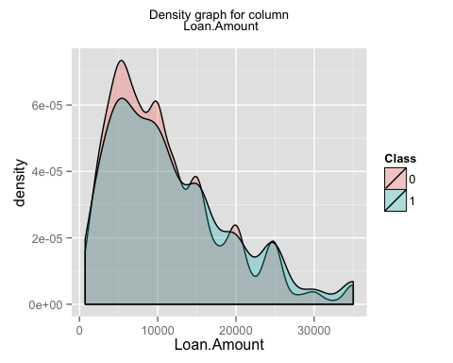

## [1] "generating graph for the column Loan.Term"

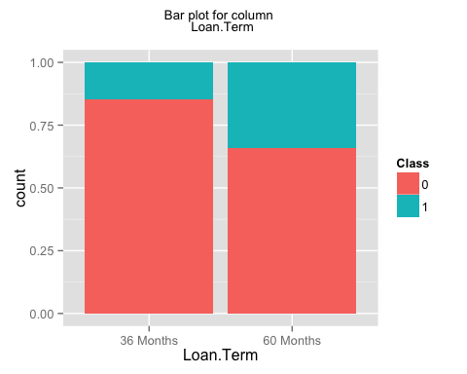

## [1] "generating graph for the column Employment.Length"

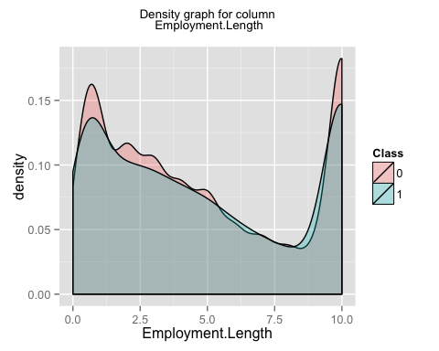

## [1] "generating graph for the column Home.Ownership"

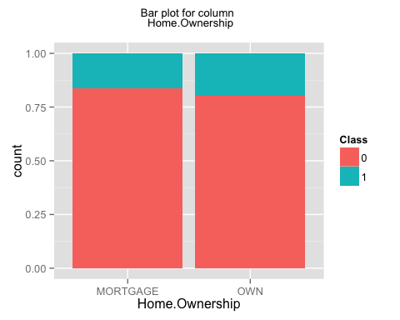

## [1] "generating graph for the column Annual.Income"

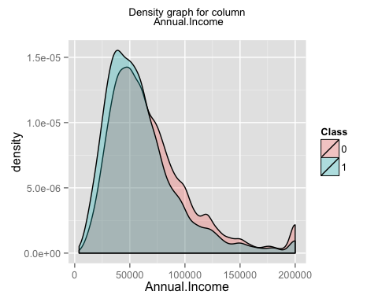

## [1] "generating graph for the column Loan.Purpose"

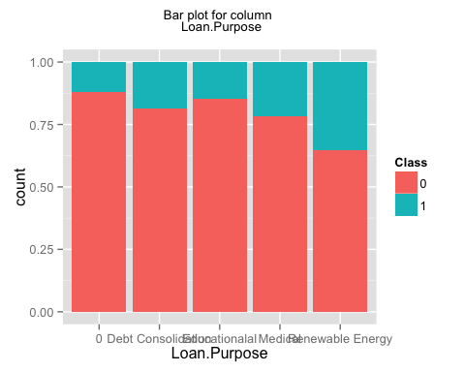

## [1] "generating graph for the column Address.State"

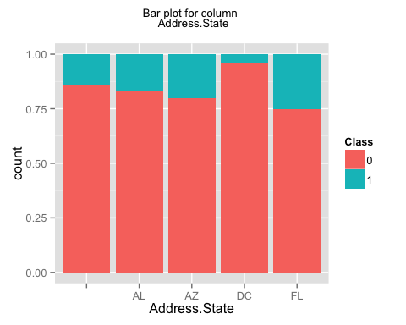

## [1] "generating graph for the column Debt.To.Income.Ratio"

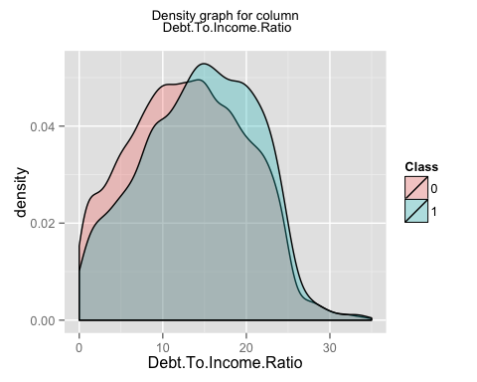

## [1] "generating graph for the column No..Delinquencies.In.Last.2.Years"

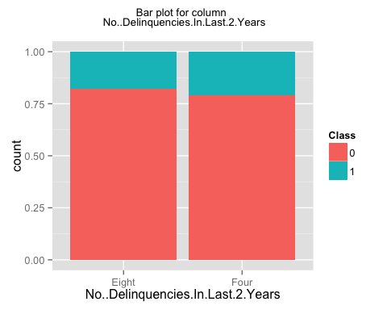

## [1] "generating graph for the column Earliest.Credit.Line.Opened"

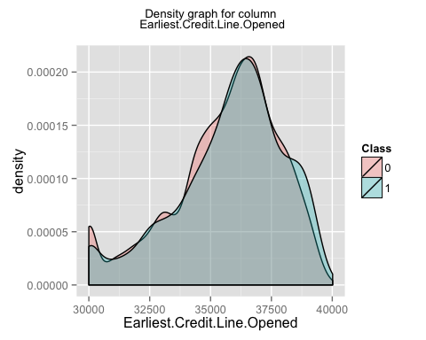

## [1] "generating graph for the column FICO.Credit.Score"

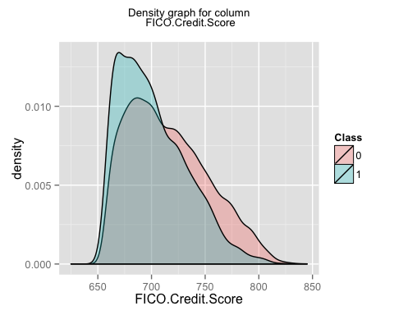

## [1] "generating graph for the column No..Inquiries.In.Last.6.Months"

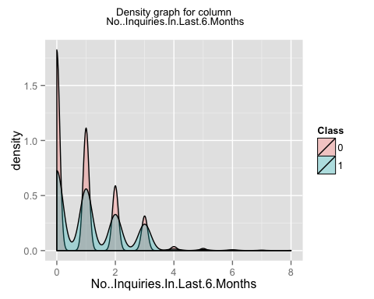

## [1] "generating graph for the column Months.Since.Last.Delinquency"

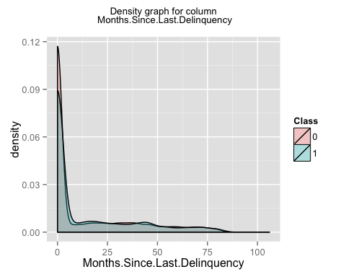

## [1] "generating graph for the column No..Of.Credit.Lines"

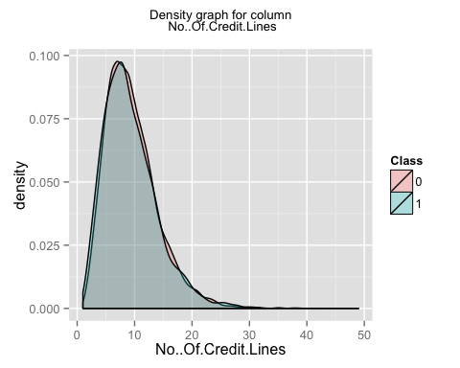

## [1] "generating graph for the column No..Adverse.Public.Records"

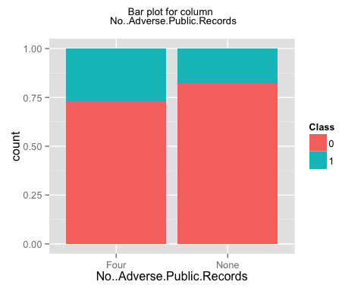

## [1] "generating graph for the column Total.Credit.Balance"

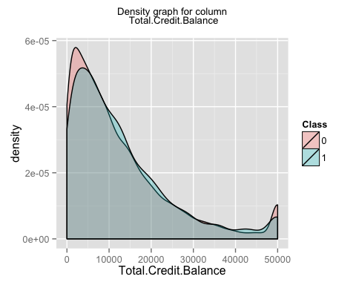

## [1] "generating graph for the column Use.Of.Credit.Line"

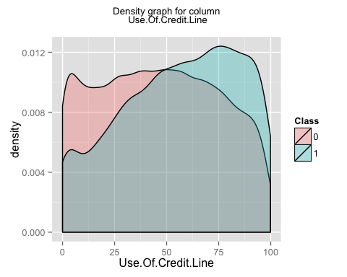

## [1] "generating graph for the column Total.Number.Of.Credit.Lines"

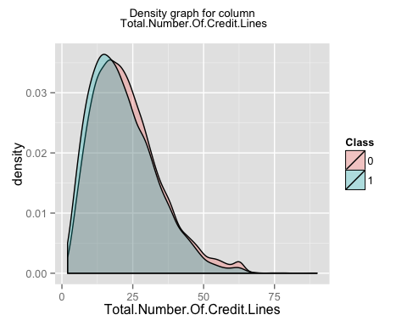

## [1] "generating graph for the column Loan.Application.Description"

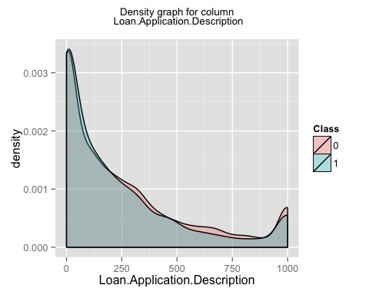

## [1] "generating graph for the column No..Of.Public.Record.Bankruptcies"

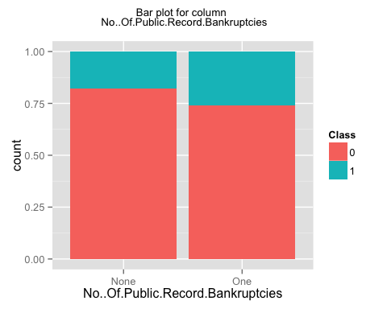

## [1] "generating graph for the column Class"

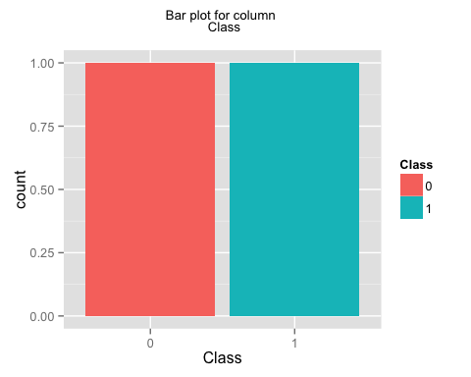

## [1] "finished generating the first set of plots i.e. individual plots for each column"  
## [1] "now generating the second set of plots i.e. plots for a pair of columns"

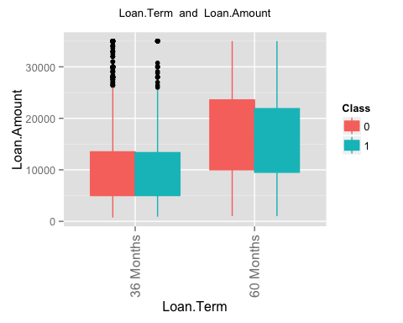 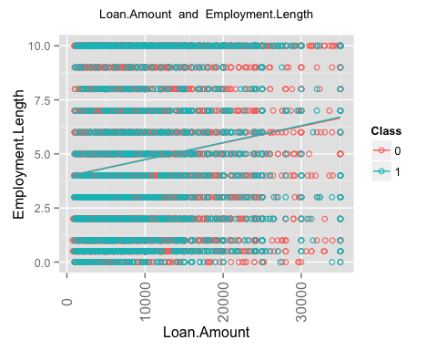 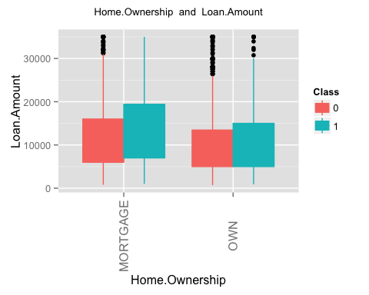 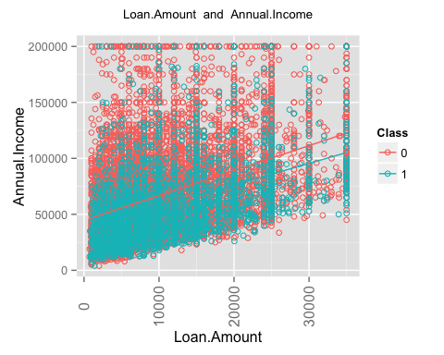 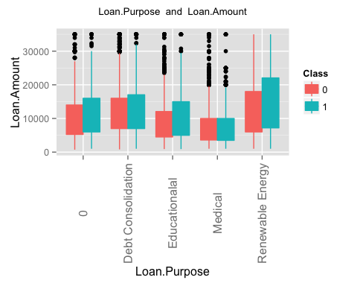 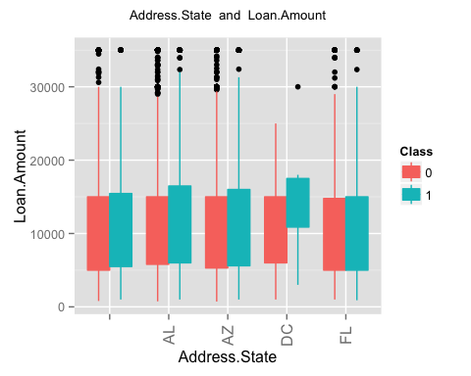 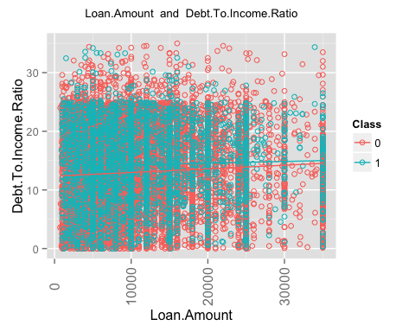 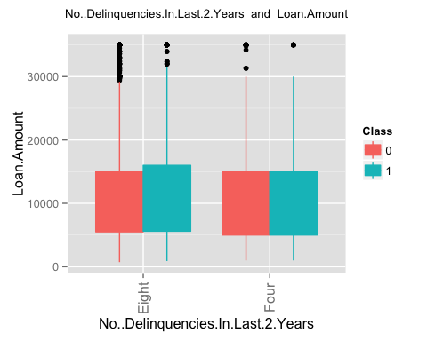 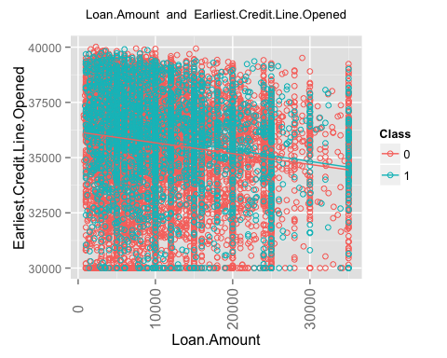 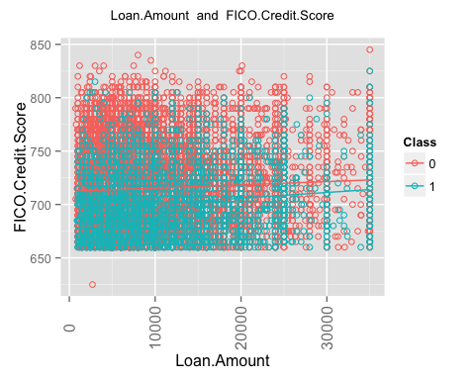 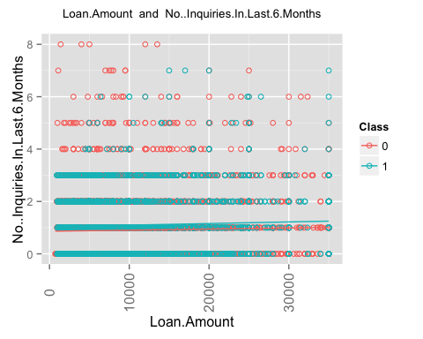 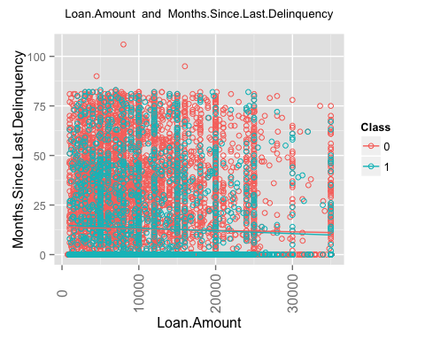 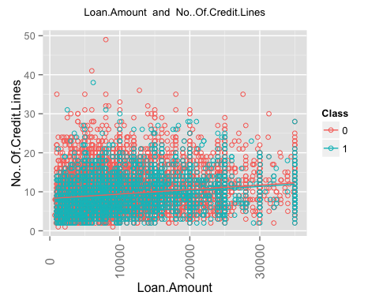 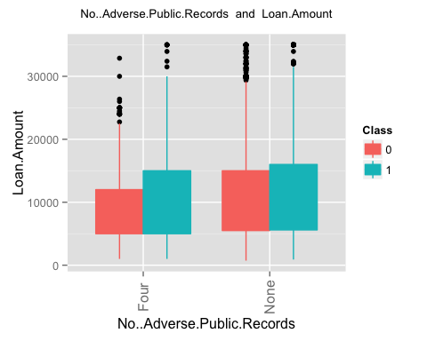 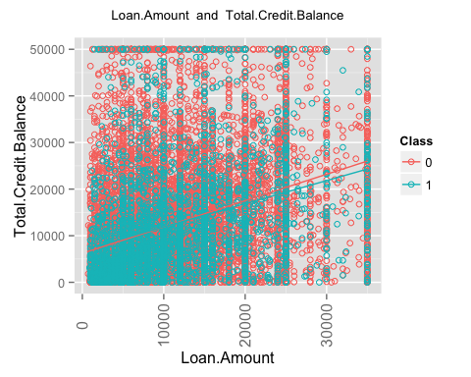 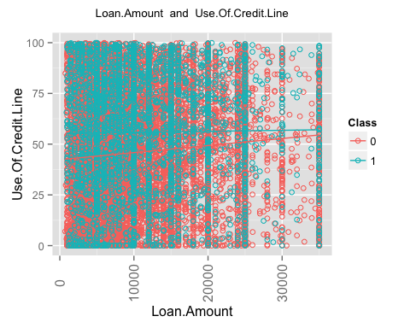 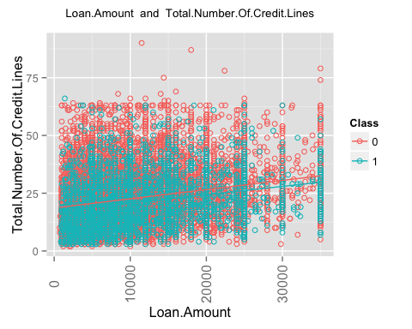 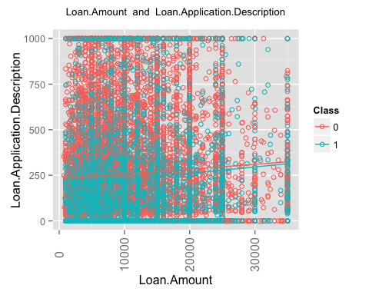 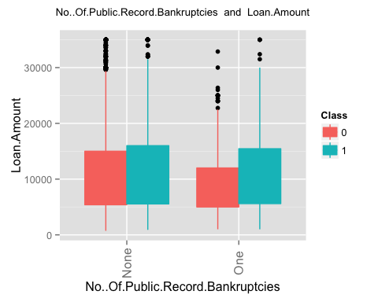 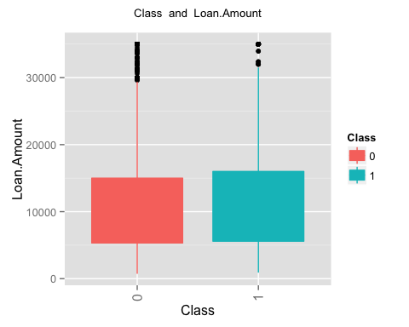 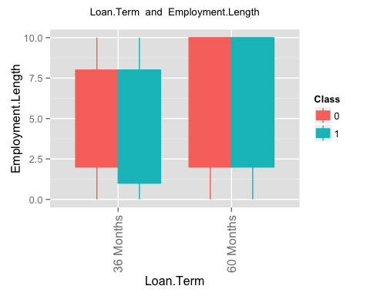 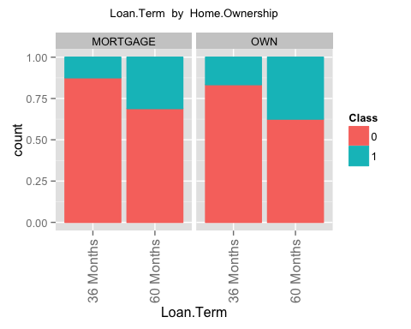 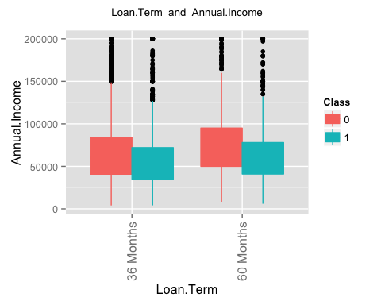 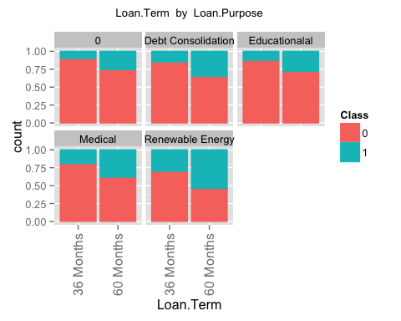 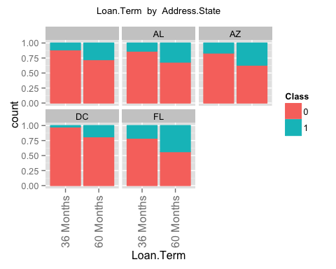 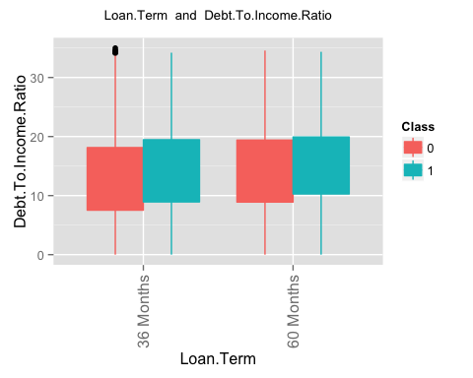 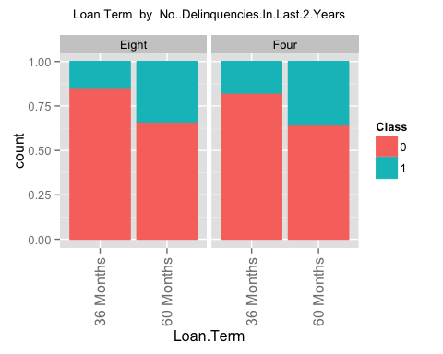 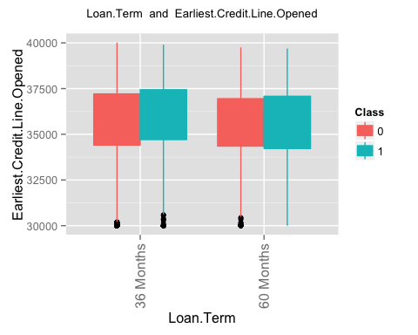 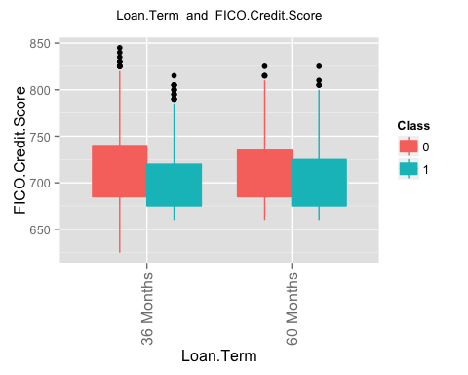 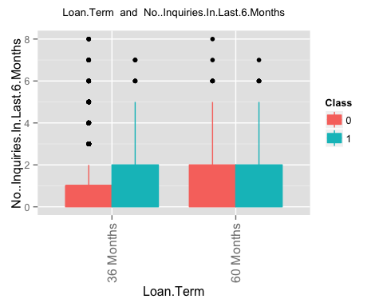 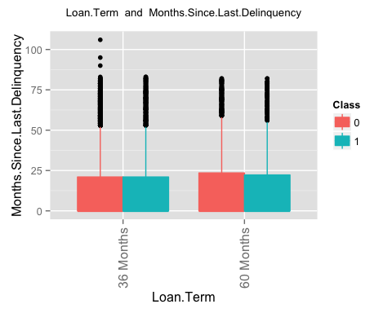 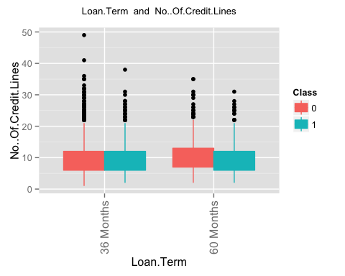 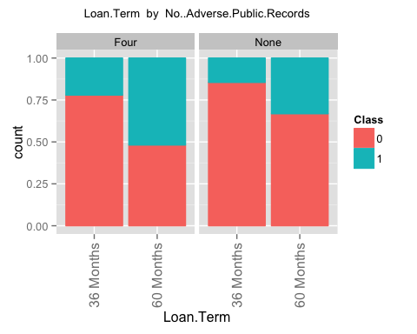 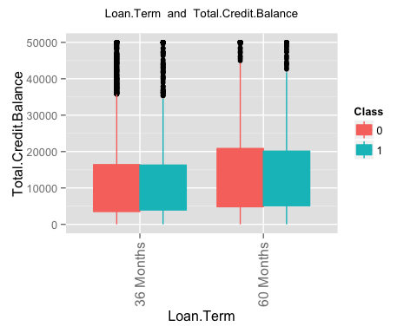 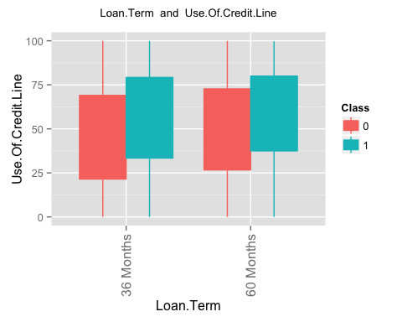 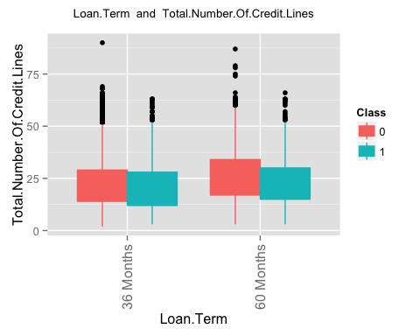 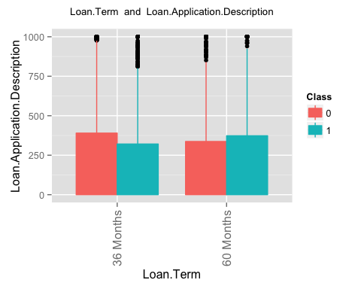 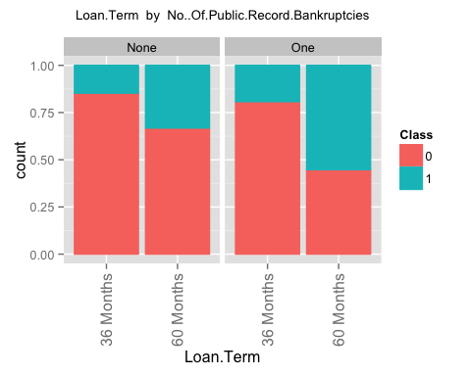 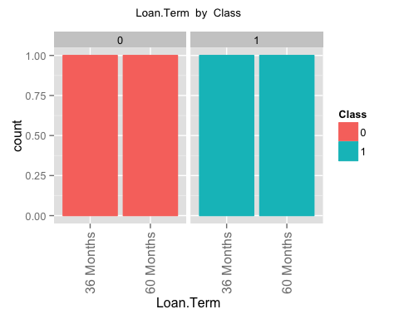 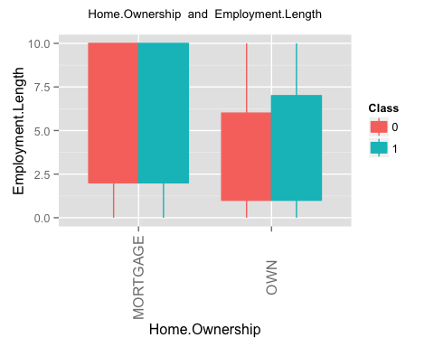 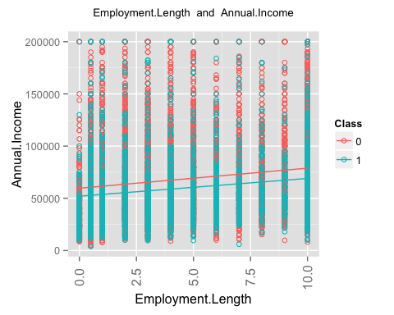 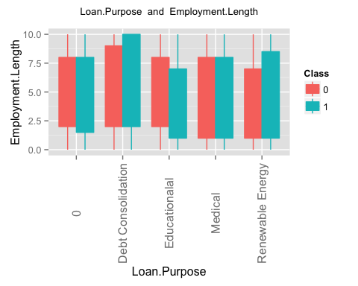 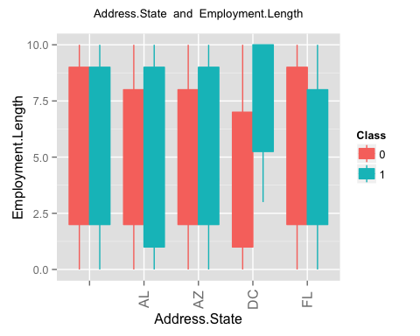 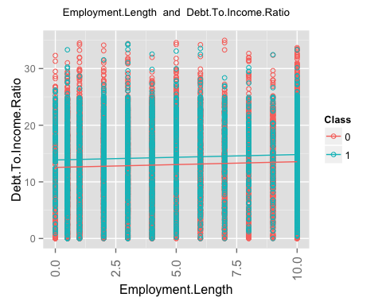 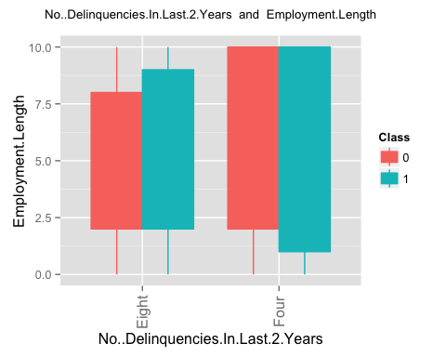 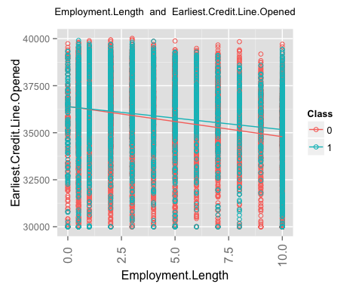 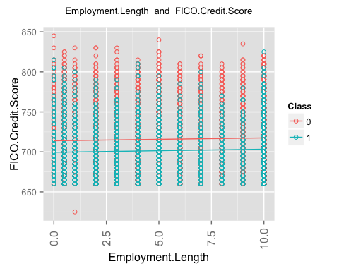 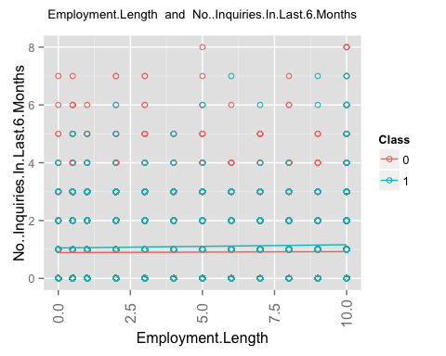 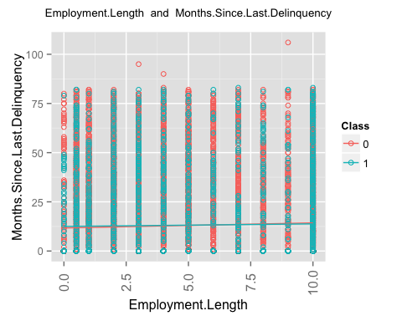 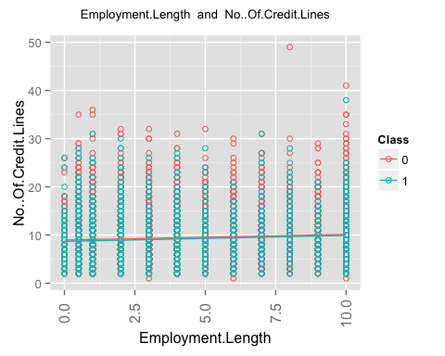 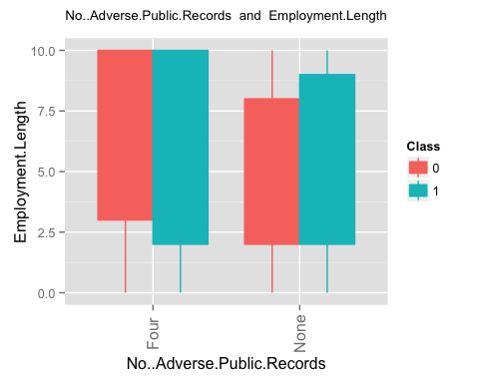 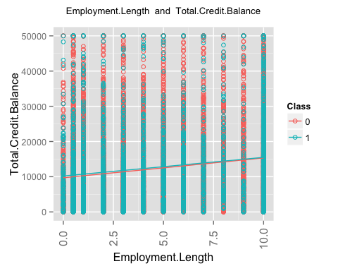 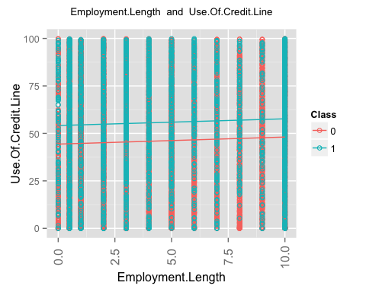 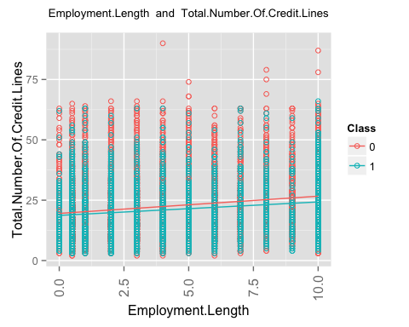 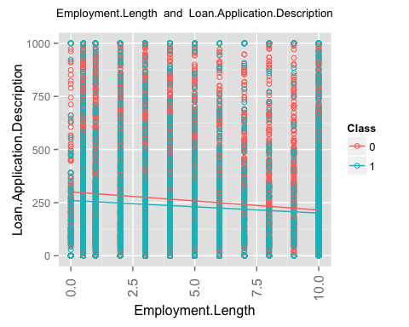 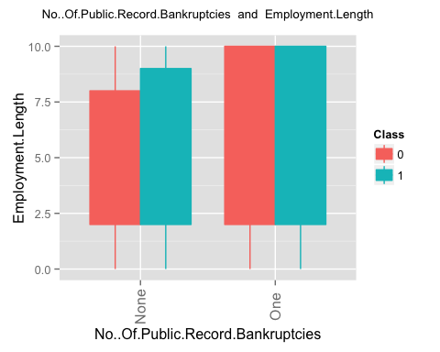 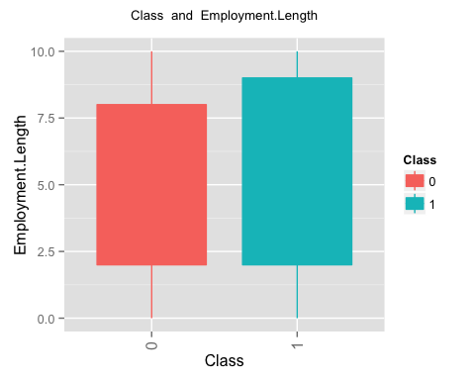 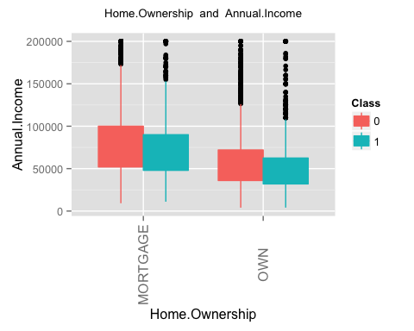 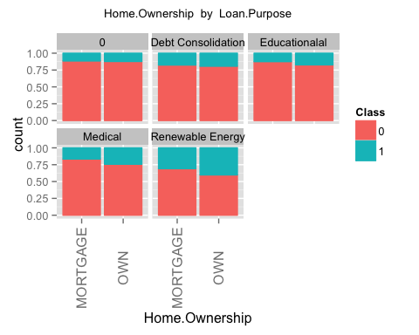 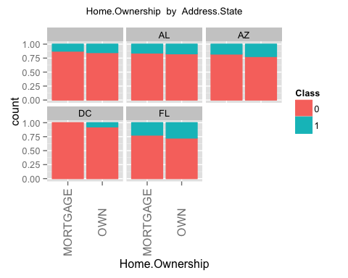 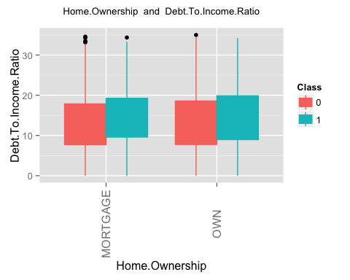 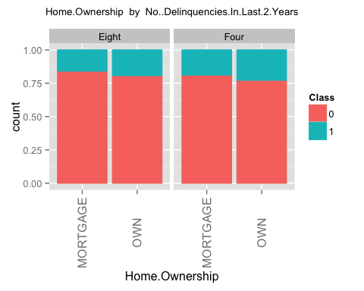 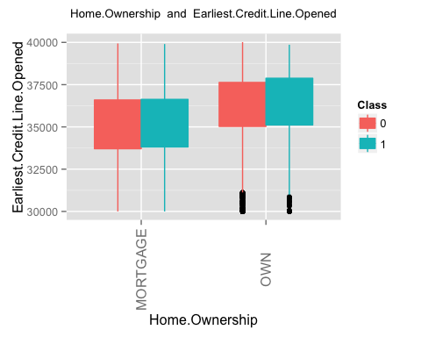 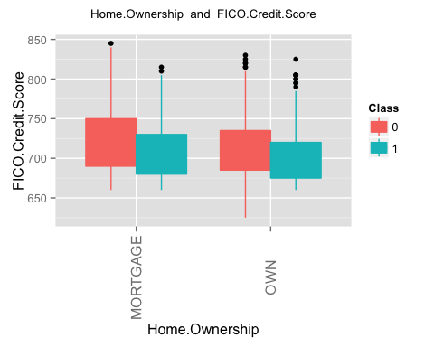 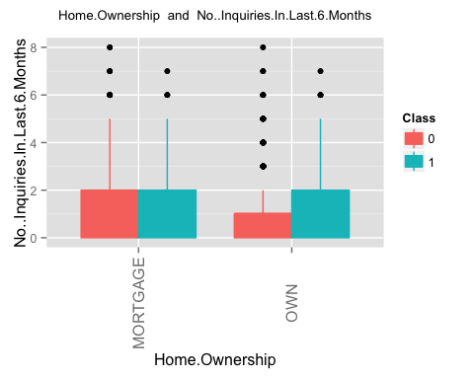 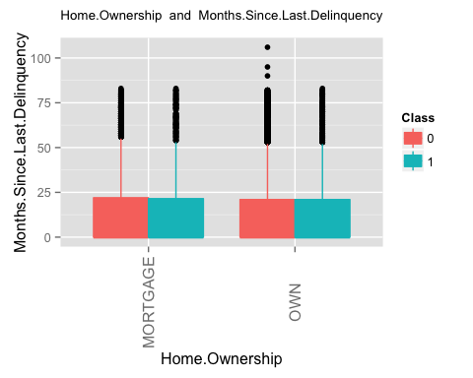 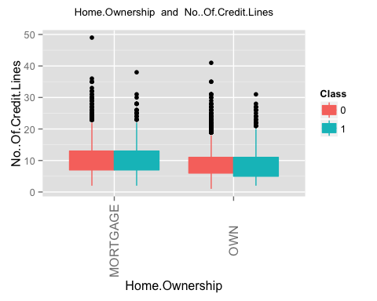 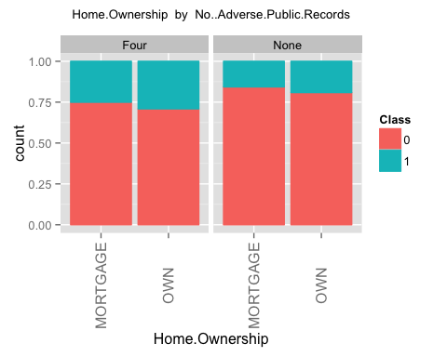 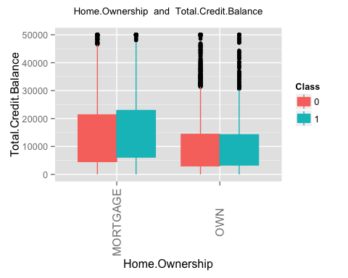 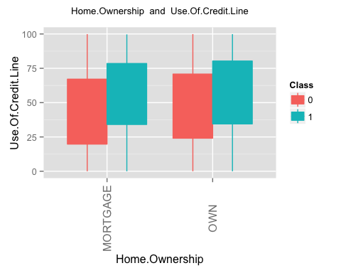 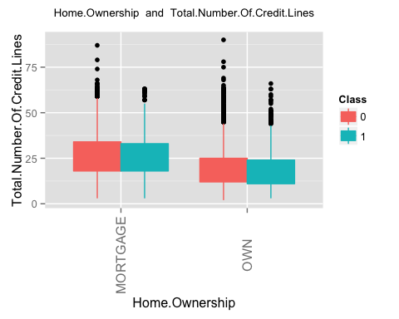 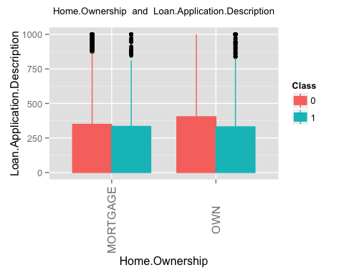 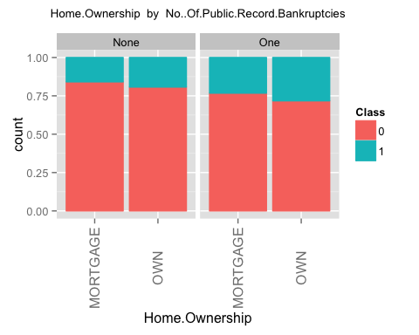 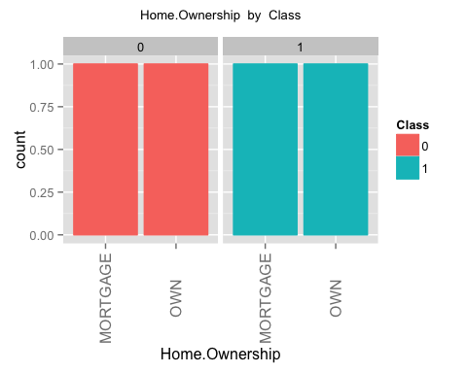 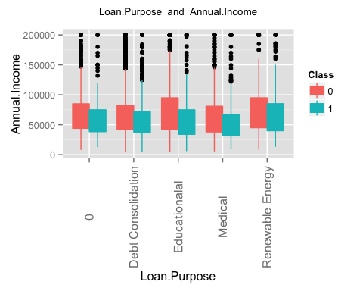 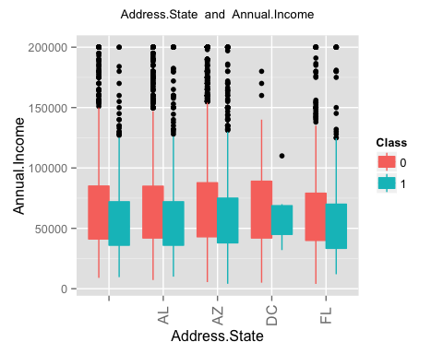 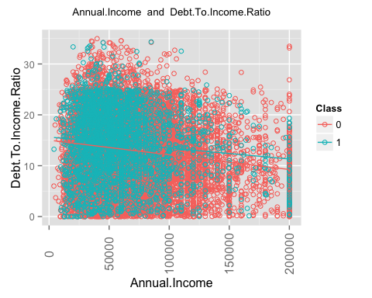 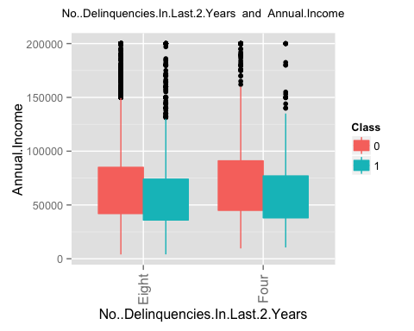 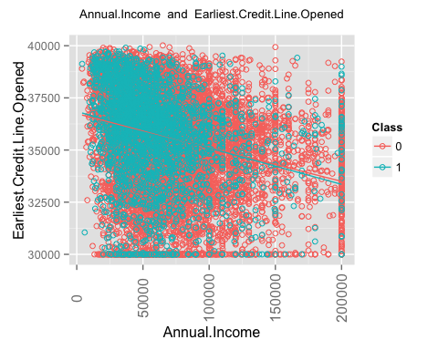 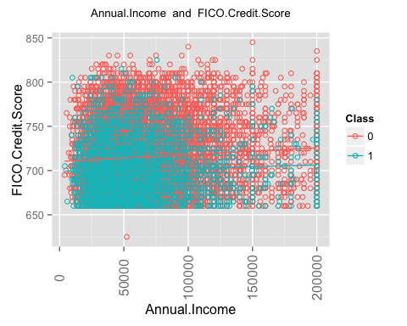 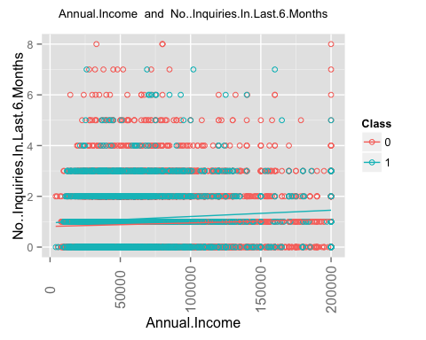 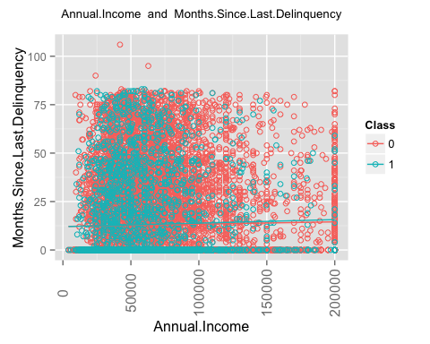 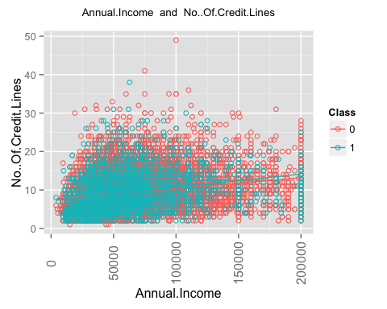 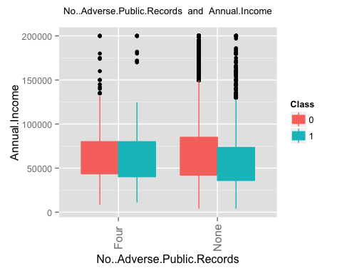 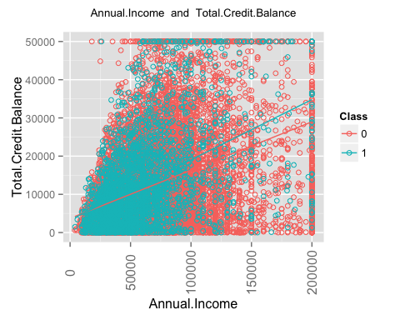 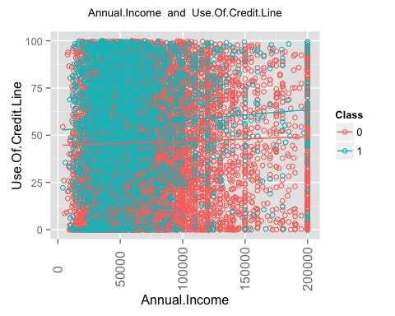 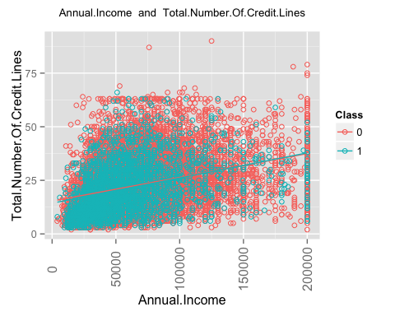 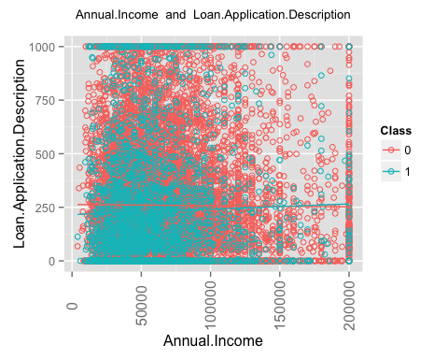 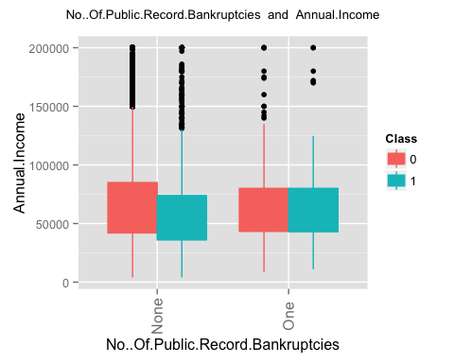 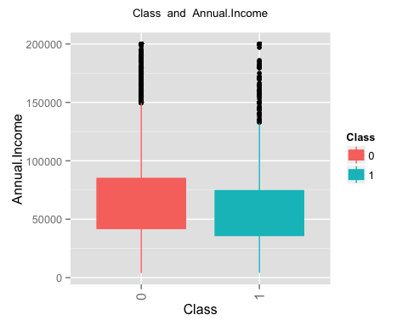 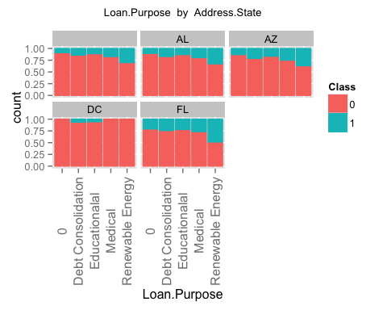 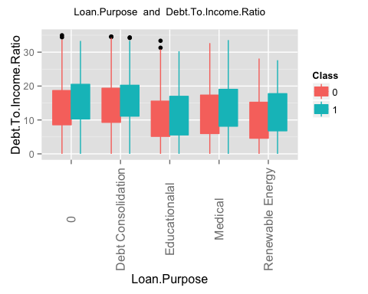 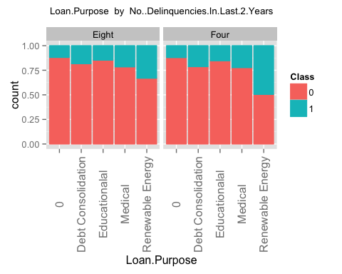 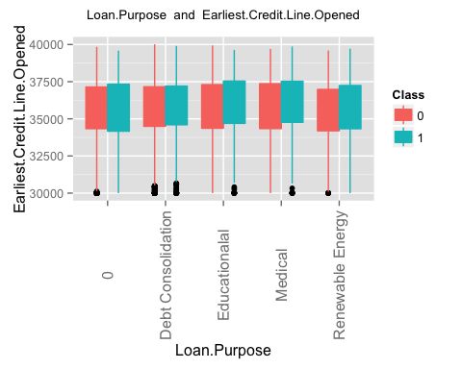 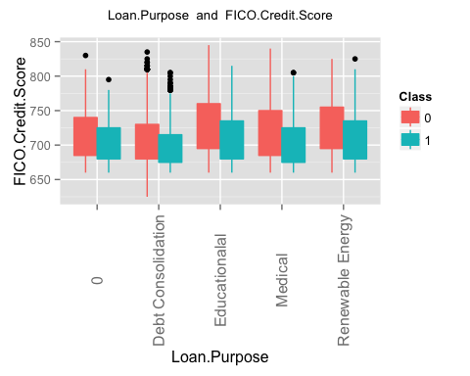 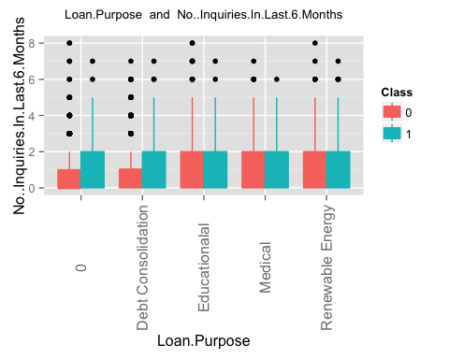 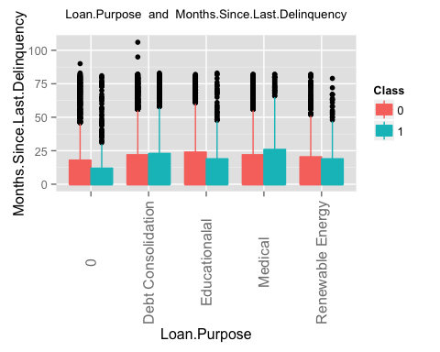 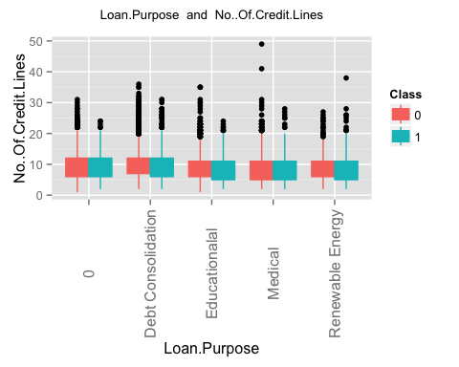 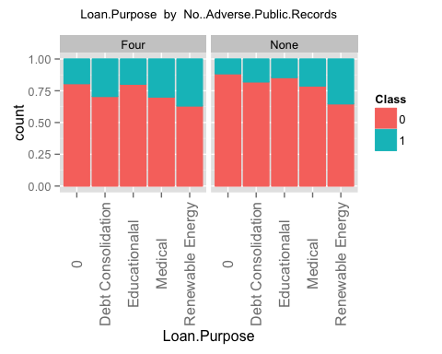 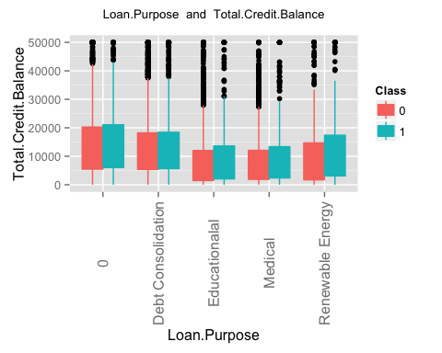 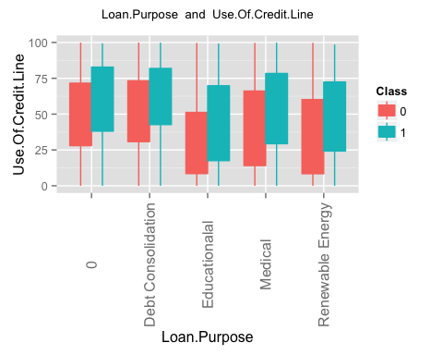 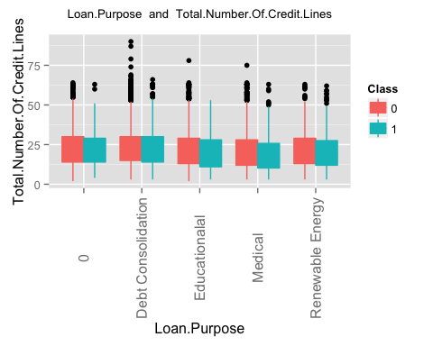 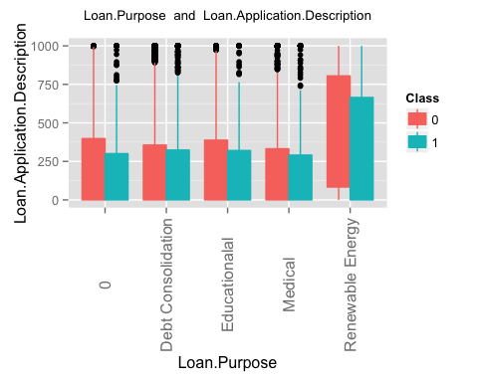 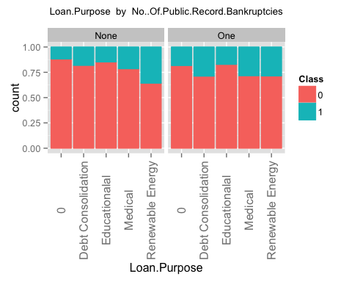 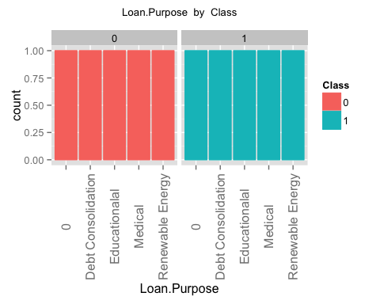 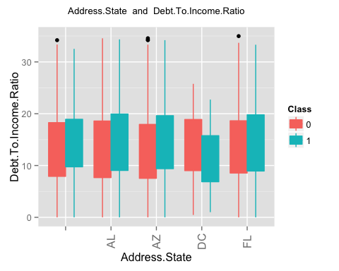 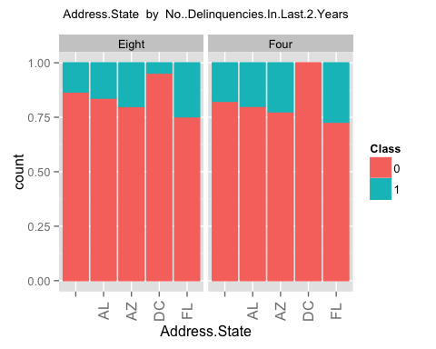 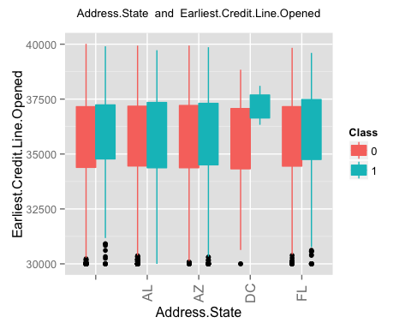 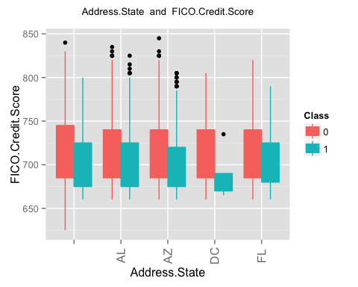 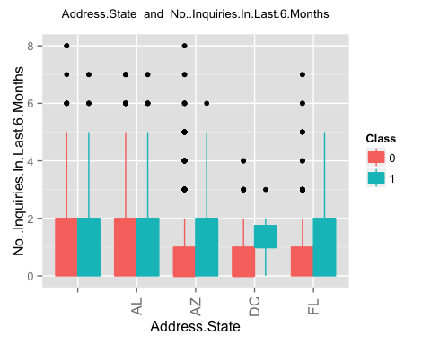 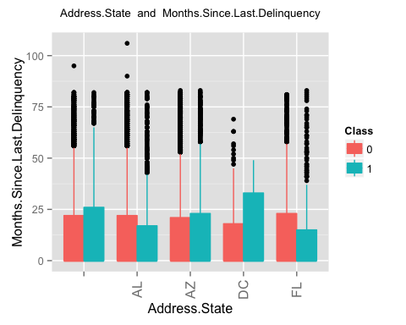 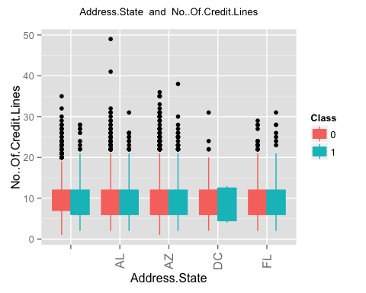 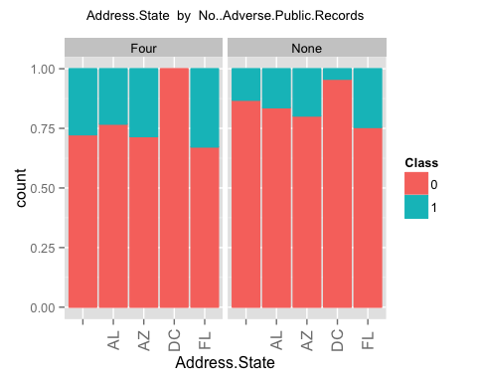 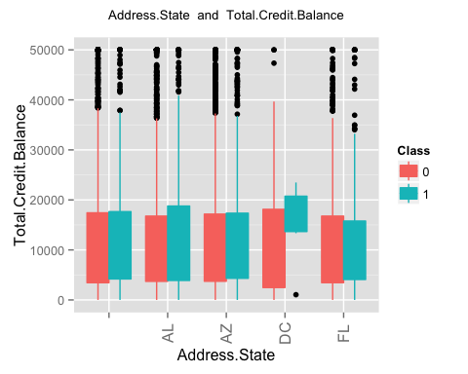 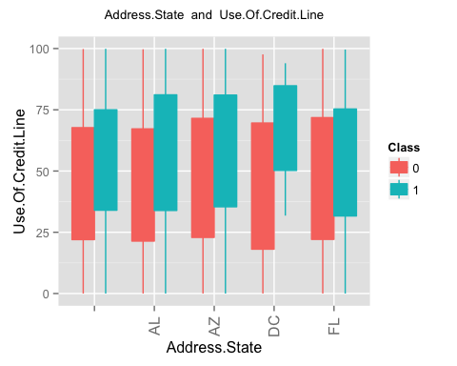 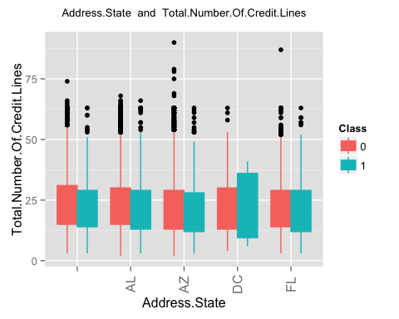 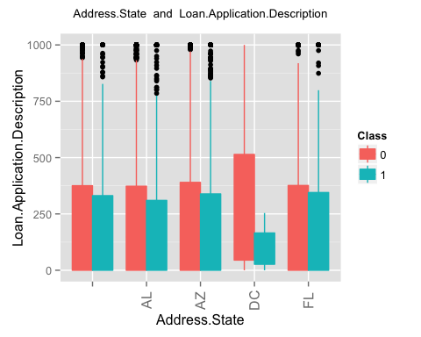 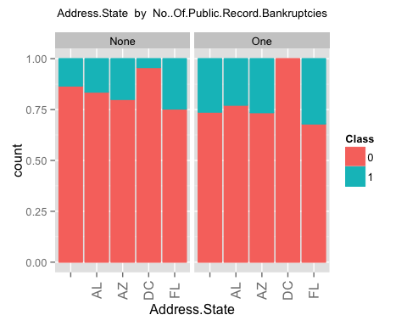 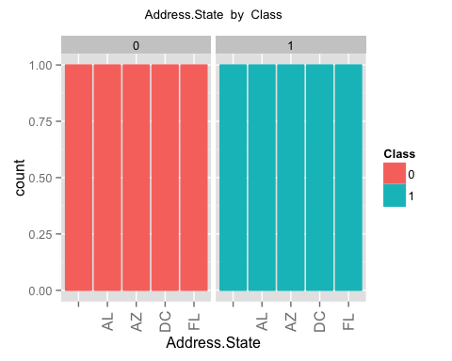 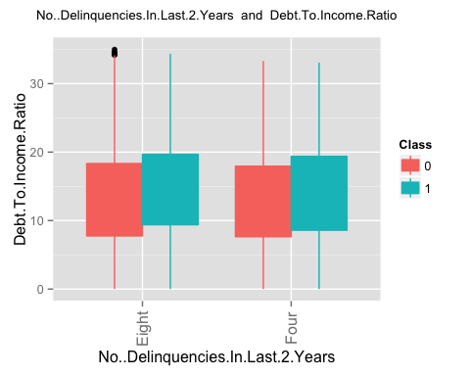 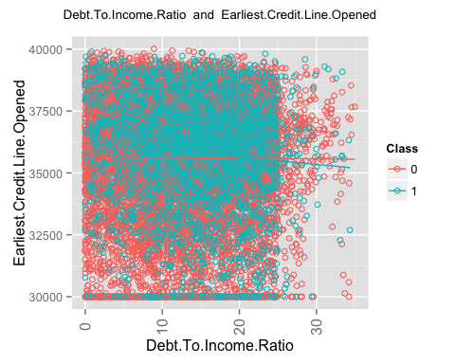 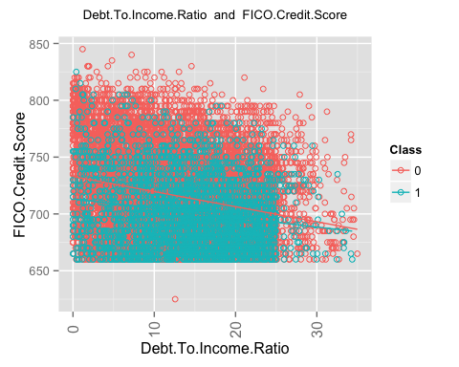 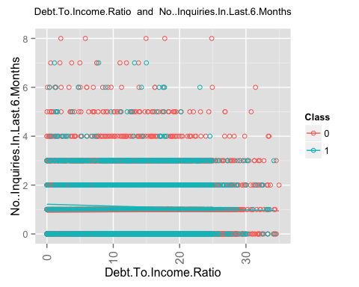 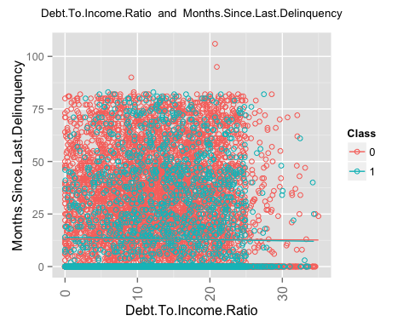 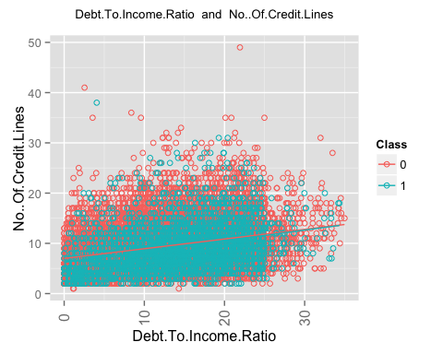 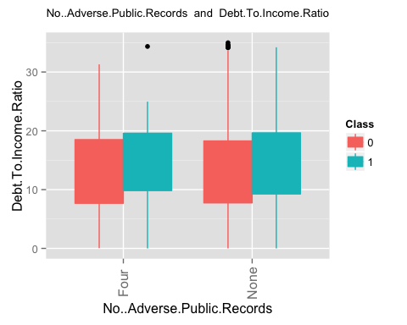 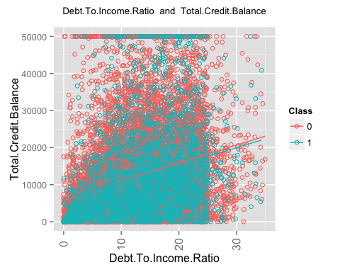 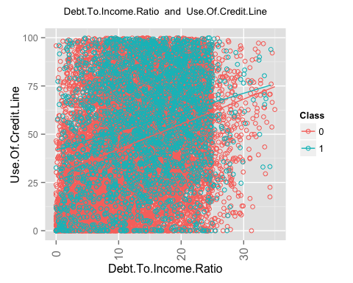 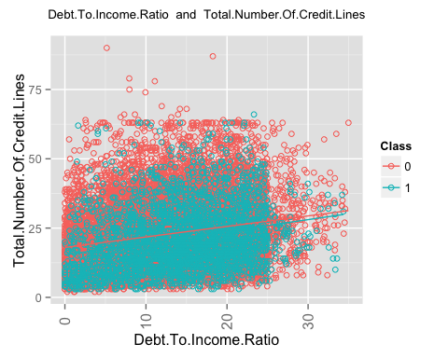 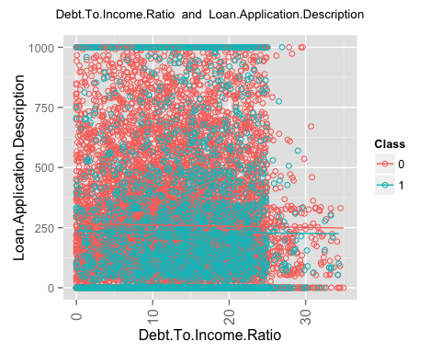 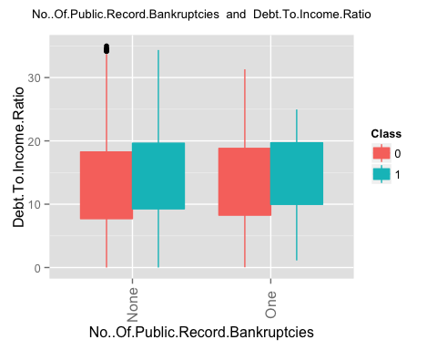 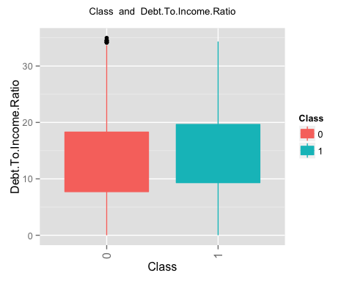 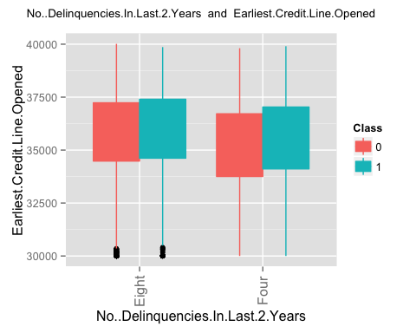 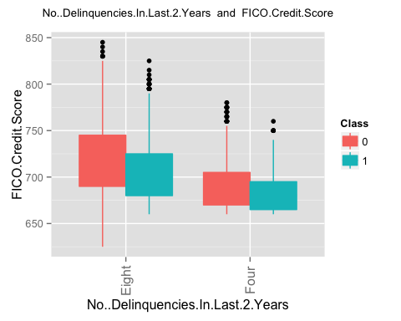 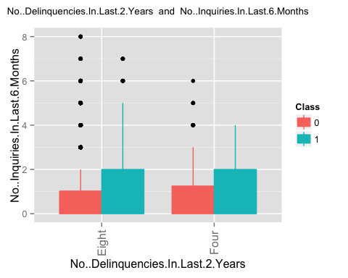 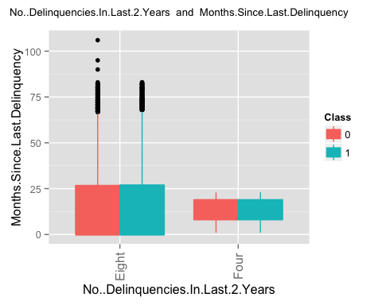 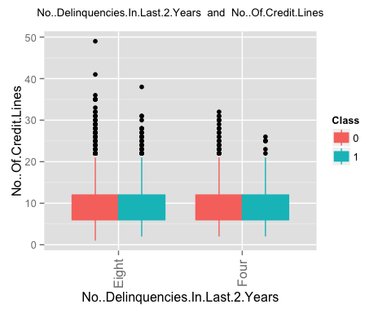 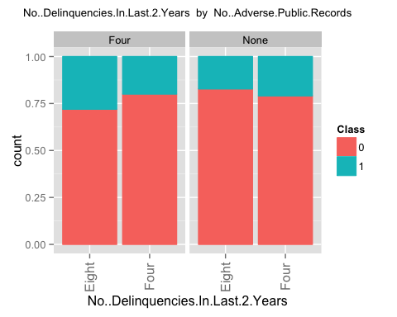 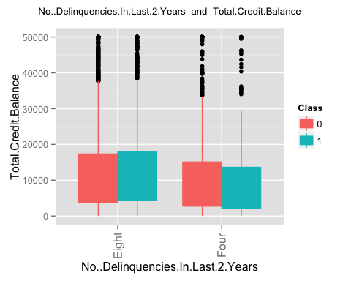 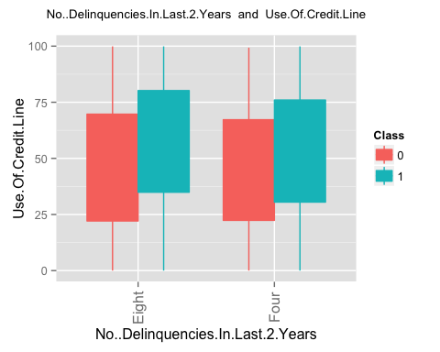 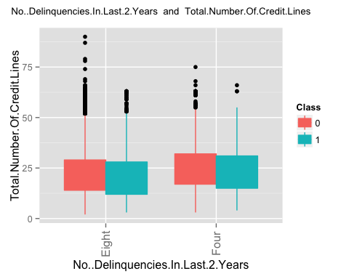 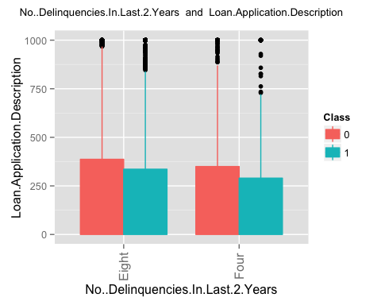 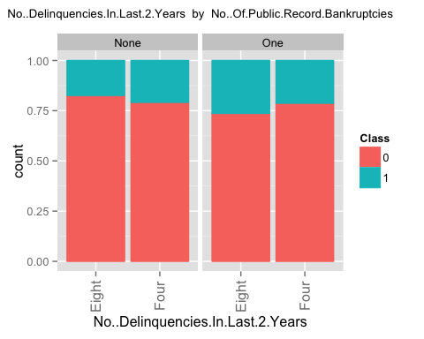 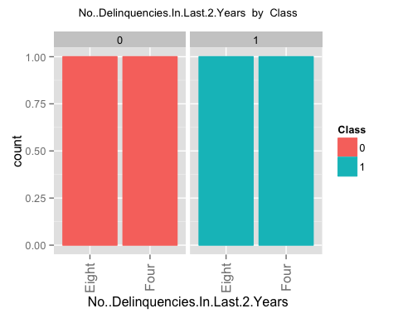 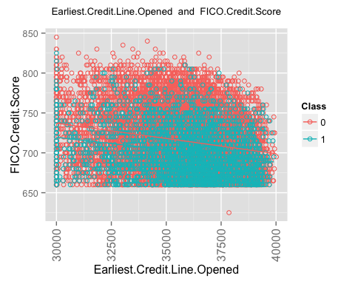 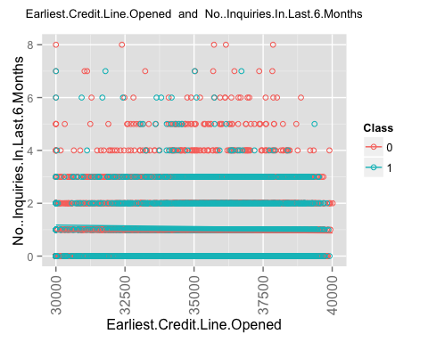 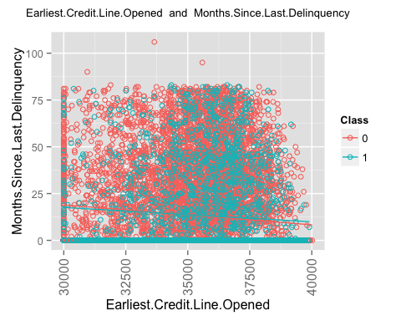 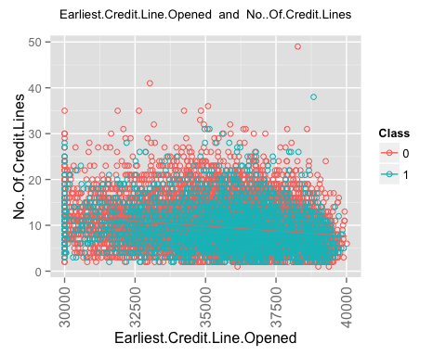 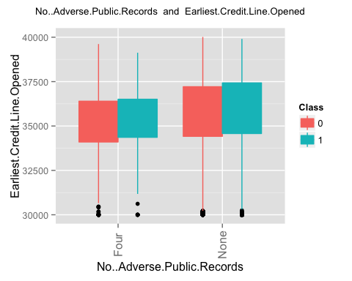 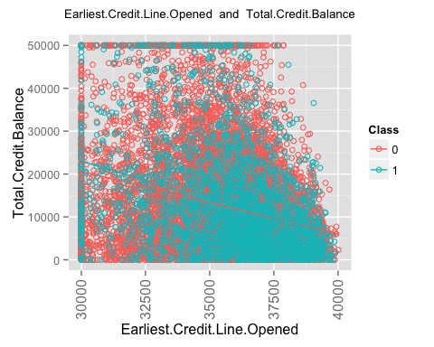 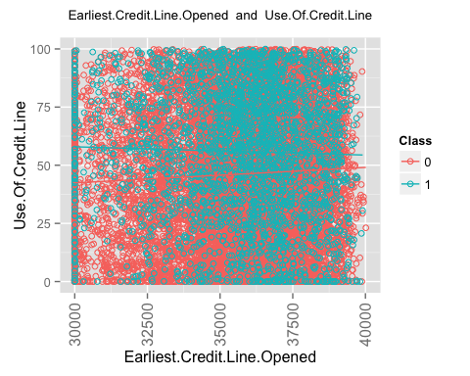 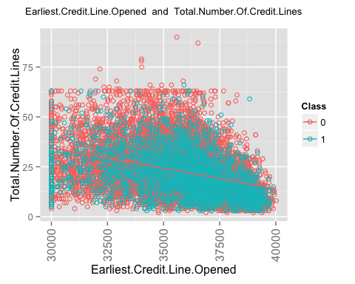 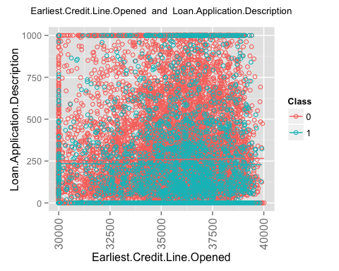 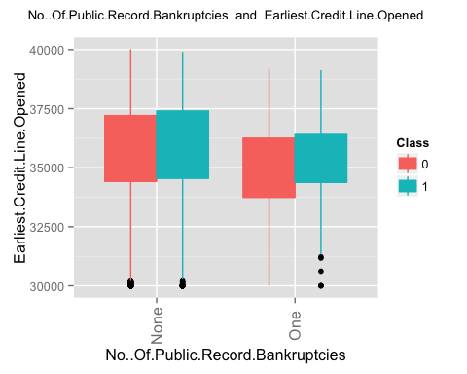 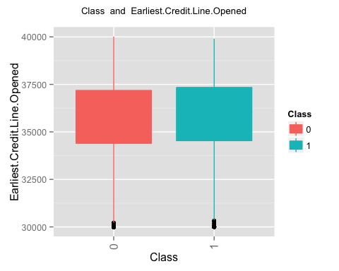 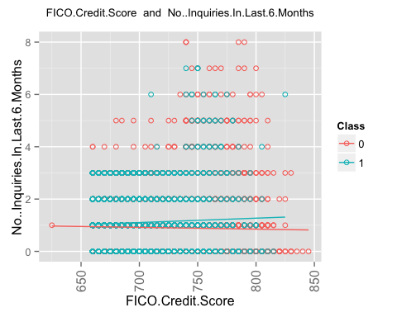 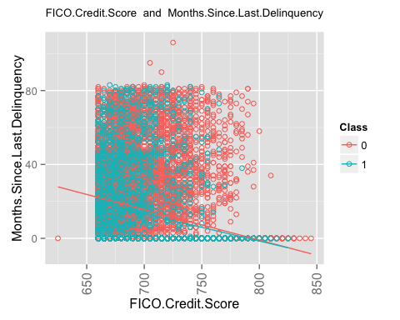 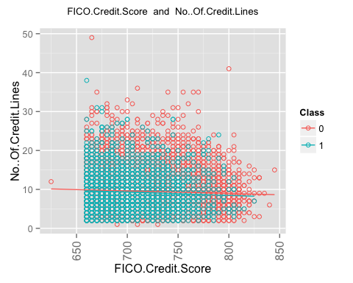 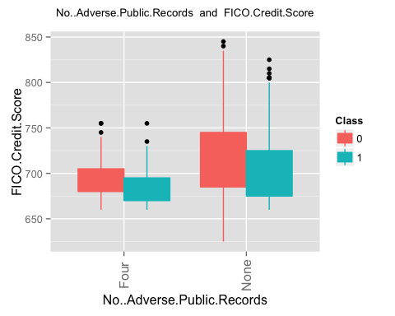 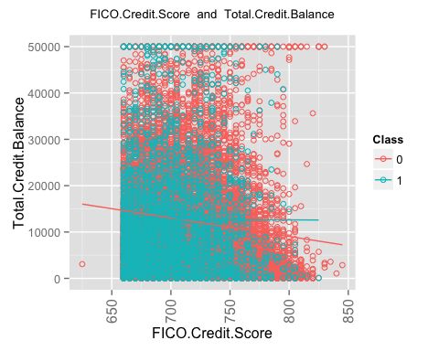 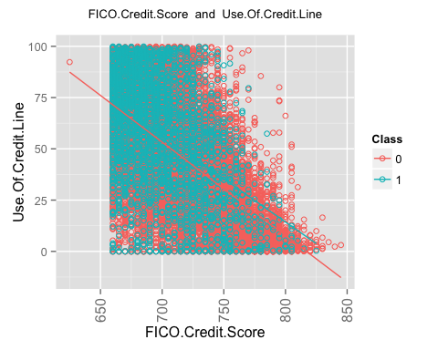 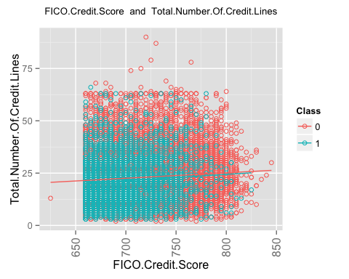 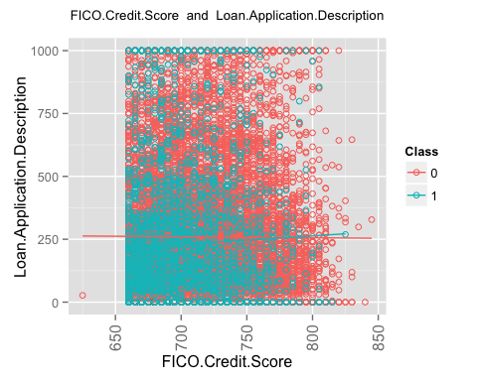 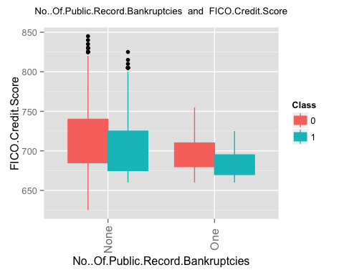 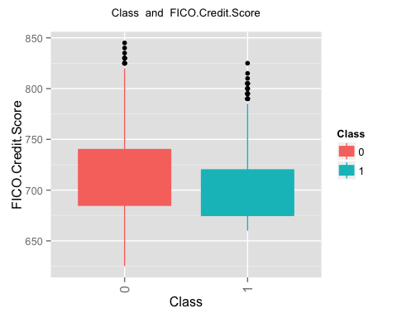 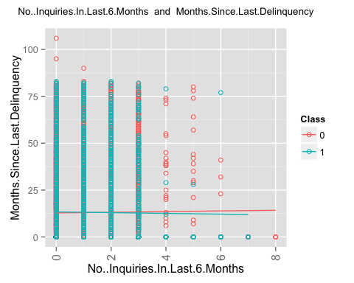 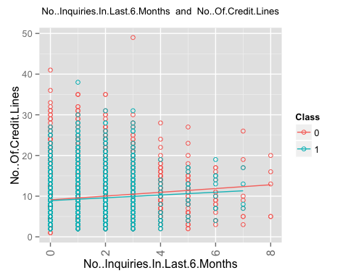 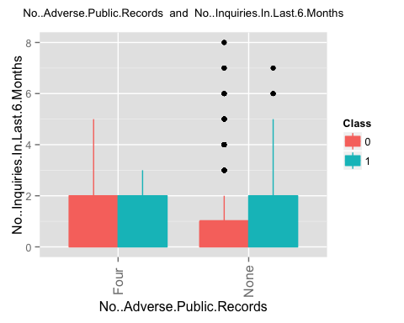 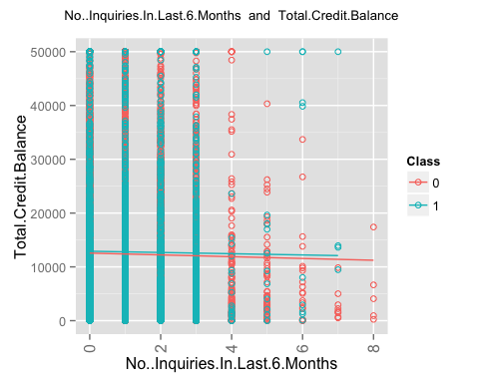 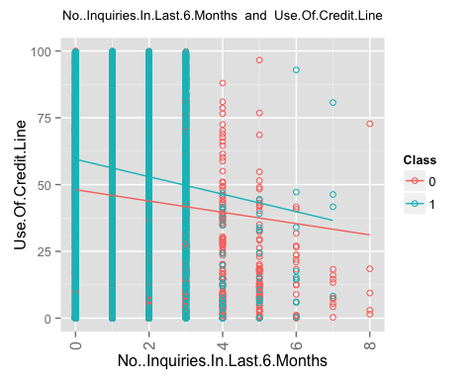 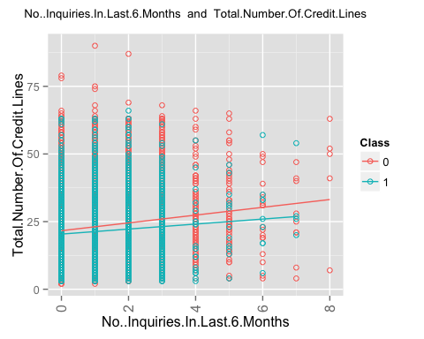 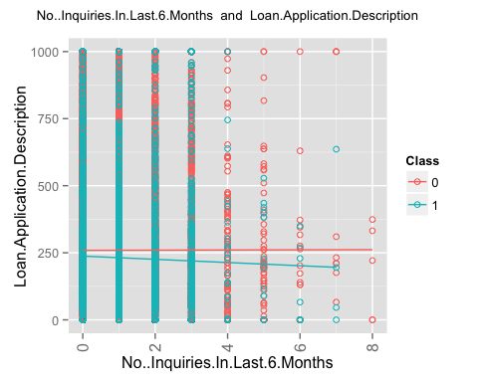 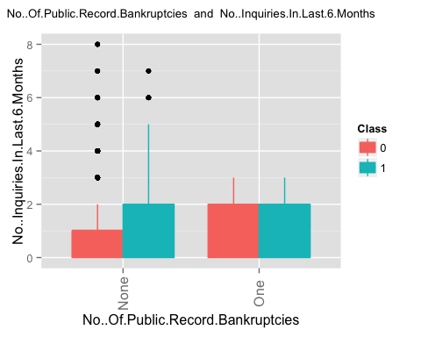 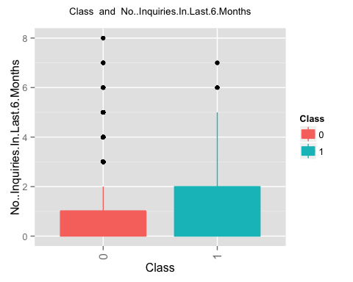 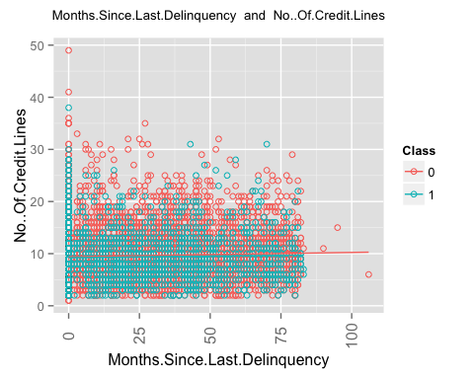 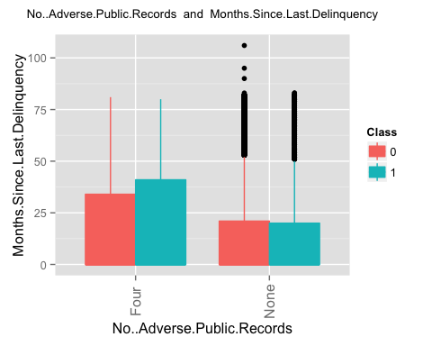 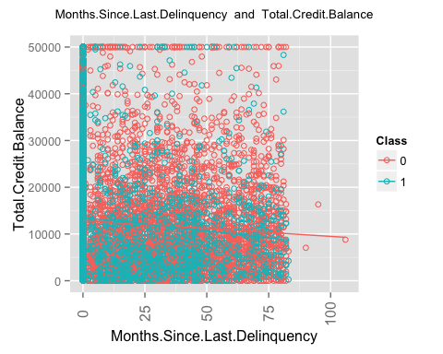 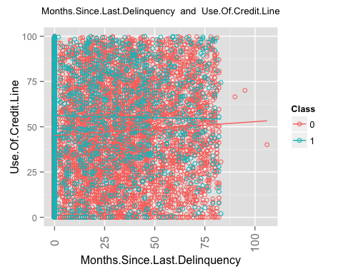 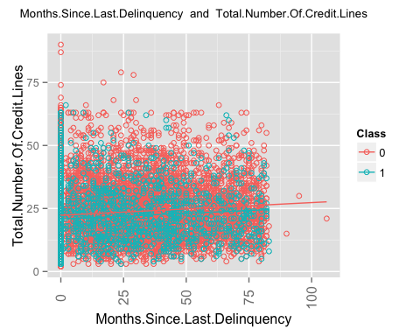 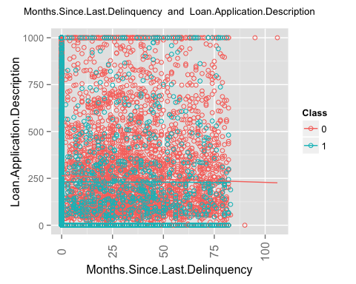 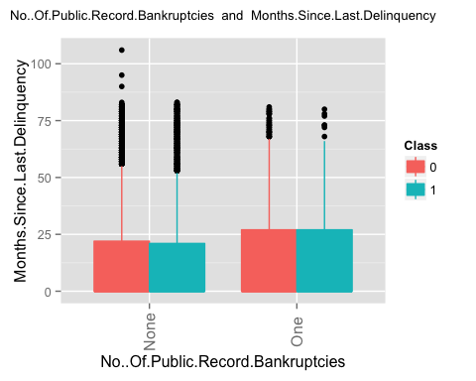 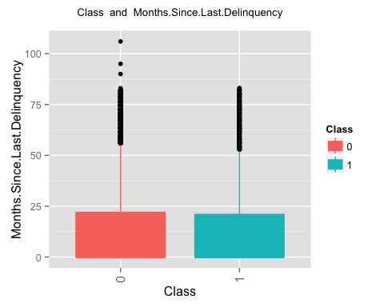 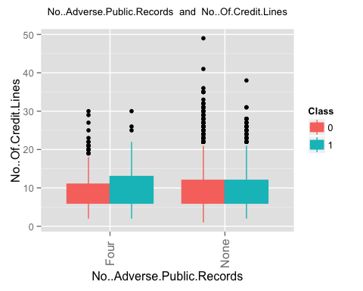 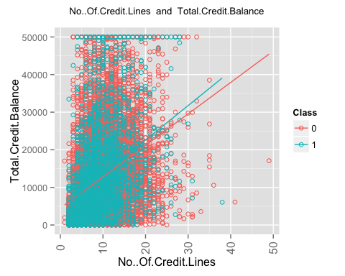 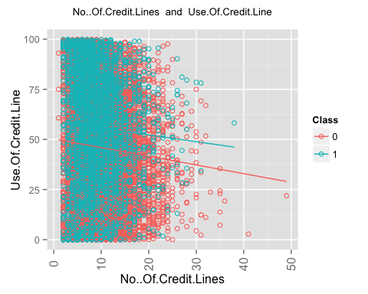 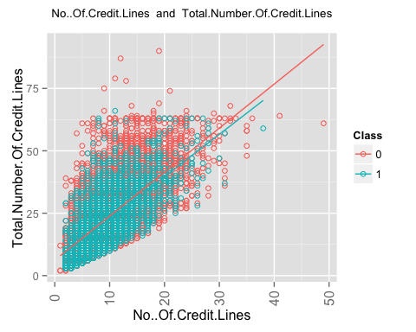 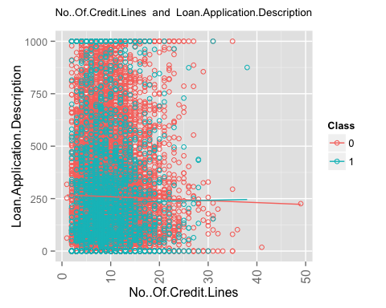 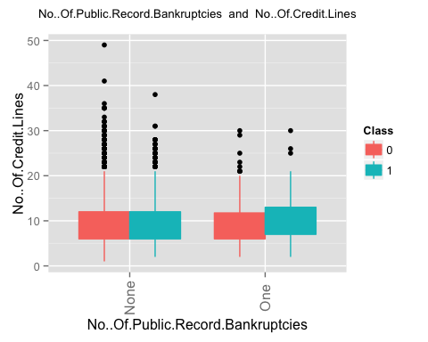 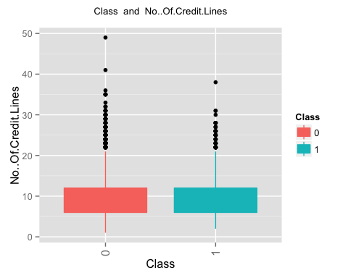 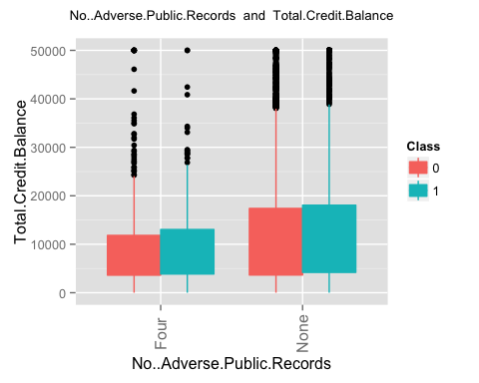 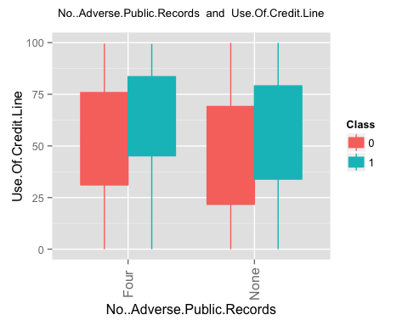 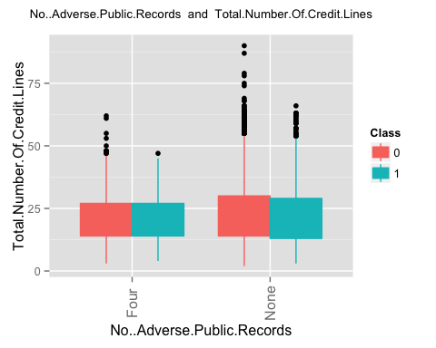 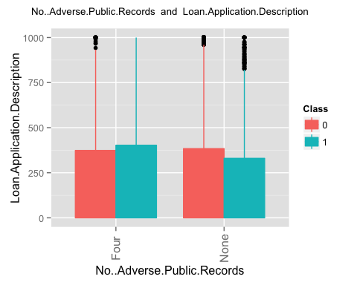 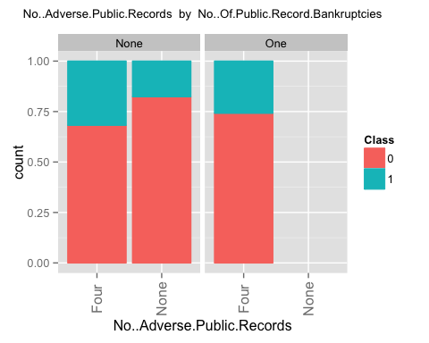 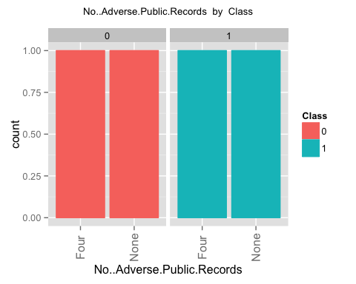 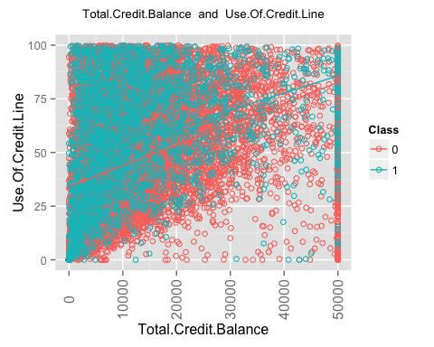 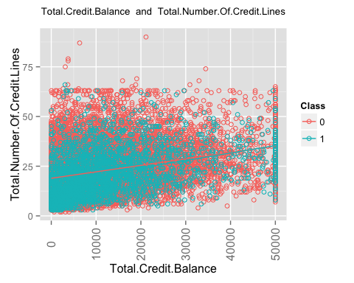 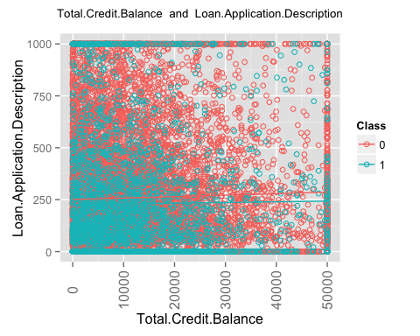 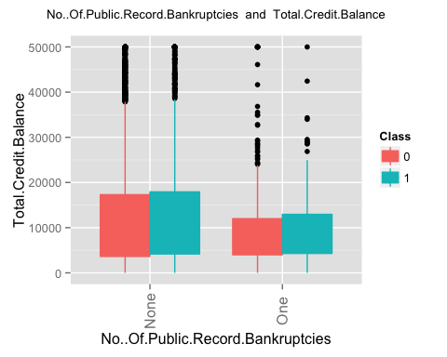 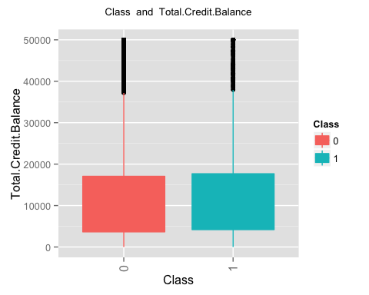 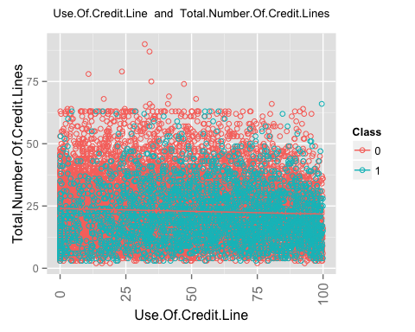 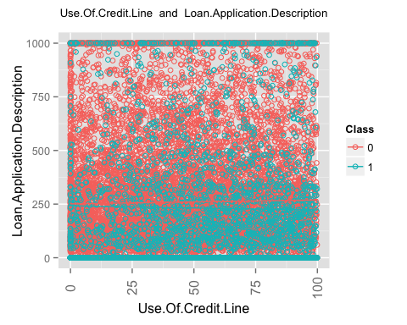 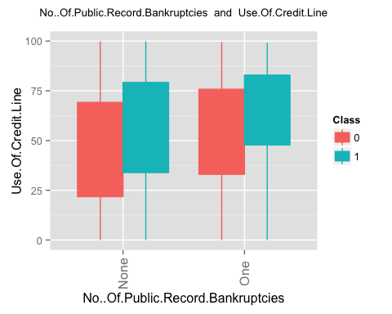 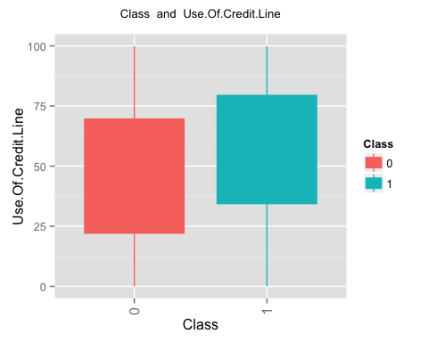 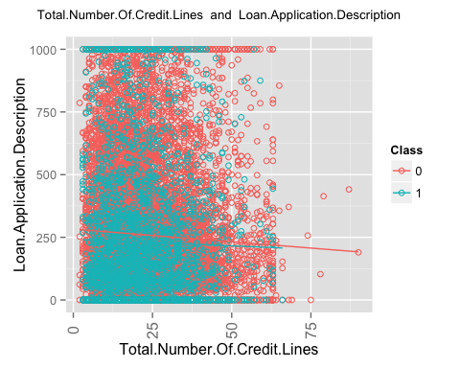 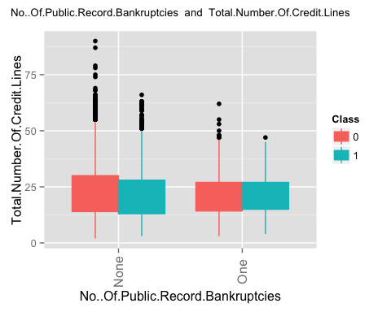 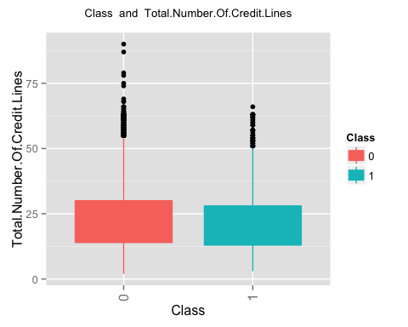 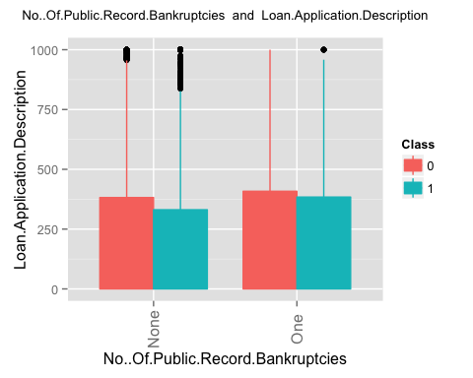 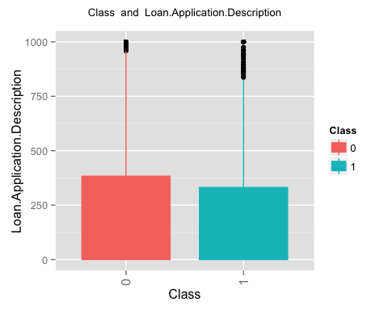

## [1] "finished generating the second set of plots i.e. plots for a pair of columns"

#  
# Now run the feature selection process. It will do following.  
# 1. It will find the top 20 features using random forest  
# 2. It will run a logistic regression based on a single column at a time.  
# 3. It will run a logistic regression based on interaction of just 2 columns at a time.  
# 4. It wil generate a decision tree based on single column at a time.  
# 5. It will generate a decision tree based on 2 column at a time.  
  
  
frml1 <- as.formula('Class ~ .')  
findusefulfeatures(train_data,alpha = 0.05,ranking='accuracy',k=20,frml1,ntree=100,cp = 0.001,valid_data)

## [1] 1 11 12 13 14 16 18 19  
## [1] 1 3 5 8 10 11 12 13 14 16 17 18 19  
## [1] 1 2 3 4 5 6 7 8 9 10 11 12  
## col1 col1_pvalue  
## 2 Loan.Amount 4.502414e-08  
## 3 Loan.Term 6.530551e-120  
## 4 Employment.Length 1.041524e-01  
## 5 Home.Ownership 5.768266e-08  
## 6 Annual.Income 3.646635e-24  
## 7 Loan.Purpose 2.046042e-54  
## 8 Address.State 3.159370e-26  
## 9 Debt.To.Income.Ratio 3.778787e-01  
## 10 No..Delinquencies.In.Last.2.Years 1.833106e-03  
## 11 Earliest.Credit.Line.Opened 8.661242e-08  
## 12 FICO.Credit.Score 2.895368e-65  
## 13 No..Inquiries.In.Last.6.Months 9.590664e-13  
## 14 Months.Since.Last.Delinquency 7.082243e-01  
## 15 No..Of.Credit.Lines 0.000000e+00  
## 16 No..Adverse.Public.Records 1.760202e-11  
## 17 Total.Credit.Balance 7.927056e-02  
## 18 Use.Of.Credit.Line 1.209010e-52  
## 19 Total.Number.Of.Credit.Lines 6.446405e-04  
## 20 Loan.Application.Description 4.523981e-02  
## 21 No..Of.Public.Record.Bankruptcies 4.460987e-07  
## [1] "here"  
## 'data.frame': 20 obs. of 4 variables:  
## $ 0 : num 15.66 18.03 7.54 3.48 19.86 ...  
## $ 1 : num -6.892 17.375 0.325 -1.876 0.689 ...  
## $ MeanDecreaseAccuracy: num 13.28 23.25 6.97 2.28 18.58 ...  
## $ MeanDecreaseGini : num 343 152.2 226.1 37.5 399.8 ...  
## NULL  
## [1] "top ranked features based on random forest accuracy"  
## [1] "Loan.Term"   
## [2] "FICO.Credit.Score"   
## [3] "Use.Of.Credit.Line"   
## [4] "Annual.Income"   
## [5] "Total.Credit.Balance"   
## [6] "Total.Number.Of.Credit.Lines"   
## [7] "Loan.Purpose"   
## [8] "Earliest.Credit.Line.Opened"   
## [9] "Loan.Amount"   
## [10] "No..Of.Credit.Lines"   
## [11] "Debt.To.Income.Ratio"   
## [12] "Employment.Length"   
## [13] "Months.Since.Last.Delinquency"   
## [14] "No..Inquiries.In.Last.6.Months"   
## [15] "No..Adverse.Public.Records"   
## [16] "No..Of.Public.Record.Bankruptcies"  
## [17] "Loan.Application.Description"   
## [18] "Address.State"   
## [19] "No..Delinquencies.In.Last.2.Years"  
## [20] "Home.Ownership"   
## [1] "now rankinsg based on logistic regression. This is custom log reg"  
## [1] "Loan.Amount" "0.525530921872921"  
## [1] "here"  
## [1] "Loan.Term" "0.593483735832125"  
## [1] "here"  
## [1] "Employment.Length" "0.480645786783489"  
## [1] "here"  
## [1] "Home.Ownership" "0.524365249897976"  
## [1] "here"  
## [1] "Annual.Income" "0.576855436382944"  
## [1] "here"  
## [1] "Loan.Purpose" "0.573045019288827"  
## [1] "here"  
## [1] "Address.State" "0.528847563024073"  
## [1] "here"  
## [1] "Debt.To.Income.Ratio" "0.564933791184633"   
## [1] "here"  
## [1] "No..Delinquencies.In.Last.2.Years" "0.497817465238399"   
## [1] "here"  
## [1] "Earliest.Credit.Line.Opened" "0.53307284209767"   
## [1] "here"  
## [1] "FICO.Credit.Score" "0.61369585656598"   
## [1] "here"  
## [1] "No..Inquiries.In.Last.6.Months" "0.562464911469806"   
## [1] "here"  
## [1] "Months.Since.Last.Delinquency" "0.502560194444006"   
## [1] "here"  
## [1] "No..Of.Credit.Lines" "0.494044250441354"   
## [1] "here"  
## [1] "No..Adverse.Public.Records" "0.511855132000514"   
## [1] "here"  
## [1] "Total.Credit.Balance" "0.50266503728121"   
## [1] "here"  
## [1] "Use.Of.Credit.Line" "0.596355076760739"   
## [1] "here"  
## [1] "Total.Number.Of.Credit.Lines" "0.548290836285091"   
## [1] "here"  
## [1] "Loan.Application.Description" "0.545008015404007"   
## [1] "here"  
## [1] "No..Of.Public.Record.Bankruptcies" "0.507210481578099"   
## [1] "here"  
## [1] "importance of single columns"  
## col1 col1_aucvalue  
## 2 Loan.Amount 0.5255309  
## 3 Loan.Term 0.5934837  
## 4 Employment.Length 0.4806458  
## 5 Home.Ownership 0.5243652  
## 6 Annual.Income 0.5768554  
## 7 Loan.Purpose 0.5730450  
## 8 Address.State 0.5288476  
## 9 Debt.To.Income.Ratio 0.5649338  
## 10 No..Delinquencies.In.Last.2.Years 0.4978175  
## 11 Earliest.Credit.Line.Opened 0.5330728  
## 12 FICO.Credit.Score 0.6136959  
## 13 No..Inquiries.In.Last.6.Months 0.5624649  
## 14 Months.Since.Last.Delinquency 0.5025602  
## 15 No..Of.Credit.Lines 0.4940443  
## 16 No..Adverse.Public.Records 0.5118551  
## 17 Total.Credit.Balance 0.5026650  
## 18 Use.Of.Credit.Line 0.5963551  
## 19 Total.Number.Of.Credit.Lines 0.5482908  
## 20 Loan.Application.Description 0.5450080  
## 21 No..Of.Public.Record.Bankruptcies 0.5072105  
## col1 col2  
## 44 Employment.Length No..Delinquencies.In.Last.2.Years  
## 49 Employment.Length No..Of.Credit.Lines  
## 48 Employment.Length Months.Since.Last.Delinquency  
## 130 No..Delinquencies.In.Last.2.Years No..Of.Credit.Lines  
## 51 Employment.Length Total.Credit.Balance  
## 55 Employment.Length No..Of.Public.Record.Bankruptcies  
## 164 Months.Since.Last.Delinquency No..Of.Credit.Lines  
## 50 Employment.Length No..Adverse.Public.Records  
## 129 No..Delinquencies.In.Last.2.Years Months.Since.Last.Delinquency  
## 176 No..Of.Credit.Lines No..Of.Public.Record.Bankruptcies  
## 136 No..Delinquencies.In.Last.2.Years No..Of.Public.Record.Bankruptcies  
## 170 Months.Since.Last.Delinquency No..Of.Public.Record.Bankruptcies  
## 185 Total.Credit.Balance No..Of.Public.Record.Bankruptcies  
## 171 No..Of.Credit.Lines No..Adverse.Public.Records  
## 132 No..Delinquencies.In.Last.2.Years Total.Credit.Balance  
## 172 No..Of.Credit.Lines Total.Credit.Balance  
## 131 No..Delinquencies.In.Last.2.Years No..Adverse.Public.Records  
## 181 No..Adverse.Public.Records No..Of.Public.Record.Bankruptcies  
## 177 No..Adverse.Public.Records Total.Credit.Balance  
## 165 Months.Since.Last.Delinquency No..Adverse.Public.Records  
## 140 Earliest.Credit.Line.Opened No..Of.Credit.Lines  
## 42 Employment.Length Address.State  
## 60 Home.Ownership No..Delinquencies.In.Last.2.Years  
## 67 Home.Ownership Total.Credit.Balance  
## 45 Employment.Length Earliest.Credit.Line.Opened  
## 65 Home.Ownership No..Of.Credit.Lines  
## 166 Months.Since.Last.Delinquency Total.Credit.Balance  
## 9 Loan.Amount No..Delinquencies.In.Last.2.Years  
## 109 Address.State Total.Credit.Balance  
## 16 Loan.Amount Total.Credit.Balance  
## 64 Home.Ownership Months.Since.Last.Delinquency  
## 3 Loan.Amount Employment.Length  
## 13 Loan.Amount Months.Since.Last.Delinquency  
## 71 Home.Ownership No..Of.Public.Record.Bankruptcies  
## 142 Earliest.Credit.Line.Opened Total.Credit.Balance  
## 102 Address.State No..Delinquencies.In.Last.2.Years  
## 139 Earliest.Credit.Line.Opened Months.Since.Last.Delinquency  
## 20 Loan.Amount No..Of.Public.Record.Bankruptcies  
## 39 Employment.Length Home.Ownership  
## 107 Address.State No..Of.Credit.Lines  
## 66 Home.Ownership No..Adverse.Public.Records  
## 126 No..Delinquencies.In.Last.2.Years Earliest.Credit.Line.Opened  
## 14 Loan.Amount No..Of.Credit.Lines  
## 15 Loan.Amount No..Adverse.Public.Records  
## 106 Address.State Months.Since.Last.Delinquency  
## 175 No..Of.Credit.Lines Loan.Application.Description  
## 58 Home.Ownership Address.State  
## 113 Address.State No..Of.Public.Record.Bankruptcies  
## 146 Earliest.Credit.Line.Opened No..Of.Public.Record.Bankruptcies  
## 53 Employment.Length Total.Number.Of.Credit.Lines  
## 61 Home.Ownership Earliest.Credit.Line.Opened  
## 7 Loan.Amount Address.State  
## 184 Total.Credit.Balance Loan.Application.Description  
## 103 Address.State Earliest.Credit.Line.Opened  
## 108 Address.State No..Adverse.Public.Records  
## 4 Loan.Amount Home.Ownership  
## 141 Earliest.Credit.Line.Opened No..Adverse.Public.Records  
## 69 Home.Ownership Total.Number.Of.Credit.Lines  
## 169 Months.Since.Last.Delinquency Loan.Application.Description  
## 134 No..Delinquencies.In.Last.2.Years Total.Number.Of.Credit.Lines  
## 135 No..Delinquencies.In.Last.2.Years Loan.Application.Description  
## 183 Total.Credit.Balance Total.Number.Of.Credit.Lines  
## 144 Earliest.Credit.Line.Opened Total.Number.Of.Credit.Lines  
## 191 Loan.Application.Description No..Of.Public.Record.Bankruptcies  
## 168 Months.Since.Last.Delinquency Total.Number.Of.Credit.Lines  
## 54 Employment.Length Loan.Application.Description  
## 112 Address.State Loan.Application.Description  
## 145 Earliest.Credit.Line.Opened Loan.Application.Description  
## 10 Loan.Amount Earliest.Credit.Line.Opened  
## 128 No..Delinquencies.In.Last.2.Years No..Inquiries.In.Last.6.Months  
## 111 Address.State Total.Number.Of.Credit.Lines  
## 19 Loan.Amount Loan.Application.Description  
## 180 No..Adverse.Public.Records Loan.Application.Description  
## 105 Address.State No..Inquiries.In.Last.6.Months  
## 190 Total.Number.Of.Credit.Lines No..Of.Public.Record.Bankruptcies  
## 70 Home.Ownership Loan.Application.Description  
## 47 Employment.Length No..Inquiries.In.Last.6.Months  
## 179 No..Adverse.Public.Records Total.Number.Of.Credit.Lines  
## 157 No..Inquiries.In.Last.6.Months No..Of.Credit.Lines  
## 101 Address.State Debt.To.Income.Ratio  
## 18 Loan.Amount Total.Number.Of.Credit.Lines  
## 174 No..Of.Credit.Lines Total.Number.Of.Credit.Lines  
## 114 Debt.To.Income.Ratio No..Delinquencies.In.Last.2.Years  
## 12 Loan.Amount No..Inquiries.In.Last.6.Months  
## 43 Employment.Length Debt.To.Income.Ratio  
## 125 Debt.To.Income.Ratio No..Of.Public.Record.Bankruptcies  
## 156 No..Inquiries.In.Last.6.Months Months.Since.Last.Delinquency  
## 163 No..Inquiries.In.Last.6.Months No..Of.Public.Record.Bankruptcies  
## 189 Total.Number.Of.Credit.Lines Loan.Application.Description  
## 118 Debt.To.Income.Ratio Months.Since.Last.Delinquency  
## 63 Home.Ownership No..Inquiries.In.Last.6.Months  
## 159 No..Inquiries.In.Last.6.Months Total.Credit.Balance  
## 120 Debt.To.Income.Ratio No..Adverse.Public.Records  
## 158 No..Inquiries.In.Last.6.Months No..Adverse.Public.Records  
## 121 Debt.To.Income.Ratio Total.Credit.Balance  
## 94 Loan.Purpose No..Of.Credit.Lines  
## 96 Loan.Purpose Total.Credit.Balance  
## 8 Loan.Amount Debt.To.Income.Ratio  
## 138 Earliest.Credit.Line.Opened No..Inquiries.In.Last.6.Months  
## 59 Home.Ownership Debt.To.Income.Ratio  
## 119 Debt.To.Income.Ratio No..Of.Credit.Lines  
## 41 Employment.Length Loan.Purpose  
## 75 Annual.Income No..Delinquencies.In.Last.2.Years  
## 89 Loan.Purpose No..Delinquencies.In.Last.2.Years  
## 56 Home.Ownership Annual.Income  
## 81 Annual.Income No..Adverse.Public.Records  
## 73 Annual.Income Address.State  
## 86 Annual.Income No..Of.Public.Record.Bankruptcies  
## 40 Employment.Length Annual.Income  
## 76 Annual.Income Earliest.Credit.Line.Opened  
## 124 Debt.To.Income.Ratio Loan.Application.Description  
## 82 Annual.Income Total.Credit.Balance  
## 79 Annual.Income Months.Since.Last.Delinquency  
## 93 Loan.Purpose Months.Since.Last.Delinquency  
## 115 Debt.To.Income.Ratio Earliest.Credit.Line.Opened  
## 100 Loan.Purpose No..Of.Public.Record.Bankruptcies  
## 95 Loan.Purpose No..Adverse.Public.Records  
## 80 Annual.Income No..Of.Credit.Lines  
## 6 Loan.Amount Loan.Purpose  
## 84 Annual.Income Total.Number.Of.Credit.Lines  
## 90 Loan.Purpose Earliest.Credit.Line.Opened  
## 161 No..Inquiries.In.Last.6.Months Total.Number.Of.Credit.Lines  
## 57 Home.Ownership Loan.Purpose  
## 162 No..Inquiries.In.Last.6.Months Loan.Application.Description  
## 31 Loan.Term Months.Since.Last.Delinquency  
## 87 Loan.Purpose Address.State  
## 34 Loan.Term Total.Credit.Balance  
## 85 Annual.Income Loan.Application.Description  
## 117 Debt.To.Income.Ratio No..Inquiries.In.Last.6.Months  
## 99 Loan.Purpose Loan.Application.Description  
## 98 Loan.Purpose Total.Number.Of.Credit.Lines  
## 74 Annual.Income Debt.To.Income.Ratio  
## 133 No..Delinquencies.In.Last.2.Years Use.Of.Credit.Line  
## 110 Address.State Use.Of.Credit.Line  
## 167 Months.Since.Last.Delinquency Use.Of.Credit.Line  
## 88 Loan.Purpose Debt.To.Income.Ratio  
## 78 Annual.Income No..Inquiries.In.Last.6.Months  
## 52 Employment.Length Use.Of.Credit.Line  
## 188 Use.Of.Credit.Line No..Of.Public.Record.Bankruptcies  
## 123 Debt.To.Income.Ratio Total.Number.Of.Credit.Lines  
## 178 No..Adverse.Public.Records Use.Of.Credit.Line  
## 27 Loan.Term No..Delinquencies.In.Last.2.Years  
## 38 Loan.Term No..Of.Public.Record.Bankruptcies  
## 173 No..Of.Credit.Lines Use.Of.Credit.Line  
## 32 Loan.Term No..Of.Credit.Lines  
## 5 Loan.Amount Annual.Income  
## 92 Loan.Purpose No..Inquiries.In.Last.6.Months  
## 68 Home.Ownership Use.Of.Credit.Line  
## 143 Earliest.Credit.Line.Opened Use.Of.Credit.Line  
## 33 Loan.Term No..Adverse.Public.Records  
## 2 Loan.Amount Loan.Term  
## 17 Loan.Amount Use.Of.Credit.Line  
## 182 Total.Credit.Balance Use.Of.Credit.Line  
## 122 Debt.To.Income.Ratio Use.Of.Credit.Line  
## 186 Use.Of.Credit.Line Total.Number.Of.Credit.Lines  
## 187 Use.Of.Credit.Line Loan.Application.Description  
## 72 Annual.Income Loan.Purpose  
## 25 Loan.Term Address.State  
## 104 Address.State FICO.Credit.Score  
## 149 FICO.Credit.Score No..Of.Credit.Lines  
## 151 FICO.Credit.Score Total.Credit.Balance  
## 46 Employment.Length FICO.Credit.Score  
## 137 Earliest.Credit.Line.Opened FICO.Credit.Score  
## 22 Loan.Term Home.Ownership  
## 127 No..Delinquencies.In.Last.2.Years FICO.Credit.Score  
## 62 Home.Ownership FICO.Credit.Score  
## 21 Loan.Term Employment.Length  
## 97 Loan.Purpose Use.Of.Credit.Line  
## 150 FICO.Credit.Score No..Adverse.Public.Records  
## 148 FICO.Credit.Score Months.Since.Last.Delinquency  
## 153 FICO.Credit.Score Total.Number.Of.Credit.Lines  
## 155 FICO.Credit.Score No..Of.Public.Record.Bankruptcies  
## 83 Annual.Income Use.Of.Credit.Line  
## 160 No..Inquiries.In.Last.6.Months Use.Of.Credit.Line  
## 11 Loan.Amount FICO.Credit.Score  
## 152 FICO.Credit.Score Use.Of.Credit.Line  
## 26 Loan.Term Debt.To.Income.Ratio  
## 154 FICO.Credit.Score Loan.Application.Description  
## 116 Debt.To.Income.Ratio FICO.Credit.Score  
## 28 Loan.Term Earliest.Credit.Line.Opened  
## 77 Annual.Income FICO.Credit.Score  
## 147 FICO.Credit.Score No..Inquiries.In.Last.6.Months  
## 37 Loan.Term Loan.Application.Description  
## 36 Loan.Term Total.Number.Of.Credit.Lines  
## 30 Loan.Term No..Inquiries.In.Last.6.Months  
## 24 Loan.Term Loan.Purpose  
## 91 Loan.Purpose FICO.Credit.Score  
## 35 Loan.Term Use.Of.Credit.Line  
## 23 Loan.Term Annual.Income  
## 29 Loan.Term FICO.Credit.Score  
## interaction_aucvalue  
## 44 0.4820888  
## 49 0.4834901  
## 48 0.4853119  
## 130 0.4872915  
## 51 0.4918031  
## 55 0.4932889  
## 164 0.4938188  
## 50 0.4994972  
## 129 0.5023144  
## 176 0.5035229  
## 136 0.5036943  
## 170 0.5057742  
## 185 0.5071169  
## 171 0.5074134  
## 132 0.5086681  
## 172 0.5086704  
## 131 0.5088091  
## 181 0.5119543  
## 177 0.5137051  
## 165 0.5164062  
## 140 0.5164784  
## 42 0.5216833  
## 60 0.5221061  
## 67 0.5222864  
## 45 0.5234115  
## 65 0.5237069  
## 166 0.5239301  
## 9 0.5239628  
## 109 0.5252119  
## 16 0.5256256  
## 64 0.5259266  
## 3 0.5272512  
## 13 0.5282388  
## 71 0.5289998  
## 142 0.5292489  
## 102 0.5295364  
## 139 0.5299772  
## 20 0.5303627  
## 39 0.5310233  
## 107 0.5311823  
## 66 0.5321890  
## 126 0.5328012  
## 14 0.5335666  
## 15 0.5356330  
## 106 0.5359521  
## 175 0.5362023  
## 58 0.5374030  
## 113 0.5376848  
## 146 0.5381470  
## 53 0.5383871  
## 61 0.5391267  
## 7 0.5417049  
## 184 0.5417308  
## 103 0.5420149  
## 108 0.5421367  
## 4 0.5430385  
## 141 0.5431434  
## 69 0.5443587  
## 169 0.5446687  
## 134 0.5447521  
## 135 0.5453135  
## 183 0.5465232  
## 144 0.5469076  
## 191 0.5488410  
## 168 0.5500754  
## 54 0.5504046  
## 112 0.5509187  
## 145 0.5514542  
## 10 0.5517833  
## 128 0.5533425  
## 111 0.5534620  
## 19 0.5545498  
## 180 0.5546941  
## 105 0.5560639  
## 190 0.5567786  
## 70 0.5572904  
## 47 0.5587458  
## 179 0.5603342  
## 157 0.5608810  
## 101 0.5609644  
## 18 0.5620602  
## 174 0.5625314  
## 114 0.5632473  
## 12 0.5636272  
## 43 0.5638718  
## 125 0.5641695  
## 156 0.5642991  
## 163 0.5643532  
## 189 0.5646350  
## 118 0.5649135  
## 63 0.5650961  
## 159 0.5660499  
## 120 0.5660871  
## 158 0.5661446  
## 121 0.5667950  
## 94 0.5680565  
## 96 0.5683339  
## 8 0.5690306  
## 138 0.5691794  
## 59 0.5694229  
## 119 0.5704194  
## 41 0.5715896  
## 75 0.5720067  
## 89 0.5724904  
## 56 0.5725231  
## 81 0.5738127  
## 73 0.5742186  
## 86 0.5743370  
## 40 0.5746334  
## 76 0.5756909  
## 124 0.5763245  
## 82 0.5769050  
## 79 0.5772410  
## 93 0.5773447  
## 115 0.5781327  
## 100 0.5788948  
## 95 0.5793739  
## 80 0.5795385  
## 6 0.5796490  
## 84 0.5797031  
## 90 0.5816714  
## 161 0.5819262  
## 57 0.5823726  
## 162 0.5833613  
## 31 0.5856656  
## 87 0.5857693  
## 34 0.5869666  
## 85 0.5876576  
## 117 0.5890443  
## 99 0.5907567  
## 98 0.5917916  
## 74 0.5921760  
## 133 0.5932898  
## 110 0.5938603  
## 167 0.5952492  
## 88 0.5953314  
## 78 0.5958388  
## 52 0.5961341  
## 188 0.5965603  
## 123 0.5968906  
## 178 0.5971814  
## 27 0.5973032  
## 38 0.5982885  
## 173 0.5984790  
## 32 0.5986233  
## 5 0.6000325  
## 92 0.6003763  
## 68 0.6005702  
## 143 0.6018204  
## 33 0.6022488  
## 2 0.6030267  
## 17 0.6032341  
## 182 0.6032973  
## 122 0.6038384  
## 186 0.6039962  
## 187 0.6052825  
## 72 0.6068484  
## 25 0.6085462  
## 104 0.6089407  
## 149 0.6110489  
## 151 0.6122946  
## 46 0.6134242  
## 137 0.6140916  
## 22 0.6145357  
## 127 0.6149900  
## 62 0.6152369  
## 21 0.6165807  
## 97 0.6175221  
## 150 0.6178084  
## 148 0.6180902  
## 153 0.6180981  
## 155 0.6182244  
## 83 0.6201860  
## 160 0.6208387  
## 11 0.6218240  
## 152 0.6220359  
## 26 0.6224215  
## 154 0.6226650  
## 116 0.6229401  
## 28 0.6247573  
## 77 0.6278654  
## 147 0.6286681  
## 37 0.6287278  
## 36 0.6330523  
## 30 0.6374986  
## 24 0.6375132  
## 91 0.6378063  
## 35 0.6478228  
## 23 0.6506546  
## 29 0.6755249  
## [1] "generating decision trees"  
## [1] "generate tree for column Loan.Amount starts"  
## [1] "not good tree"  
## [1] "generate tree for column Loan.Term starts"  
## [1] "not good tree"  
## [1] "generate tree for column Employment.Length starts"  
## [1] "not good tree"  
## [1] "generate tree for column Home.Ownership starts"  
## [1] "not good tree"  
## [1] "generate tree for column Annual.Income starts"  
## [1] "not good tree"  
## [1] "generate tree for column Loan.Purpose starts"  
## [1] "not good tree"  
## [1] "generate tree for column Address.State starts"  
## [1] "not good tree"  
## [1] "generate tree for column Debt.To.Income.Ratio starts"  
## [1] "not good tree"  
## [1] "generate tree for column No..Delinquencies.In.Last.2.Years starts"  
## [1] "not good tree"  
## [1] "generate tree for column Earliest.Credit.Line.Opened starts"  
## [1] "not good tree"  
## [1] "generate tree for column FICO.Credit.Score starts"  
## [1] "not good tree"  
## [1] "generate tree for column No..Inquiries.In.Last.6.Months starts"  
## [1] "not good tree"  
## [1] "generate tree for column Months.Since.Last.Delinquency starts"  
## [1] "not good tree"  
## [1] "generate tree for column No..Of.Credit.Lines starts"  
## [1] "not good tree"  
## [1] "generate tree for column No..Adverse.Public.Records starts"  
## [1] "not good tree"  
## [1] "generate tree for column Total.Credit.Balance starts"  
## [1] "not good tree"  
## [1] "generate tree for column Use.Of.Credit.Line starts"  
## [1] "not good tree"  
## [1] "generate tree for column Total.Number.Of.Credit.Lines starts"  
## [1] "not good tree"  
## [1] "generate tree for column Loan.Application.Description starts"  
## [1] "not good tree"  
## [1] "generate tree for column No..Of.Public.Record.Bankruptcies starts"  
## [1] "not good tree"  
## [1] "generate tree for column Loan.Amount starts"  
## [1] ""  
## [1] "not good tree"  
## [1] "Class ~ Loan.Amount + Loan.Term"  
## [1] "not good tree"  
## [1] "Class ~ Loan.Amount + Employment.Length"  
## [1] "not good tree"  
## [1] "Class ~ Loan.Amount + Home.Ownership"  
## [1] "not good tree"  
## [1] "Class ~ Loan.Amount + Annual.Income"

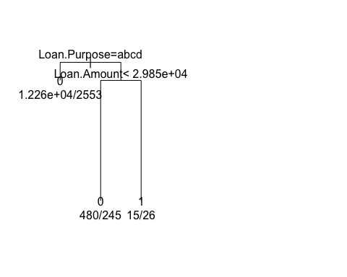

## $x  
## [1] 1.75 1.00 2.50 2.00 3.00  
##   
## $y  
## [1] 1.0000000 0.9994157 0.9994157 0.9955205 0.9955205  
##   
## NULL  
##   
## Classification tree:  
## rpart(formula = as.formula(frml1), data = X, control = rpart.control(cp = cp))  
##   
## Variables actually used in tree construction:  
## [1] Loan.Amount Loan.Purpose  
##   
## Root node error: 2824/15578 = 0.18128  
##   
## n= 15578   
##   
## CP nsplit rel error xerror xstd  
## 1 0.0019476 0 1.0000 1.00000 0.017027  
## 2 0.0010000 2 0.9961 0.99858 0.017017  
## [1] "Class ~ Loan.Amount + Loan.Purpose"  
## [1] "not good tree"  
## [1] "Class ~ Loan.Amount + Address.State"  
## [1] "not good tree"  
## [1] "Class ~ Loan.Amount + Debt.To.Income.Ratio"  
## [1] "not good tree"  
## [1] "Class ~ Loan.Amount + No..Delinquencies.In.Last.2.Years"  
## [1] "not good tree"  
## [1] "Class ~ Loan.Amount + Earliest.Credit.Line.Opened"  
## [1] "not good tree"  
## [1] "Class ~ Loan.Amount + FICO.Credit.Score"  
## [1] "not good tree"  
## [1] "Class ~ Loan.Amount + No..Inquiries.In.Last.6.Months"  
## [1] "not good tree"  
## [1] "Class ~ Loan.Amount + Months.Since.Last.Delinquency"  
## [1] "not good tree"  
## [1] "Class ~ Loan.Amount + No..Of.Credit.Lines"

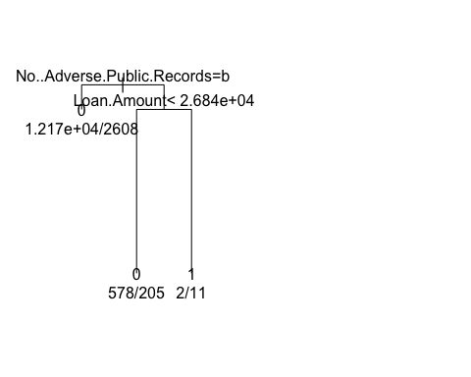

## $x  
## [1] 1.75 1.00 2.50 2.00 3.00  
##   
## $y  
## [1] 1.000000 0.999522 0.999522 0.996335 0.996335  
##   
## NULL  
##   
## Classification tree:  
## rpart(formula = as.formula(frml1), data = X, control = rpart.control(cp = cp))  
##   
## Variables actually used in tree construction:  
## [1] Loan.Amount No..Adverse.Public.Records  
##   
## Root node error: 2824/15578 = 0.18128  
##   
## n= 15578   
##   
## CP nsplit rel error xerror xstd  
## 1 0.0015935 0 1.00000 1.0000 0.017027  
## 2 0.0010000 2 0.99681 1.0007 0.017032  
## [1] "Class ~ Loan.Amount + No..Adverse.Public.Records"  
## [1] "not good tree"  
## [1] "Class ~ Loan.Amount + Total.Credit.Balance"  
## [1] "not good tree"  
## [1] "Class ~ Loan.Amount + Use.Of.Credit.Line"  
## [1] "not good tree"  
## [1] "Class ~ Loan.Amount + Total.Number.Of.Credit.Lines"  
## [1] "not good tree"  
## [1] "Class ~ Loan.Amount + Loan.Application.Description"  
## [1] "not good tree"  
## [1] "generate tree for column Loan.Term starts"  
## [1] "Class ~ Loan.Amount + No..Of.Public.Record.Bankruptcies"  
## [1] "not good tree"  
## [1] "Class ~ Loan.Term + Employment.Length"  
## [1] "not good tree"  
## [1] "Class ~ Loan.Term + Home.Ownership"  
## [1] "not good tree"  
## [1] "Class ~ Loan.Term + Annual.Income"

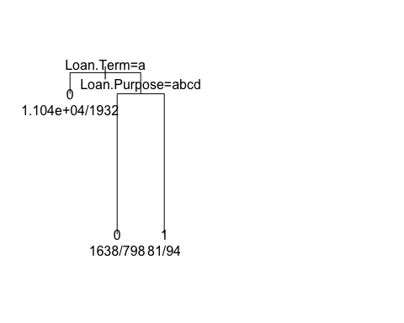

## $x  
## [1] 1.75 1.00 2.50 2.00 3.00  
##   
## $y  
## [1] 1.0000000 0.9993095 0.9993095 0.9947061 0.9947061  
##   
## NULL  
##   
## Classification tree:  
## rpart(formula = as.formula(frml1), data = X, control = rpart.control(cp = cp))  
##   
## Variables actually used in tree construction:  
## [1] Loan.Purpose Loan.Term   
##   
## Root node error: 2824/15578 = 0.18128  
##   
## n= 15578   
##   
## CP nsplit rel error xerror xstd  
## 1 0.0023017 0 1.0000 1.0000 0.017027  
## 2 0.0010000 2 0.9954 1.0014 0.017036  
## [1] "Class ~ Loan.Term + Loan.Purpose"  
## [1] "not good tree"  
## [1] "Class ~ Loan.Term + Address.State"  
## [1] "not good tree"  
## [1] "Class ~ Loan.Term + Debt.To.Income.Ratio"  
## [1] "not good tree"  
## [1] "Class ~ Loan.Term + No..Delinquencies.In.Last.2.Years"  
## [1] "not good tree"  
## [1] "Class ~ Loan.Term + Earliest.Credit.Line.Opened"  
## [1] "not good tree"  
## [1] "Class ~ Loan.Term + FICO.Credit.Score"  
## [1] "not good tree"  
## [1] "Class ~ Loan.Term + No..Inquiries.In.Last.6.Months"  
## [1] "not good tree"  
## [1] "Class ~ Loan.Term + Months.Since.Last.Delinquency"  
## [1] "not good tree"  
## [1] "Class ~ Loan.Term + No..Of.Credit.Lines"  
## [1] "not good tree"  
## [1] "Class ~ Loan.Term + No..Adverse.Public.Records"  
## [1] "not good tree"  
## [1] "Class ~ Loan.Term + Total.Credit.Balance"  
## [1] "not good tree"  
## [1] "Class ~ Loan.Term + Use.Of.Credit.Line"  
## [1] "not good tree"  
## [1] "Class ~ Loan.Term + Total.Number.Of.Credit.Lines"  
## [1] "not good tree"  
## [1] "Class ~ Loan.Term + Loan.Application.Description"

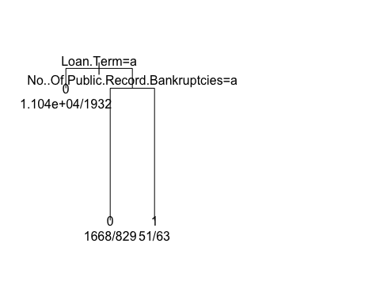

## $x  
## [1] 1.75 1.00 2.50 2.00 3.00  
##   
## $y  
## [1] 1.0000000 0.9993626 0.9993626 0.9951133 0.9951133  
##   
## NULL  
##   
## Classification tree:  
## rpart(formula = as.formula(frml1), data = X, control = rpart.control(cp = cp))  
##   
## Variables actually used in tree construction:  
## [1] Loan.Term No..Of.Public.Record.Bankruptcies  
##   
## Root node error: 2824/15578 = 0.18128  
##   
## n= 15578   
##   
## CP nsplit rel error xerror xstd  
## 1 0.0021246 0 1.00000 1.00000 0.017027  
## 2 0.0010000 2 0.99575 0.99752 0.017010  
## [1] "generate tree for column Employment.Length starts"  
## [1] "Class ~ Loan.Term + No..Of.Public.Record.Bankruptcies"  
## [1] "not good tree"  
## [1] "Class ~ Employment.Length + Home.Ownership"  
## [1] "not good tree"  
## [1] "Class ~ Employment.Length + Annual.Income"  
## [1] "not good tree"  
## [1] "Class ~ Employment.Length + Loan.Purpose"  
## [1] "not good tree"  
## [1] "Class ~ Employment.Length + Address.State"  
## [1] "not good tree"  
## [1] "Class ~ Employment.Length + Debt.To.Income.Ratio"  
## [1] "not good tree"  
## [1] "Class ~ Employment.Length + No..Delinquencies.In.Last.2.Years"  
## [1] "not good tree"  
## [1] "Class ~ Employment.Length + Earliest.Credit.Line.Opened"  
## [1] "not good tree"  
## [1] "Class ~ Employment.Length + FICO.Credit.Score"  
## [1] "not good tree"  
## [1] "Class ~ Employment.Length + No..Inquiries.In.Last.6.Months"  
## [1] "not good tree"  
## [1] "Class ~ Employment.Length + Months.Since.Last.Delinquency"  
## [1] "not good tree"  
## [1] "Class ~ Employment.Length + No..Of.Credit.Lines"  
## [1] "not good tree"  
## [1] "Class ~ Employment.Length + No..Adverse.Public.Records"  
## [1] "not good tree"  
## [1] "Class ~ Employment.Length + Total.Credit.Balance"  
## [1] "not good tree"  
## [1] "Class ~ Employment.Length + Use.Of.Credit.Line"  
## [1] "not good tree"  
## [1] "Class ~ Employment.Length + Total.Number.Of.Credit.Lines"  
## [1] "not good tree"  
## [1] "Class ~ Employment.Length + Loan.Application.Description"  
## [1] "not good tree"  
## [1] "generate tree for column Home.Ownership starts"  
## [1] "Class ~ Employment.Length + No..Of.Public.Record.Bankruptcies"  
## [1] "not good tree"  
## [1] "Class ~ Home.Ownership + Annual.Income"  
## [1] "not good tree"  
## [1] "Class ~ Home.Ownership + Loan.Purpose"  
## [1] "not good tree"  
## [1] "Class ~ Home.Ownership + Address.State"  
## [1] "not good tree"  
## [1] "Class ~ Home.Ownership + Debt.To.Income.Ratio"  
## [1] "not good tree"  
## [1] "Class ~ Home.Ownership + No..Delinquencies.In.Last.2.Years"  
## [1] "not good tree"  
## [1] "Class ~ Home.Ownership + Earliest.Credit.Line.Opened"  
## [1] "not good tree"  
## [1] "Class ~ Home.Ownership + FICO.Credit.Score"  
## [1] "not good tree"  
## [1] "Class ~ Home.Ownership + No..Inquiries.In.Last.6.Months"  
## [1] "not good tree"  
## [1] "Class ~ Home.Ownership + Months.Since.Last.Delinquency"  
## [1] "not good tree"  
## [1] "Class ~ Home.Ownership + No..Of.Credit.Lines"  
## [1] "not good tree"  
## [1] "Class ~ Home.Ownership + No..Adverse.Public.Records"  
## [1] "not good tree"  
## [1] "Class ~ Home.Ownership + Total.Credit.Balance"  
## [1] "not good tree"  
## [1] "Class ~ Home.Ownership + Use.Of.Credit.Line"  
## [1] "not good tree"  
## [1] "Class ~ Home.Ownership + Total.Number.Of.Credit.Lines"  
## [1] "not good tree"  
## [1] "Class ~ Home.Ownership + Loan.Application.Description"  
## [1] "not good tree"  
## [1] "generate tree for column Annual.Income starts"  
## [1] "Class ~ Home.Ownership + No..Of.Public.Record.Bankruptcies"  
## [1] "not good tree"  
## [1] "Class ~ Annual.Income + Loan.Purpose"  
## [1] "not good tree"  
## [1] "Class ~ Annual.Income + Address.State"  
## [1] "not good tree"  
## [1] "Class ~ Annual.Income + Debt.To.Income.Ratio"  
## [1] "not good tree"  
## [1] "Class ~ Annual.Income + No..Delinquencies.In.Last.2.Years"  
## [1] "not good tree"  
## [1] "Class ~ Annual.Income + Earliest.Credit.Line.Opened"  
## [1] "not good tree"  
## [1] "Class ~ Annual.Income + FICO.Credit.Score"  
## [1] "not good tree"  
## [1] "Class ~ Annual.Income + No..Inquiries.In.Last.6.Months"  
## [1] "not good tree"  
## [1] "Class ~ Annual.Income + Months.Since.Last.Delinquency"  
## [1] "not good tree"  
## [1] "Class ~ Annual.Income + No..Of.Credit.Lines"  
## [1] "not good tree"  
## [1] "Class ~ Annual.Income + No..Adverse.Public.Records"  
## [1] "not good tree"  
## [1] "Class ~ Annual.Income + Total.Credit.Balance"  
## [1] "not good tree"  
## [1] "Class ~ Annual.Income + Use.Of.Credit.Line"  
## [1] "not good tree"  
## [1] "Class ~ Annual.Income + Total.Number.Of.Credit.Lines"  
## [1] "not good tree"  
## [1] "Class ~ Annual.Income + Loan.Application.Description"  
## [1] "not good tree"  
## [1] "generate tree for column Loan.Purpose starts"  
## [1] "Class ~ Annual.Income + No..Of.Public.Record.Bankruptcies"  
## [1] "not good tree"  
## [1] "Class ~ Loan.Purpose + Address.State"  
## [1] "not good tree"  
## [1] "Class ~ Loan.Purpose + Debt.To.Income.Ratio"  
## [1] "not good tree"  
## [1] "Class ~ Loan.Purpose + No..Delinquencies.In.Last.2.Years"  
## [1] "not good tree"  
## [1] "Class ~ Loan.Purpose + Earliest.Credit.Line.Opened"  
## [1] "not good tree"  
## [1] "Class ~ Loan.Purpose + FICO.Credit.Score"  
## [1] "not good tree"  
## [1] "Class ~ Loan.Purpose + No..Inquiries.In.Last.6.Months"

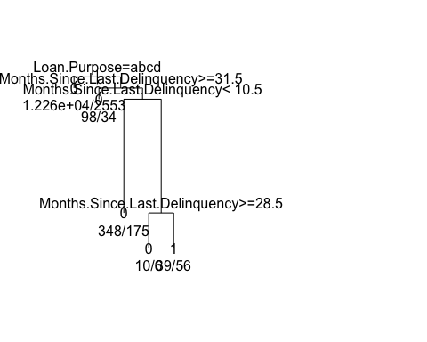

## $x  
## [1] 1.9375 1.0000 2.8750 2.0000 3.7500 3.0000 4.5000 4.0000 5.0000  
##   
## $y  
## [1] 1.0000000 0.9995485 0.9995485 0.9990970 0.9990970 0.9944936 0.9944936  
## [8] 0.9930772 0.9930772  
##   
## NULL  
##   
## Classification tree:  
## rpart(formula = as.formula(frml1), data = X, control = rpart.control(cp = cp))  
##   
## Variables actually used in tree construction:  
## [1] Loan.Purpose Months.Since.Last.Delinquency  
##   
## Root node error: 2824/15578 = 0.18128  
##   
## n= 15578   
##   
## CP nsplit rel error xerror xstd  
## 1 0.0015345 0 1.00000 1.0000 0.017027  
## 2 0.0014164 3 0.99540 1.0011 0.017034  
## 3 0.0010000 4 0.99398 1.0000 0.017027  
## [1] "Class ~ Loan.Purpose + Months.Since.Last.Delinquency"  
## [1] "not good tree"  
## [1] "Class ~ Loan.Purpose + No..Of.Credit.Lines"  
## [1] "not good tree"  
## [1] "Class ~ Loan.Purpose + No..Adverse.Public.Records"

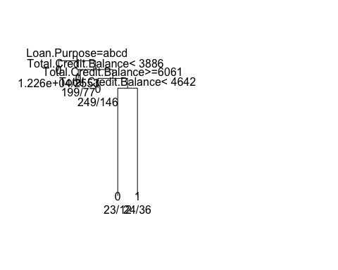

## $x  
## [1] 1.9375 1.0000 2.8750 2.0000 3.7500 3.0000 4.5000 4.0000 5.0000  
##   
## $y  
## [1] 1.0000000 0.9996813 0.9996813 0.9993626 0.9993626 0.9990085 0.9990085  
## [8] 0.9951133 0.9951133  
##   
## NULL  
##   
## Classification tree:  
## rpart(formula = as.formula(frml1), data = X, control = rpart.control(cp = cp))  
##   
## Variables actually used in tree construction:  
## [1] Loan.Purpose Total.Credit.Balance  
##   
## Root node error: 2824/15578 = 0.18128  
##   
## n= 15578   
##   
## CP nsplit rel error xerror xstd  
## 1 0.0010623 0 1.00000 1.0000 0.017027  
## 2 0.0010000 4 0.99575 1.0021 0.017041  
## [1] "Class ~ Loan.Purpose + Total.Credit.Balance"  
## [1] "not good tree"  
## [1] "Class ~ Loan.Purpose + Use.Of.Credit.Line"  
## [1] "not good tree"  
## [1] "Class ~ Loan.Purpose + Total.Number.Of.Credit.Lines"  
## [1] "not good tree"  
## [1] "Class ~ Loan.Purpose + Loan.Application.Description"  
## [1] "not good tree"  
## [1] "generate tree for column Address.State starts"  
## [1] "Class ~ Loan.Purpose + No..Of.Public.Record.Bankruptcies"  
## [1] "not good tree"  
## [1] "Class ~ Address.State + Debt.To.Income.Ratio"  
## [1] "not good tree"  
## [1] "Class ~ Address.State + No..Delinquencies.In.Last.2.Years"  
## [1] "not good tree"  
## [1] "Class ~ Address.State + Earliest.Credit.Line.Opened"  
## [1] "not good tree"  
## [1] "Class ~ Address.State + FICO.Credit.Score"  
## [1] "not good tree"  
## [1] "Class ~ Address.State + No..Inquiries.In.Last.6.Months"  
## [1] "not good tree"  
## [1] "Class ~ Address.State + Months.Since.Last.Delinquency"  
## [1] "not good tree"  
## [1] "Class ~ Address.State + No..Of.Credit.Lines"  
## [1] "not good tree"  
## [1] "Class ~ Address.State + No..Adverse.Public.Records"  
## [1] "not good tree"  
## [1] "Class ~ Address.State + Total.Credit.Balance"  
## [1] "not good tree"  
## [1] "Class ~ Address.State + Use.Of.Credit.Line"  
## [1] "not good tree"  
## [1] "Class ~ Address.State + Total.Number.Of.Credit.Lines"  
## [1] "not good tree"  
## [1] "Class ~ Address.State + Loan.Application.Description"  
## [1] "not good tree"  
## [1] "generate tree for column Debt.To.Income.Ratio starts"  
## [1] "Class ~ Address.State + No..Of.Public.Record.Bankruptcies"  
## [1] "not good tree"  
## [1] "Class ~ Debt.To.Income.Ratio + No..Delinquencies.In.Last.2.Years"  
## [1] "not good tree"  
## [1] "Class ~ Debt.To.Income.Ratio + Earliest.Credit.Line.Opened"  
## [1] "not good tree"  
## [1] "Class ~ Debt.To.Income.Ratio + FICO.Credit.Score"  
## [1] "not good tree"  
## [1] "Class ~ Debt.To.Income.Ratio + No..Inquiries.In.Last.6.Months"  
## [1] "not good tree"  
## [1] "Class ~ Debt.To.Income.Ratio + Months.Since.Last.Delinquency"  
## [1] "not good tree"  
## [1] "Class ~ Debt.To.Income.Ratio + No..Of.Credit.Lines"  
## [1] "not good tree"  
## [1] "Class ~ Debt.To.Income.Ratio + No..Adverse.Public.Records"  
## [1] "not good tree"  
## [1] "Class ~ Debt.To.Income.Ratio + Total.Credit.Balance"  
## [1] "not good tree"  
## [1] "Class ~ Debt.To.Income.Ratio + Use.Of.Credit.Line"  
## [1] "not good tree"  
## [1] "Class ~ Debt.To.Income.Ratio + Total.Number.Of.Credit.Lines"  
## [1] "not good tree"  
## [1] "Class ~ Debt.To.Income.Ratio + Loan.Application.Description"  
## [1] "not good tree"  
## [1] "generate tree for column No..Delinquencies.In.Last.2.Years starts"  
## [1] "Class ~ Debt.To.Income.Ratio + No..Of.Public.Record.Bankruptcies"  
## [1] "not good tree"  
## [1] "Class ~ No..Delinquencies.In.Last.2.Years + Earliest.Credit.Line.Opened"  
## [1] "not good tree"  
## [1] "Class ~ No..Delinquencies.In.Last.2.Years + FICO.Credit.Score"  
## [1] "not good tree"  
## [1] "Class ~ No..Delinquencies.In.Last.2.Years + No..Inquiries.In.Last.6.Months"  
## [1] "not good tree"  
## [1] "Class ~ No..Delinquencies.In.Last.2.Years + Months.Since.Last.Delinquency"  
## [1] "not good tree"  
## [1] "Class ~ No..Delinquencies.In.Last.2.Years + No..Of.Credit.Lines"  
## [1] "not good tree"  
## [1] "Class ~ No..Delinquencies.In.Last.2.Years + No..Adverse.Public.Records"  
## [1] "not good tree"  
## [1] "Class ~ No..Delinquencies.In.Last.2.Years + Total.Credit.Balance"  
## [1] "not good tree"  
## [1] "Class ~ No..Delinquencies.In.Last.2.Years + Use.Of.Credit.Line"  
## [1] "not good tree"  
## [1] "Class ~ No..Delinquencies.In.Last.2.Years + Total.Number.Of.Credit.Lines"  
## [1] "not good tree"  
## [1] "Class ~ No..Delinquencies.In.Last.2.Years + Loan.Application.Description"  
## [1] "not good tree"  
## [1] "generate tree for column Earliest.Credit.Line.Opened starts"  
## [1] "Class ~ No..Delinquencies.In.Last.2.Years + No..Of.Public.Record.Bankruptcies"  
## [1] "not good tree"  
## [1] "Class ~ Earliest.Credit.Line.Opened + FICO.Credit.Score"  
## [1] "not good tree"  
## [1] "Class ~ Earliest.Credit.Line.Opened + No..Inquiries.In.Last.6.Months"  
## [1] "not good tree"  
## [1] "Class ~ Earliest.Credit.Line.Opened + Months.Since.Last.Delinquency"  
## [1] "not good tree"  
## [1] "Class ~ Earliest.Credit.Line.Opened + No..Of.Credit.Lines"  
## [1] "not good tree"  
## [1] "Class ~ Earliest.Credit.Line.Opened + No..Adverse.Public.Records"  
## [1] "not good tree"  
## [1] "Class ~ Earliest.Credit.Line.Opened + Total.Credit.Balance"  
## [1] "not good tree"  
## [1] "Class ~ Earliest.Credit.Line.Opened + Use.Of.Credit.Line"  
## [1] "not good tree"  
## [1] "Class ~ Earliest.Credit.Line.Opened + Total.Number.Of.Credit.Lines"  
## [1] "not good tree"  
## [1] "Class ~ Earliest.Credit.Line.Opened + Loan.Application.Description"  
## [1] "not good tree"  
## [1] "generate tree for column FICO.Credit.Score starts"  
## [1] "Class ~ Earliest.Credit.Line.Opened + No..Of.Public.Record.Bankruptcies"  
## [1] "not good tree"  
## [1] "Class ~ FICO.Credit.Score + No..Inquiries.In.Last.6.Months"  
## [1] "not good tree"  
## [1] "Class ~ FICO.Credit.Score + Months.Since.Last.Delinquency"  
## [1] "not good tree"  
## [1] "Class ~ FICO.Credit.Score + No..Of.Credit.Lines"  
## [1] "not good tree"  
## [1] "Class ~ FICO.Credit.Score + No..Adverse.Public.Records"  
## [1] "not good tree"  
## [1] "Class ~ FICO.Credit.Score + Total.Credit.Balance"  
## [1] "not good tree"  
## [1] "Class ~ FICO.Credit.Score + Use.Of.Credit.Line"  
## [1] "not good tree"  
## [1] "Class ~ FICO.Credit.Score + Total.Number.Of.Credit.Lines"  
## [1] "not good tree"  
## [1] "Class ~ FICO.Credit.Score + Loan.Application.Description"  
## [1] "not good tree"  
## [1] "generate tree for column No..Inquiries.In.Last.6.Months starts"  
## [1] "Class ~ FICO.Credit.Score + No..Of.Public.Record.Bankruptcies"  
## [1] "not good tree"  
## [1] "Class ~ No..Inquiries.In.Last.6.Months + Months.Since.Last.Delinquency"  
## [1] "not good tree"  
## [1] "Class ~ No..Inquiries.In.Last.6.Months + No..Of.Credit.Lines"  
## [1] "not good tree"  
## [1] "Class ~ No..Inquiries.In.Last.6.Months + No..Adverse.Public.Records"  
## [1] "not good tree"  
## [1] "Class ~ No..Inquiries.In.Last.6.Months + Total.Credit.Balance"  
## [1] "not good tree"  
## [1] "Class ~ No..Inquiries.In.Last.6.Months + Use.Of.Credit.Line"  
## [1] "not good tree"  
## [1] "Class ~ No..Inquiries.In.Last.6.Months + Total.Number.Of.Credit.Lines"  
## [1] "not good tree"  
## [1] "Class ~ No..Inquiries.In.Last.6.Months + Loan.Application.Description"  
## [1] "not good tree"  
## [1] "generate tree for column Months.Since.Last.Delinquency starts"  
## [1] "Class ~ No..Inquiries.In.Last.6.Months + No..Of.Public.Record.Bankruptcies"  
## [1] "not good tree"  
## [1] "Class ~ Months.Since.Last.Delinquency + No..Of.Credit.Lines"  
## [1] "not good tree"  
## [1] "Class ~ Months.Since.Last.Delinquency + No..Adverse.Public.Records"  
## [1] "not good tree"  
## [1] "Class ~ Months.Since.Last.Delinquency + Total.Credit.Balance"  
## [1] "not good tree"  
## [1] "Class ~ Months.Since.Last.Delinquency + Use.Of.Credit.Line"  
## [1] "not good tree"  
## [1] "Class ~ Months.Since.Last.Delinquency + Total.Number.Of.Credit.Lines"  
## [1] "not good tree"  
## [1] "Class ~ Months.Since.Last.Delinquency + Loan.Application.Description"  
## [1] "not good tree"  
## [1] "generate tree for column No..Of.Credit.Lines starts"  
## [1] "Class ~ Months.Since.Last.Delinquency + No..Of.Public.Record.Bankruptcies"  
## [1] "not good tree"  
## [1] "Class ~ No..Of.Credit.Lines + No..Adverse.Public.Records"  
## [1] "not good tree"  
## [1] "Class ~ No..Of.Credit.Lines + Total.Credit.Balance"  
## [1] "not good tree"  
## [1] "Class ~ No..Of.Credit.Lines + Use.Of.Credit.Line"  
## [1] "not good tree"  
## [1] "Class ~ No..Of.Credit.Lines + Total.Number.Of.Credit.Lines"  
## [1] "not good tree"  
## [1] "Class ~ No..Of.Credit.Lines + Loan.Application.Description"  
## [1] "not good tree"  
## [1] "generate tree for column No..Adverse.Public.Records starts"  
## [1] "Class ~ No..Of.Credit.Lines + No..Of.Public.Record.Bankruptcies"  
## [1] "not good tree"  
## [1] "Class ~ No..Adverse.Public.Records + Total.Credit.Balance"  
## [1] "not good tree"  
## [1] "Class ~ No..Adverse.Public.Records + Use.Of.Credit.Line"  
## [1] "not good tree"  
## [1] "Class ~ No..Adverse.Public.Records + Total.Number.Of.Credit.Lines"  
## [1] "not good tree"  
## [1] "Class ~ No..Adverse.Public.Records + Loan.Application.Description"  
## [1] "not good tree"  
## [1] "generate tree for column Total.Credit.Balance starts"  
## [1] "Class ~ No..Adverse.Public.Records + No..Of.Public.Record.Bankruptcies"  
## [1] "not good tree"  
## [1] "Class ~ Total.Credit.Balance + Use.Of.Credit.Line"  
## [1] "not good tree"  
## [1] "Class ~ Total.Credit.Balance + Total.Number.Of.Credit.Lines"  
## [1] "not good tree"  
## [1] "Class ~ Total.Credit.Balance + Loan.Application.Description"  
## [1] "not good tree"  
## [1] "generate tree for column Use.Of.Credit.Line starts"  
## [1] "Class ~ Total.Credit.Balance + No..Of.Public.Record.Bankruptcies"  
## [1] "not good tree"  
## [1] "Class ~ Use.Of.Credit.Line + Total.Number.Of.Credit.Lines"  
## [1] "not good tree"  
## [1] "Class ~ Use.Of.Credit.Line + Loan.Application.Description"  
## [1] "not good tree"  
## [1] "generate tree for column Total.Number.Of.Credit.Lines starts"  
## [1] "Class ~ Use.Of.Credit.Line + No..Of.Public.Record.Bankruptcies"  
## [1] "not good tree"  
## [1] "Class ~ Total.Number.Of.Credit.Lines + Loan.Application.Description"  
## [1] "not good tree"  
## [1] "generate tree for column Loan.Application.Description starts"  
## [1] "Class ~ Total.Number.Of.Credit.Lines + No..Of.Public.Record.Bankruptcies"  
## [1] "not good tree"  
## [1] "generate tree for column No..Of.Public.Record.Bankruptcies starts"  
## [1] "Class ~ Loan.Application.Description + No..Of.Public.Record.Bankruptcies"  
## [1] "not good tree"  
## [1] "Class ~ No..Of.Public.Record.Bankruptcies + Class"  
## [1] "not good tree"

options(warn=0)